

AUSTROADS TEST METHOD ATM 250

Modified Surface Texture Depth (Pestle Method)

Contents

1. Scope 1

2. References 1

3. Apparatus 2

4. Procedure 2

5. Calculation 3

6. Test Report 3

7. Notes 3

Appendix A Texture Conversion Charts 5

Amendment Record 7

# Scope

This method describes the procedure for the determination of the surface texture depth of road surfaces, by the sand patch technique. This method is only applicable to surface texture depths greater than 0.3 mm and is the preferred method for determining surface texture allowances in the design of sprayed seals.

# References

The following documents are referred to in this method:

|  |  |
| --- | --- |
| **Austroads Test Method** | |
| ATM 020 | Random selection of sampling or test locations |
| **Australian/New Zealand Standard** | |
| AS/NZS 2009 | Glass beads for pavement-marking materials |
| AS 1141.2:2015 | Methods for sampling and testing aggregates, Method 2: Basic testing equipment |

# Apparatus

The following apparatus is required:

1. Measuring cylinder with a volume of 50.0 ± 0.25 ml. Typical device shown in Figure 7.1.
2. Circular spreading device, between 55 an 75mm in diameter such as a hard rubber disk.
3. 300 mm rule graduated in mm or measuring tape.
4. Either:
   1. clean dry closely graded sand (see Notes 1 and 2); or
   2. glass beads conforming to AS/NZS 2009 (either Type A or Type B).
5. Soft hand brush.

**Note 1:** Quarry sand has a significantly different Coefficient of Uniformity (Cu) than naturally occurring sand or manufactured glass beads and is also more likely to absorb and retain available moisture (in the air or otherwise) at a higher rate than angular or rounded material of a single size.

**Note 2:** Sand, where used, shall conform to one of the following particle size requirements using equipment compliant with AS 1141.2:

* 100% passing 0.850 mm and retained on the 0.600 mm sieve.
* 100% passing 0.600 mm and retained on the 0.300 mm sieve.
* 100% passing 0.300 mm and retained on the 0.150 mm sieve.

# Procedure

1. Select a sample site in accordance with ATM 020.

**Note 3:** Testing may only be performed on dry, mainly horizontal surfaces in weather conditions that do not adversely affect the test result. Rain and wind greater than 19 km/hr will affect the quality of the test measurements.

**Note 4:** Other requirements or restrictions on the location of the sample sites may be included in the relevant specification.

1. The surface of the sample site must be dry, clean and free of significant shape loss (e.g. shoving). If necessary, sweep clean using the soft hand brush.
2. Fill the cylinder with sand or glass beads. When full, gently tap the base of the cylinder three times on a hard surface, top up the cylinder with sand or glass beads and level the top with a straight edge.
3. Pour the sand or glass beads directly onto the surface of the sample site to form a cone (see Figure 7.2). Repeat this step, filling the cylinder as in step (b), as often as necessary to obtain the volume of sand or glass beads required for the texture determination. The volume of sand or glass beads used for the texture determination shall be such that the sand patch has a minimum diameter of 170 mm. Table 4.1 is given as a guide to the volume of sand or glass beads required.

Table 4.1: Texture depth/volume relationship

|  |  |
| --- | --- |
| **Surface texture depth (mm)** | **Volume of sand or glass beads (cm3)** |
| > 0.3 to < 2.0 | 50 |
| ≥ 2.0 to < 4.0 | 100 |
| ≥ 4.0 to < 6.0 | 150 |

1. Spread the sand or glass beads evenly by placing the base of the cylinder on the apex of the cone and rotate the base so that the material flows outwards from the cone.

**Note 5:** Apply only horizontal forces to the cylinder working outwards in a spiral fashion to spread the material in a circular pattern until the surface depressions are filled to the levels of the peaks as shown in Figure 7.3.

1. Measure the diameter of the sand patch to the nearest 5mm. The diameter shall be measured at four locations at approximately equally spaced distances around the sand patch.

# Calculation

1. Calculate the average sand patch diameter to the nearest 1 mm.
2. Calculate the surface texture depth using the formula:

|  |  |  |  |
| --- | --- | --- | --- |
|  |  |  |  |
| where |  |  |  |
| STD | = | surface texture depth in mm |  |
| V | = | volume of sand in patch in cm³ |  |
| D | = | average diameter of sand patch in mm |  |

**Note 6:** A conversion chart is included as Appendix A to convert the sand patch diameter to surface texture depth without the need for a calculator.

# Test Report

Report the following:

1. the location of the test (road, chainage, wheel path, etc.)
2. the date and time of test
3. the surface texture depth to the nearest 0.1 mm.

# Notes

1. Select the size of the sand or glass beads according to the road texture to be measured. The size of the material used should not exceed the texture depth to be measured.
2. The sand or glass beads shall be spread so as not to reach the levels of abnormally high peaks.

Figure 7.1: Typical texture depth measuring cylinder

|  |  |  |
| --- | --- | --- |
| 1. | Nitrile rubber base with an international rubber hardness of 70 – 80. | pestle |
| 2. | All dimensions are in mm unless otherwise stated.  Mass = 325 ± 25 g  Volume = 50.0 ± 0.20 cm3 |

Figure 7.2: Known volume of sand poured onto the surface to form a cone

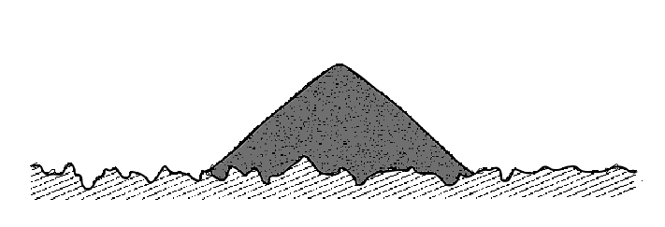

Figure 7.3: Sand spread to form a circular patch

**Diameter**

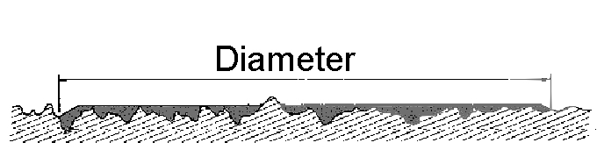

Appendix A Texture Conversion Charts

Table A1 and the chart shown in Figure A1 are provided to convert the sand patch diameter to surface texture depth without the need for a calculator. Operators can use either the table or the chart.

Table A1: Diameter vs. texture depth conversion table

|  |  |  |  |  |  |
| --- | --- | --- | --- | --- | --- |
| **Sand volume 50 cm³** | | **Sand volume 100 cm³** | | **Sand volume 150 cm³** | |
| Diameter  (mm) | Texture depth (mm) | Diameter (mm) | Texture depth (mm) | Diameter  (mm) | Texture depth (mm) |
| 460 | 0.3 | 252 | 2.0 | 219 | 4.0 |
| 400 | 0.4 | 246 | 2.1 | 213 | 4.2 |
| 357 | 0.5 | 241 | 2.2 | 208 | 4.4 |
| 326 | 0.6 | 235 | 2.3 | 204 | 4.6 |
| 301 | 0.7 | 230 | 2.4 | 199 | 4.8 |
| 282 | 0.8 | 226 | 2.5 | 195 | 5.0 |
| 266 | 0.9 | 221 | 2.6 | 192 | 5.2 |
| 252 | 1.0 | 217 | 2.7 | 188 | 5.4 |
| 241 | 1.1 | 213 | 2.8 | 185 | 5.6 |
| 230 | 1.2 | 209 | 2.9 | 181 | 5.8 |
| 221 | 1.3 | 206 | 3.0 | 178 | 6.0 |
| 213 | 1.4 | 200 | 3.2 |  |  |
| 206 | 1.5 | 194 | 3.4 |  |  |
| 200 | 1.6 | 188 | 3.6 |  |  |
| 193 | 1.7 | 183 | 3.8 |  |  |
| 188 | 1.8 | 179 | 4.0 |  |  |
| 183 | 1.9 |  |  |  |  |
| 178 | 2.0 |  |  |  |  |

Figure A1: Diameter vs. texture depth conversion chart



Amendment Record

|  |  |  |  |
| --- | --- | --- | --- |
| **Amendment no.** | **Clauses amended** | Action | Date |
| 1 | Commentary Page | New | June 2005 |
| Footer and header | Format |
| Applied revised test method number | Format |
| Applied new styles | Format |
| 2 | Preface | Substitution | June 2006 |
| 3 | Changed the required number of patch diameters from five to four | Substitution | Oct 2006 |
| 4 | Changed list numbering in apparatus section | Substitution | Jan 2007 |
| 5 | Appendix A added | New | May 2008 |
| Notes 1, 2, 3 and 5 added | New |
| 6 | Whole document | Format | November 2023 |
| Whole document | References updated |
| Title page | Test Method Number amended |
| 7 | Whole document | Format | February 2025 |
| Commentary | Substitution |
| References | Substitution |
| 3. (d) Apparatus | Substitution |
| 4. (a) Procedure.  New Note 4 inserted | Substitution |
| 7, Notes (a) | Substitution |
| 8 | 5.Calculation | Substitution | March 2025 |

|  |  |
| --- | --- |
| **Key** |  |
| Format | Change in format |
| Substitution | Old clause removed and replaced with new clause |
| New | Insertion of new clause |
| Removed | Old clauses removed |