AUSTROADS TECHNICAL SPECIFICATION ATS 3310  Construction of Unbound Granular Pavements | 
Contents
1. Scope 2
2. Referenced Documents 2
3. Definitions 3
4. Quality System Requirements 4
5. Constituent Materials 4
General 4
Granular Pavement Material 5
Stockpiling of Granular Material 5
Water 6
Testing and Approval of Constituent Materials 6
6. Plant and Equipment 7
General 7
Paver 7
Intelligent Construction Rollers 7
7. Construction 8
Quality Plan 8
Trial Pavement 9
Management of the Moisture Content 9
Spreading, Compaction and Trimming 10
Intelligent Construction 10
Construction Joints 11
Segregation 11
Surface of the Pavement Layer 11
Protection and Maintenance of the Works 12
8. Conformity of the Pavement Layers 12
Quality Plan 12
Conformance Testing 13
Surface Finish 14
Compaction 14
Post Compaction Particle Size Distribution 15
Ball Penetration Testing 15
Dryback 15
Proof Rolling 15
9. Conformity – Geometrics 16
General 16
Geometric Tolerances 17
Surface Levels 17
Deviation from a Straightedge 18
Crossfall 18
10. Acceptance 19
Annexure A Summary of Hold Points, Witness Points and Records 20
Annexure B Examples of Pavements Surfaces Prior to Bituminous Surfacing 21
Amendment Record 23
Attachment A Contract Specific Requirements 24

Scope
Austroads Technical Specification ATS 3310 sets out the requirements for the construction of an unbound granular pavement.
The following is excluded from the scope of ATS 3310:
  - the construction of pavements using Marginal/Non-standard Materials; and
  - the supply of granular pavement materials.

Referenced Documents
The following documents are referenced in this Specification:
Australian/New Zealand Standards
AS 1289 Methods of testing soils for engineering purposes
Method 3.6.1: Soil classification tests – Determination of the particle size distribution of a soil – Standard method of analysis by sieving
Method 4.2.1: Soil chemical tests – Determination of the sulfate content of a natural soil and the sulfate content of the groundwater – Normal method
Method 5.4.1: Soil compaction and density tests – Compaction control test – Dry density ratio, moisture variation and moisture ratio
AS/NZS 4276 Water microbiology
Method 5: Escherichia coli and thermotolerant coliforms – Membrane filtration method
Method 6: Coliforms, Escherichia coli and thermotolerant coliforms – Determination of most probable number (MPN)
Austroads
AGAM-T001 Pavement Roughness Measurement with an Inertial Profilometer
AGPT-T251 Ball Penetration Test
AP-C87 Austroads Glossary of Terms
AP-T335 Appropriate Use of Marginal and Non-standard Materials in Road Construction and Maintenance
ATM-020 Random Selection of Sampling or Test Locations
ATM-030 Characteristic Value of a Lot
ATM-440 Proof Rolling
ATM-453 Surface Deviation Using a Straightedge
ATM-940 Moisture Ratio Determination for Assessment of Dry-Back of Granular Pavement Materials
ATS-1140 Environmental Management Systems
Australian Government: National Health and Medical Research Council
ADWG6 Australian Drinking Water Guidelines 6
American Public Health Association
Standard Methods for the Examination of Water and Wastewater:
APHA 2510 B Conductivity – Laboratory Method
APHA 2540 D Total Suspended Solids Dried at 103-105°
APHA 4500 Cl Chlorine (Residual)
APHA 4500 H B pH Value in Water by Potentiometry Using a Standard Hydrogen Electrode

Definitions
In addition to the definitions in AP-C87, the following definitions/abbreviations apply to this Specification.
Characteristic Value: | The characteristic value determined from statistical analysis of individual test results in accordance with ATM-030.
Intelligent  Construction (IC): | A process that uses vibratory rollers equipped with a measurement and documentation system that automatically records various critical parameters. Further details are included in Clause 7.24.
Optimum Moisture  Content (OMC): | The optimum moisture content determined in accordance with the compactive effort and test method specified in Attachment A.
Marginal/Non-standard Materials: | Refer to AP-T335.
Pavement Design Documentation: | The drawings and any other document identified as such which set out the design of the pavement. The design of the pavement includes the specified layer types, layer thickness, cross sections and other geometric details.
Principal’s Registration Scheme: | Any scheme for the prequalification, registration or approval of products, quarries, manufacturers and/or suppliers in operation in the jurisdiction where the unbound granular material is to be placed.
Segregation: | The separation of material by particle size so that the actual grading at a particular location is not representative of the grading of the entire Lot. Typically evidenced by the separation of coarse material from the matrix of finer material, leading to areas with a deficiency or excess of a particular particle size.

Quality System Requirements
The Contractor must prepare and implement a Quality Plan that includes the documentation in Table 4.1.
Table 4.1: Quality Plan
Clause | Description of document
5.1 | Details of materials and procedures for handling/stockpiling.
6.1 | Details of construction plant and equipment.
7.1 | Details and procedures for pavement construction.
8.1 | Testing program and test methods for conformance testing.
9.1 | Testing program and methodologies for verifying the geometrics.

HOLD POINT 1
Process Held | Construction of unbound pavement layers, including any trial pavements
Submission Details | The Quality Plan must be provided to the Principal at least 10 working days prior to the commencement of work on site.

Constituent Materials

General
The Quality Plan must include details, procedures and/or Inspection and Test Plans for the following:
  - Details (including applicable specification) and source of the granular material.
  - Procedure for ensuring that only conforming granular material is transported to the construction site and that the test reports and certification of conformity are submitted to the Principal prior to incorporation into the Works.
  - If site stockpiles are used, the planned location of the stockpiles and details/procedures for the construction, operation and restoration of the stockpile sites.
  - Details of the method of handling and transporting the granular material.
  - Procedures/methodology to prevent segregation and/or loss of fines at all stages of materials handling, storage and transportation.
  - Methodology to provide traceability of granular pavement materials from source through to material incorporated into the final pavement.
  - If water is not sourced from a reticulated mains system, details of the source of the water and test results that demonstrate that the water complies with Clause 5.13.
The constituent materials must comply with this Specification and the requirements specified in Attachment A.

Granular Pavement Material
Where a Principal’s Registration Scheme is in place for the supply of unbound granular material, the unbound granular material must be a registered product which has been approved in accordance with that scheme.
The granular material must be handled, stockpiled and transported in a manner which prevents Segregation, loss/wastage of material or contamination and keeps the material at the required moisture content.

Stockpiling of Granular Material
  - A stockpile, where used, must:
  - be clearly identified by signposting, stating the type and quantity of material present in the stockpile;
  - only contain material of the same standard or type;
  - be separated from other stockpiles by at least 2 m to prevent the stockpiled materials from becoming intermixed, or contaminated with foreign material; and
  - not be more than 4 m high.
  - Nonconforming Lots must be removed from the stockpile prior to the addition of further material. Where material in a stockpile has been tested and certified to be conforming, additional material must not be added to that stockpile unless it has also been certified to be conforming.
  - Unless otherwise specified in Attachment A, the Contractor is responsible for preparation of the site on which the stockpiles are placed and the site must comply with any requirements or restrictions regarding the location stated in Attachment A. The stockpile site must be located on clear, even, firm, well-drained ground and has been prepared so that there will be no contamination of the material during the handling and loading.
  - Conformance testing of the imported granular material must be completed before material is removed from the stockpile. Unless specified otherwise in Attachment A, the Contractor must submit a certificate to the Principal verifying that the stockpile conforms to this Specification prior to the material being transported from the stockpile.
  - In addition to the requirements of the approved Contractor’s Environmental Management Plan (refer to ATS 1140) and any other environmental management requirements included in the Contract documents:
  - measures must be in place to ensure that erosion and sedimentation is controlled;
  - the surface of the stockpile must be sufficiently damp to avoid loss of fines and to keep dust levels down; and
  - on completion of Works, the area is cleared of all surplus material and rehabilitated to the pre-existing condition (unless specified otherwise).
  - Any Stockpile of material that is blended with reclaimed granular materials must be managed by the Contractor to comply fully with the requirements of this Specification.
  - If processed/blended reclaimed granular material is used, it must be placed in separate stockpiles prior to use. Where reclaimed granular material is not in a free-flowing condition, it must be reprocessed to ensure that it is free flowing and homogeneous at the time of its use.

Water
  - Water used in the construction of an unbound pavement must:
  - be free of any matter that may be deleterious to the pavement, including organic matter, oils, salts, acids and alkalis;
  - not be marine water; and
  - be potable (i.e. satisfy the requirements of ADWG6).
If water is not sourced from a reticulated system operated by an approved water authority, the water must be tested for compliance with Table 5.13.
Table 5.13: Water quality
Property | Test frequency | Test method | Acceptance criteria
pH | At periods not exceeding 3 months or whenever the source of water has changed | - APHA 4500 H B; or  - approved equivalent | 6 to 10
Electrical Conductivity |  | - APHA 2510 B; or  - approved equivalent | < 3500 µS/cm
Chloride |  | - APHA 4500 Cl; or  - approved equivalent | < 600 mg/L
Sulfate Content  (expressed as SO₄) |  | - AS 1289.4.2.1; or  - other published or validated classical chemistry technique or instrumentation technique ⁽¹⁾ | 1.9 g/L or 0.05%
Undissolved Solids |  | - APHA 2540 D; or  - approved equivalent | 1% by mass
Concentration of thermo-tolerant coliforms |  | - AS/NZS 4276.5 (for low turbidity water); or  - AS/NZS 4276.6 (for turbid water) | ≤ 1,000 coliforms per 100 ml
Note:
- Instrumentation techniques include Ion Chromatography, Inductively Coupled Plasma and Discrete Analyser. NATA or IANZ endorsed test results are evidence of a validated technique.
  - Where recycled water is used, the water must:
  - comply with the requirements in Clause 5.13; and
  - comply with any other specified environmental management requirements included in the Contract documents.

Testing and Approval of Constituent Materials
  - The Contractor must ensure that testing of each Lot is undertaken to verify that all constituent materials comply with this Clause 5. A Lot must not include more than one type of granular material. Samples for compliance testing must be selected by random sampling in accordance with ATM-020.
  - All test results and a certificate of conformity for each Lot must be submitted to the Principal prior to incorporation into the Works. In addition, the test results must be included in the Lot Compliance Report (refer to Clause 10.1).
HOLD POINT 2
Process Held | Incorporation of granular material into the Works
Submission Details | Test results demonstrating the constituent materials comply with this Specification must be submitted to the Principal prior to the materials being incorporated into the Works.
  - The constituent materials and sources used in the Works must be the same as those for materials supplied as samples or for which certificates of compliance with this Specification are provided. If the source or properties of a constituent material changes from that originally submitted and approved in the Quality Plan, the Contractor must submit all test results required under this Specification with the proposed replacement materials and Hold Point 2 will reapply.
The Contractor must ensure that the properties of the constituent material do not change between conformance testing and completion of incorporation into the Works (for example, due to segregation, breakdown during compaction, contamination or weathering). If there is any evidence that the material properties have changed, prior to the pavement layer being covered, the Contractor must retest the Lot to demonstrate that it remains conforming.

Plant and Equipment

General
The Quality Plan must include details of all plant and equipment to be used in the construction of the pavement layers, including:
- placement equipment, including paver and/or grader;
- equipment capable of roughening the surface of the pavement layers (where required);
- equipment for sweeping the layer surface;
- equipment for the preparation of a surface to be covered by a bituminous treatment; and
- compaction equipment, including Intelligent Construction (IC) rollers, if used.

Paver
If a paver is used, it must be a self-propelled spreading machine, purpose-built for this work with the capacity to either:
  - receive the material in a hopper and place and spread the material on the prepared surface to the required uncompacted layer thickness, width and shape in one pass; or
  - spread previously-placed windrows of the material to the required uncompacted layer thickness, width and shape in one pass.
Where the material is being placed adjacent to a fixed edge or the width of the layer varies, the paver must be fitted with a variable width screed.
In areas where the pavement width is such that the use of a paver is not practical, the Quality Plan must document the paving equipment to be used and the proposed construction methodology.

Intelligent Construction Rollers
If the use of Intelligent Construction (IC) is specified in Attachment A, the IC rollers must be:
  - self-propelled, single smooth drum vibratory rollers equipped to measure the stiffness of the layer being compacted;
  - capable of recording and displaying:
    - real-time, colour-coded maps of the roller position, coverage and stiffness of the compacted layer;
    - number of roller passes;
    - roller speeds; and
    - vibration frequency and amplitude of the roller drums.
The data output from the IC roller must be compatible with Veta standardised software used for the display, analysis and reporting of data collected by IC.

Construction

Quality Plan
The Quality Plan must include details, procedures and Inspection and Test Plans for all aspects of the pavement construction, including:
  - a procedure to verify that the Hold Point applicable to the completion of new subgrade construction has been released and that the condition of the subgrade has not deteriorated since release of that Hold Point;
  - the lengths, widths and detail of joints for each paving run;
  - the procedure to incorporate water into the granular material and to achieve uniform distribution of moisture within the target moisture content envelope;
  - procedures for the transport, placement, joint preparation, compaction and trimming of the pavement material;
  - where the specified pavement course is constructed in 2 or more layers, details of the procedure to ensure that a hard-rough surface on the lower layer is achieved and a homogeneous pavement course that is continuous across the interface between layers is created;
  - the proposed rolling pattern and number of passes needed to achieve the specified compaction standard for each layer thickness and support condition;
  - details for placing and compacting material up to or against to structures, kerbs, road safety barriers, access chambers, drainage gullies and other fixed infrastructure within or adjacent to the pavement;
  - procedure for preparing the surface and preventing the surface from drying out to the point where excessive dust may be generated by traffic;
  - procedure and equipment proposed for proof rolling pavement layers;
  - procedure to ensure that after the release of the applicable Hold Point and prior to the placement of a subsequent pavement layer or the bituminous surfacing, the condition of the surface does not deteriorate and the moisture content does not exceed the specified dryback limit; and
  - procedure and equipment to prepare the surface prior to bituminous surfacing (where applicable).

Existing Structures and Utilities
  - If not undertaken previously, the Contractor must:
  - undertake a site inspection and check that any site information provided by the Principal is complete and sufficiently accurate for construction purposes;
  - determine the location and depth of utility services (such as pipes, conduits and cables) and any associated existing infrastructure with sufficient accuracy to ensure that the stabilisation work will not damage the utility services; and
  - submit evidence of the site inspection and determination of the location of utilities to the Principal.

General
  - The Contractor must: construct the pavement in accordance with the Pavement Design Documentation and this Specification, including:
  - spreading, shaping and compacting the pavement material in accordance with this Clause 7;
  - achieving the construction requirements specified in Clause 8; and
  - achieving the geometric requirements specified on Clause 9.
If a Lot is damaged or subject to rainfall/moisture ingress after conformance testing and before placement of bituminous surfacing or a subsequent pavement layer, the Lot must be reworked, repaired or replaced (where appropriate). The Lot must be retested for conformance in accordance with Clause 8.9.
Cementitious material must not be added to any material used for the construction of a pavement layer.

Trial Pavement
The Contractor must construct a trial section of pavement if:
  - specified in Attachment A; or
  - the nominal pavement material size is 40 mm or more.
WITNESS POINT 1
Process | Construction of trial pavement (where applicable)
Notification Period | At least 3 working days before the commencement of the trial.
The purpose of the trial is to validate that the construction procedures, when used with the approved materials, will achieve the requirements specified in this Specification.
The trial section must:
  - be between 100 m and 200 m long and constructed to the width of the proposed Lot;
  - be constructed using the same materials, plant and processes used for the remainder of the works; and
  - be tested to demonstrate that it conforms to the requirements of this Specification, including:
    - the construction joint requirements of Clause 7;
    - the surface finish requirements of Clause 8; and
    - compliance with the specified post compaction grading requirements.
A trial section for an upper base layer may be constructed as part of a lower pavement layer.
A new trial section must be constructed if a change in the material type/source or a change in construction procedure is proposed during construction.
All test results and records carried out on the trial section and a completed Inspection and Test Plan must be submitted to the Principal.

HOLD POINT 3
Process Held | Construction of unbound pavement layers (where a trial section is specified)
Submission Details | Test results, records and the Inspection and Test Plan from the trial pavement must be submitted to the Principal at least 3 working days prior to the commencement of pavement construction.

Management of the Moisture Content
The Contractor must develop a work method and target moisture content envelope to ensure that:
  - there is adequate moisture in the pavement material to achieve the specified compaction; and
  - the pavement is capable of taking traffic load without deformation on completion of compaction.
Moisture must be uniformly distributed throughout the layer immediately prior to compaction.
Unless specified otherwise in Attachment A, the moisture content of the material during compaction must not be less than 85% of Optimum Moisture Content (OMC) and be within the target moisture content envelope.
After completion of compaction of a layer, the moisture content of the material in the layer must be maintained at a moisture content of not less than that specified in Clause 7.14 until Proofing Rolling (refer to Clause 8.27) has been completed. The placement of an overlying pavement layer or bituminous surfacing must not commence until the moisture content (‘dryback’) of the underlying pavement layer is less than that specified in Table 8.6.

Spreading, Compaction and Trimming
Material must be spread and compacted such that the material is uniformly and consistently mixed both transversely and longitudinally to produce a homogeneous material for each lot.
Each pavement layer must be spread and compacted in uniform thicknesses which, after final trimming, will achieve the specified layer thickness within the tolerances specified in Clause 9. Where multiple layers of the same material are placed in a single course, each layer must be of equal thickness.
Unless specified otherwise in Attachment A, the completed layer thicknesses (after compaction and surface preparation) must comply with Table 7.18.
Table 7.18: Pavement layer thickness limitations
Layer | Minimum thickness | Maximum thickness
Base | 100 mm or 4 times the nominal size of the material, whichever is the greater | 150 mm
Sub-base | 75 mm or 4 times the nominal size of the material, whichever is the greater | 250 mm
This Clause 7.19 applies where the pavement layer is being constructed over an existing surface. If the dimension between the design level at the top of the pavement layer and the underlying surface is less than the thickness specified in Table 7.18, the underlying material must be removed so that the resulting compacted thickness of the layer to be worked complies with Table 7.18. If the underlying material is the same as that used the layer being constructed, it may be scarified to such a depth to achieve the required layer thickness.
Final trim is limited to removing no more than 20 mm of material at any point while meeting the layer requirements of Table 7.18.
Any material that has been compacted and then trimmed from the compacted surface to conform to the specified level or thickness must not be re-used in the construction of a pavement layer, unless approved by the Principal.
The full depth of the pavement must be compacted over the entire area.
Roller marks must not remain on the pavement surface after trimming.

Intelligent Construction
  - Intelligent Construction (IC) is a process that uses vibratory rollers equipped with a measurement and documentation system that automatically and continuously records various critical compaction parameters, which are correlated to standard testing protocols in real time during the compaction process. The position and number of passes of the roller is tracked using a global positioning system (GPS). IC may be used to assist with the assessment of compaction uniformity.
  - If the use of IC Rollers is specified in Attachment A, the IC Roller Coverage (RC) for each Lot must not be less than 90%. RC is calculated as:
RC = A_{r}/A_{t}
where:
A_{r} = The area of the Lot (that is to be incorporated into the Works) which has achieved the minimum number of roller passes nominated in the relevant procedure in the approved Quality Plan.
A_{t} = The total area of the Lot that is to be incorporated into the Works.
The minimum number of roller passes nominated in the Quality Plan is that required to achieve the conformity requirements specified in Clause 8.
  - For each Lot where IC is used, the Contractor must use Veta to analyse the IC data for RC. The following must be submitted to the Principal within 24 hours of completion of compaction:
- All input files necessary to analyse the data in Veta.
- A report of the Veta analysis (which has been output directly from Veta).
  - The Veta report must also be included in the Lot Conformance Repot (refer to Clause 10.1) and cross referenced to the locations and values of all individual compaction compliance test results. All data and files must be clearly linked to the construction Lot that they relate to.

Construction Joints
The layout of joints must conform to the following requirements:
  - Material must be spread in such a manner as to minimise the number of joints.
  - For all pavement layers, transverse joints in adjoining paver runs must be offset by not less than 2 m.
  - Transverse joints must be offset from one layer to the next by not less than 2 m.
  - Longitudinal joints must be offset from one layer to the next by not less than 150 mm.
  - Longitudinal joints must be located within 300 mm of the planned position of traffic lanes lines or within 300 mm of the centre of a traffic lane.
  - Longitudinal joints in the final (uppermost) layer of unbound pavement bases must coincide with the final traffic lane markings and/or line of change in crossfall (for example, crown of the pavement.
The exposed end of each lot and the exposed edges of any part width construction must be kept moist until spreading and compaction has been completed over the entire layer.

Segregation
The pavement material must not become Segregated at any stage of the construction process and it must comply with the specified grading at all times prior to compaction.
Any Segregated area of placed material is non-conforming and must be removed and replaced with new material before compaction commences.

Surface of the Pavement Layer
The surface of each granular pavement layer must be constructed to comply with the requirements of Clause 8.11 and Clause 8.12 (where applicable).
The preparation of the surface must not reduce the density of the layer or compromise the integrity of the surface.
Where the uppermost pavement layer will be covered by bituminous surfacing, the layer must be prepared to produce a surface that meets the requirements of Clause 8. The addition of fine material to the surface of a compacted pavement layer is not permitted.

Protection and Maintenance of the Works
The surface of each compacted pavement layer must be maintained in such a way as to:
  - prevent moisture damage, which includes ponding, scouring and water ingress into a pavement layer;
  - minimise dust;
  - prevent ravelling, erosion, deformation or any other damage to the layer; and
  - ensure that the layer is free of contamination.
Prior to placing an overlying granular pavement layer or bituminous surfacing, the pavement layer must be tested for conformance in accordance with Clause 8 and Clause 9.
Following the testing and acceptance of a granular pavement layer, the condition of the surface must not deteriorate and the moisture content must not exceed the specified dryback limit. Until the pavement layer is covered by an overlying granular pavement layer or bituminous surfacing, the pavement layer must be maintained so that it remains in the same condition that it was at the time of acceptance.

Conformity of the Pavement Layers

Quality Plan
The Quality Plan must include:
  - A testing program and testing methodologies, which address the assessment of each property listed in Table 8.6.
  - Procedures for:
- repair of test holes; and
- reworking, repair and/or replacement of a pavement layer if it does not conform the requirements of this Clause 8 or Clause 9.
The location of tests (i.e. the longitudinal coordinate and lateral coordinate/offset) must be selected by the Contractor for each Lot on a stratified random basis in accordance with ATM-020. The number of strata must be equal to the number of tests required for a given lot.
All testing to verify conformance with this Specification must be performed by a laboratory that is accredited to meet the requirements of AS ISO/IEC 17025 for the test method. The laboratory’s accreditation body must be a signatory to the International Laboratory Accreditation Cooperation Mutual Recognition Arrangement (ILAC MRA) for testing laboratories. The National Association of Testing Authorities (NATA) and International Accreditation New Zealand (IANZ) are signatories to the ILAC MRA.
Where a Characteristic Value of a property is specified, the Characteristic Value must be determined in accordance with ATM-030.
All test holes must be reinstated with material complying with the same specification used for that pavement layer and the material must be compacted to the standard specified for that layer.

Conformance Testing
Each pavement layer must be tested for conformance with the requirements set out in Table 8.6.
Table 8.6: Conformance requirements – general
Property | Test method | Minimum testing frequency | Acceptance criteria
Roller Coverage  (where IC is specified) | Refer to Clause 7.25 | Every Lot | Not less than 90%
Surface finish  (Clause 8.11 and  Clause 8.12) | Visual inspection | Entire surface of the Lot | Refer to Clause 8.11 and Clause 8.12
Road Roughness  (where specified)  (Clause 8.15) | AGAM-T001 | Entire lane | Refer to Attachment A
Compaction  (Clause 8.16) | AS 1289.5.4.1 | 6 per Lot | Refer to Attachment A
Post Compaction Particle Size Distribution  (Clause 8.19) | AS 1289.3.6.1 | Refer to Clause 8.20 | Refer to Clause 8.21
Ball Penetration Value  (Clause 8.22) | AGPT-T251 | 6 per Lot | Individual result: ≤ 3 mm
Dryback (Clause 8.26) | ATM 940 | 9 per Lot under a bituminous surfacing; 6 per Lot otherwise | Refer to Attachment A
Proof rolling  (Clause 8.27) | ATM-440 | Entire surface of each completed pavement layer | No perceptible surface deformation
For road widening and/or pavement works adjoining an existing pavement, testing of compaction which is in addition to that specified in Table 8.6 must be carried out. The additional tests must be carried out at locations within 200 mm of the joint line. The minimum test frequency is one test per 100 lineal metres or part thereof and the distance between each test must not exceed 100 m.
The maximum Lot size is the lesser of the area of work completed on a single day and 4,000 m².
Test results must be representative of the condition of the Lot immediately prior to it being covered. If, after the completion of the testing, the pavement layer lot has been subjected to rainfall or moisture ingress, or any other deterioration, the Contractor must retest the Lot to demonstrate that it remains conforming with the requirements of this Specification before work commences on the construction of the subsequent layer or bituminous surfacing.
In the event of a non-conformance, the Contractor’s non-conformance report must identify the cause of the nonconformity and propose preventative action to prevent any reoccurrence. If rectification of the non-conformance requires replacement or reworking of the material, the full depth of the layer must be replaced or reworked and additional testing to demonstrate compliance with this specification must be undertaken, unless approved otherwise by the Principal.

Surface Finish
  - The entire finished surface of each pavement layer must be inspected to verify conformance with this Clause 8.11. The finished surface must be:
  - hard, tightly bonded, homogenous and uniformly textured in appearance;
  - free of slurry at the surface;
  - free of loose, dusty or contaminated areas;
  - free of roller marks or localised depressions;
  - free of visible areas of Segregation;
  - free of delamination; and
  - free of cracking.
  - Where the pavement layer is to be covered by a sprayed bituminous treatment, in addition to the requirements of Clause 8.11, the surface must:
  - be free of tearing and scabbing;
  - not be friable when subject to rotary road mechanical brooming;
  - appear as a stone mosaic interlocked with fine material after brooming; and
  - have the course particles of the pavement layer slightly exposed.
  - Reference may be made to Annexure B to determine whether the surface is conforming or non-conforming prior to the application of sprayed initial treatment.
Where a non-conforming area is identified, in addition to identifying the proposed rectification of the non-conformance, the Contractor’s non-conformance report must identify the cause of the non-conformance and the proposed action to prevent reoccurrence of the non-conformance.

Road Roughness
if testing for road roughness is specified in Attachment A, the road roughness of the uppermost pavement layer must be tested to demonstrate that the actual road roughness value (Rs) does not exceed the value specified in Attachment A.

Compaction
The Characteristic Value of compaction for each layer for the Lot must not be less than the value specified in Attachment A.
The compaction of each layer must be determined using the test methods specified in Attachment A. The locations of all tests undertaken for the determination of in situ density must be at the same locations of samples taken to determine the corresponding moisture density ratio and be recorded in accordance with the approved Quality Plan.
Where a nuclear surface moisture-density gauge is used and in direct transmission mode, the probe must be positioned at a depth between 10 mm and 30 mm above the underside of the constructed layer, in a hole drilled or driven in the pavement, at least 25 mm deeper than the probe position.

Post Compaction Particle Size Distribution
The Contractor must not work the pavement material to the extent that breakdown of the material occurs and the particle size distribution no longer meets the requirements of this Contract. Unless specified otherwise in the Pavement Design Documentation or the Principal waives the requirement for post-compaction testing, the Contractor must test the material to determine the post-compaction particle size distribution.
The test samples to be used for post-compaction particle size distribution testing must be a combined sample made up from 6 randomly selected increments extracted from the Lot of pavement construction being assessed. The sample must be taken from the same sample site as the compaction testing. The particle size distribution must be determined in accordance with AS 1289.3.6.1.
The pavement material is non-conforming if the post-compaction particle size distribution does not comply with the requirements specified for the supply of that pavement material, with the following modification:
  - The maximum permissible amount of material retained on the 2.36 mm sieve (or finer) is one percentage point greater than maximum permitted in the specification for the supply of that pavement material.

Ball Penetration Testing
Prior to undertaking the bituminous surfacing on the completed base course, the Contractor must undertake testing to verify that the Ball Penetration Value complies with the criteria specified in Table 8.6.
Notwithstanding Clause 8.2, the ball penetration test must be undertaken in the outer wheel path at each longitudinal test location.
Each of the 5 test points required by AGPT-T251 for a test location must be on surfaces undisturbed by the density test sampling and subsequent repair.
Where both dryback and ball penetration testing are required, the distance between each test must not exceed 1.0 m.

Dryback
The placement of an overlying pavement layer or bituminous surfacing must not commence until the moisture content of the underlying pavement layer is less than that specified in Attachment A.

Proof Rolling
The Proof Rolling test must be carried out in the presence of the Principal on all areas of each completed pavement layer, including trafficked lanes, shoulders and other areas. The Proof Rolling test must be carried out in accordance with ATM-440.
WITNESS POINT 2
Process | Proof Rolling (if applicable)
Notification Period | At least one working day (not less than 24 hours) before the commencement of the Proof Rolling.
Proof Rolling is exempt from the requirements of Clause 8.3.
If the ‘Observer’ in ATM-440 is an employee of the Contractor or engaged by the Contractor, that person must be suitably experienced and approved by the Principal.
Apart from necessary construction traffic, trafficking of the pavement is not permitted until the Proof Rolling test is carried out and perceptible surface deformation is not observed.
Any perceptible surface deformation observed under Proof Rolling is a non-conformance and construction of any overlying pavement layer and/or application of bituminous surfacing must not proceed until the non-conformance is resolved, which may require additional testing.

Conformity – Geometrics

General
The Quality Plan must include a program and procedures for undertaking testing and survey to assess compliance with the geometric requirements specified in this Clause 9.
Except for measuring the deviation under a straightedge and the measurement of road roughness (where applicable), conformance with all specified geometric requirements must be determined by survey which is undertaken in accordance with the survey requirements included in the Contract documents.
Survey must be carried to determine the levels at the top of:
  - underlying surface, over which the pavement course is to be placed; and
  - finished surface of the pavement course.
Levels must be determined using a survey staff (or reflector) with a flat base of area between 300 mm² and 4,000 mm². Any loose material must be removed before the survey. The location of each survey point must be recoverable in the horizontal plane to within ±50 mm.
All measurements must be submitted to the Principal in a tabulated format which shows the specified design value, the actual value and the applicable tolerance. Any non-conformances must be clearly highlighted.

Geometric Tolerances
Each pavement layer must be constructed to within the geometric tolerances specified in Table 9.6. The acceptance criteria apply to all points on the pavement.
Table 9.6: Geometric tolerances
Property | Minimum testing frequency | Tolerance
Vertical level of the finished surface ⁽¹⁾ | Every 20 linear metres | Refer to Attachment A
Actual Pavement Layer Thickness ⁽¹⁾ | Every 20 linear metres | Refer to Attachment A
Horizontal position of any point on the pavement or the edge ⁽¹⁾ | Every 20 linear metres | ±50 mm, but the actual layer width must not be less than the specified width
Deviation from a straightedge
Within lane | 1 test per 20 linear metres along each stabilising run | Refer to Clause 9.8
Longitudinal joint | 1 test per 20 linear metres along each joint | Refer to Clause 9.8
Transverse joint | 1 measurement per joint in each wheel path in each lane and in accordance with Clause 9.10 | Refer to Clause 9.8
Joint to existing pavement | 1 measurement per joint in each wheel path in each lane and in accordance with Clause 9.11 | Refer to Clause 9.8
Crossfall ⁽²⁾  (if applicable – refer to Clause 9.13) | Every 20 linear metres | ±0.5 Percentage Points ⁽³⁾
Notes:
- Sufficient measurements must be made at each cross section to verify conformance at all points on the cross section. At a minimum, a measurement must be made at all shoulder edges (where applicable), lane lines and at any change in grade across the pavement.
- Measurement must also be made at any point where crossfall is specified in the Pavement Design Documentation.
- A ‘Percentage Point’ is the numerical difference between 2 percentages. For example, a change from 3% to 3.5% is a change of 0.5 Percentage Points.

Surface Levels
After compaction and final trimming on both the base and subbase courses, the pavement surface must be parallel to the finished surface. Water must not pond on the surface of any pavement layer.

Deviation from a Straightedge
The deviation from a 3 m long straightedge placed anywhere on the surface must not exceed the limit stated in Table 9.8 using ATM-453. Unless specified otherwise in Attachment A, Alternative A applies.
Table 9.8: Tolerance for deviation from a straightedge
Alternative | Maximum value (mm)
A | 5
B | 8
C | 10
Measurement of deviation within a lane must be taken in both the transverse and longitudinal directions.
  - The measurement of deviation at a transverse pavement layer joints constructed under this Contract must be undertaken in accordance with ATM-453 and the following methodology:
  - The straightedge is placed on the completed layer in the wheel path, perpendicular to the joint.
  - With the end of the straightedge directly over the joint, the straightedge is gradually moved across the joint for its full length.
  - The point on the layer that produces the largest deviation under the straightedge (between 2 points of contact) is identified and recorded.
  - The measurement of deviation at a joint between a pavement layer (constructed under this Contract) and an existing structure or pavement (not constructed under this Contract) must be undertaken in accordance with ATM-453 and the following methodology:
  - The straightedge is placed on the completed layer in the wheel path, perpendicular to the joint.
  - One end of the straightedge is placed directly over the joint and the other end located is located within the new pavement work.
  - The point on the layer that produces the largest deviation under the straightedge (between 2 points of contact) is identified and recorded.
Where a new pavement layer (constructed under this Contract) abuts an existing structure or pavement (not constructed under this Contract):
  - the new work must join the existing surface in a smooth manner without abrupt changes in the surface and comply with any other requirement included in the Pavement Design Documentation; and
  - for new pavement located within 2 m of the joint, the deviation from a 3 m long straightedge must comply with Clause 9.8, which takes precedence over the requirements for position and thickness specified and Table 9.6.

Crossfall
Measurement of crossfall is only required if the final surface of the road is specified by crossfall in the Pavement Design Documentation. Crossfall must be measured:
  - between any 2 points more than 2 m apart (except where a verge is less than 2 m wide, in which case it is measured between the extreme edges of the verge);
  - transverse to the centre line of the carriageway; and
  - within the boundaries of a cross-section element that has a constant crossfall.

Acceptance
For each completed pavement Lot, the Contractor must prepare a Lot Conformance Report which includes complete details of all testing, demonstrating compliance with this Specification.
The Lot Compliance Report must include test results and other data for:
  - granular pavement materials (Clause 5.8);
  - actual roller coverage if IC is used (Clause 7.27);
  - properties of the pavement layer (Clause 8.6); and
  - geometrics (Clause 9.6).

HOLD POINT 4
Process Held | Placement of overlying pavement layer or bituminous surfacing (as applicable)
Submission Details | The Lot Conformance Report must be submitted to the Principal:  - within 72 hours after the completion of finishing the surface; and  - at least one working day (not less than 24 hours) prior to the placement of subsequent stabilised layer or bituminous surfacing.
- Summary of Hold Points, Witness Points and Records
The following is a summary of the Witness Points/Hold Points that apply to this Specification and the Records that the Contractor must submit to the Principal to demonstrate compliance with this Specification.
CLAUSE | HOLD POINT | WITNESS POINT | RECORD
4.1 | - Construction of unbound pavement layers, including any trial pavements |  | Quality Plan
5.16 | - Incorporation of granular material into the Works |  | Test results for the constituent materials
7.6 |  | - Construction of trial pavement (where applicable)
7.11 | - Construction of unbound pavement layers (where a trial section is specified) |  | Documentation from trial pavement
7.27 |  |  | Veta files and report
8.27 |  | - Proof Rolling (if applicable)
10.1 | - Placement of overlying pavement layer or bituminous surfacing (as applicable) |  | Lot Conformance Report

- Examples of Pavements Surfaces Prior to Bituminous Surfacing
    - Examples 1 to 4 meet the requirements of Clause 8.12 for surface condition prior to bituminous surfacing and are conforming.
Figure B.1.1: Examples of surface conditions prior to bituminous surfacing conforming
Example 1  Uniform texture and appearance.  Tops of aggregate clearly visible. | 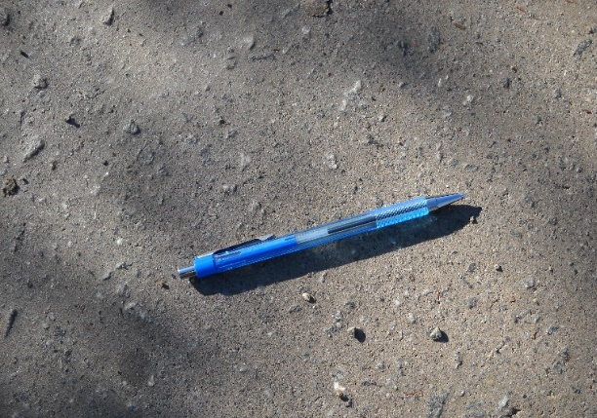
Example 2  Hard, tight dense surface.  Tops of aggregate clearly visible. | 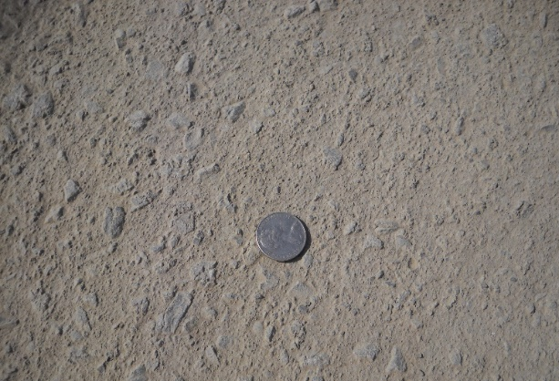
Example 3  Hard, tight uniform surface.  Tops of aggregate visible. | 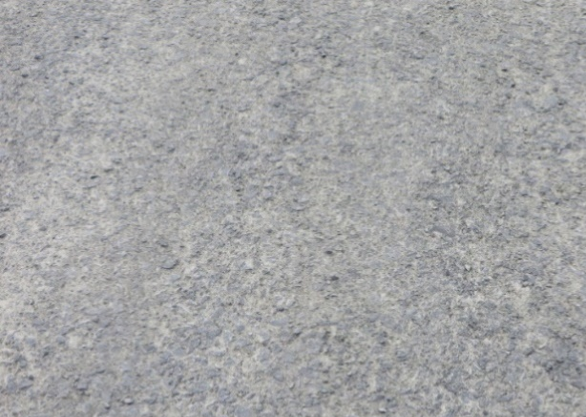
Example 4  Hard dense surface.  Uniform texture with aggregate visible. | 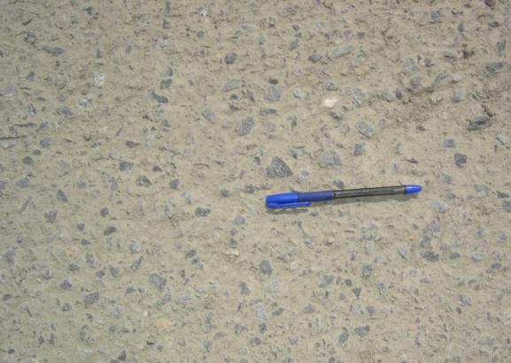

    - Examples 5 to 8 do not meet the requirements of Clause 8.12 for surface condition prior to bituminous surfacing and are non-conforming.
Figure B1.2: Examples of surface conditions prior to bituminous surfacing not confirming
Example 5  Slurrying of fines on the surface.  Non uniform, soft, uneven surface.  Not level with adjacent kerb and channel. | 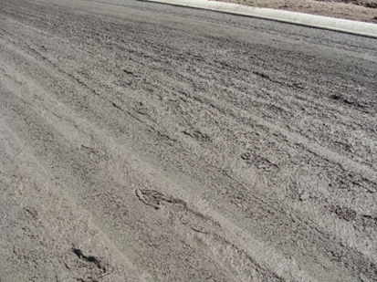
Example 6  Scabbing and excess fines on the surface.  Non uniform texture. | 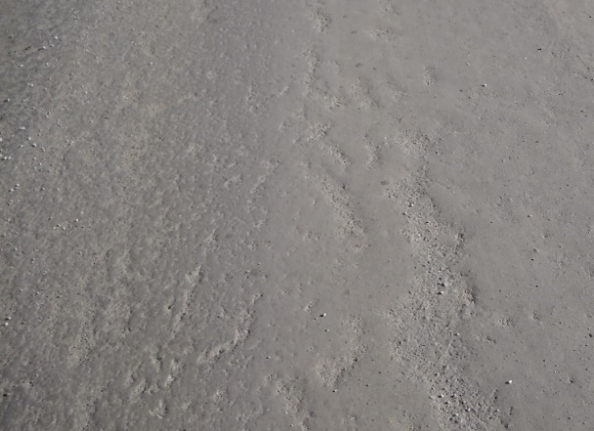
Example 7  Tearing and delamination of surface post sweeping.  Non uniform surface finish. | 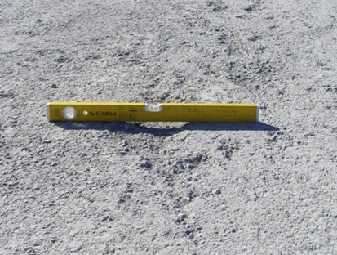
Example 8  Non uniform surface finish/texture.  Scabbing and tearing of the surface.  Uneven drying indicates non homogenous material. | 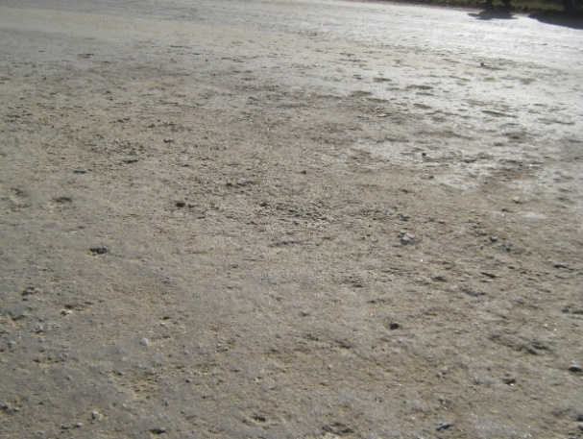

Amendment Record
Amendment no. | Clauses amended | Action | Date
- | New specification | New | September 2025

Key
Format | Change in format
Substitution | Old Clause removed and replaced with new clause
New | Insertion of new clause
Removed | Old clauses removed
- Contract Specific Requirements
The content of this Attachment will be published by each state or territory transport agency, in accordance with their requirements.

A ‘Percentage Point’ is the numerical difference between 2 percentages. For example, a change from 3% to 3.5% is a change of 0.5 Percentage Points.

