
AUSTROADS TEST METHOD AGPT/T530
Calibration of Bitumen Sprayers: General Introduction and List of Methods
Contents
1. Preface 1
2. Foreword 1
3. Scope 2
4. General 2
5. References 2
6. Sprayer Calibration Requirements 3
6.1 General 3
6.2 Sprayer Calibration Certificates 3
7. Safety Disclaimer, and Legal and Environmental Requirements 3
8. Testing of Various Types of Bitumen Sprayers 4
9. Equipment Required for Testing 4
9.1 Collection Device 4
9.1.1 Fixed Test Trough 4
9.1.2 Test Mat 6
9.1.3 Portable Trough 6
9.2 Bitumen Sprayer 8
9.2.1 Bitumen Pump 8
9.2.2 Spray Bar 8
9.3 Timing Device 8
10. Reporting 9
10.1 Sprayer Calibration Certificate 9

Preface
This guidelines document has been prepared by the Bituminous Surfacings Working Group (BSWG) on behalf of the Austroads Pavement Task Force (PTF). Representatives of Austroads, the Australian Road Research Board (ARRB), the National Association of Testing Authorities (NATA) and the Australian Asphalt Pavement Association (AAPA) have been involved in the development, review and update of this document.

Foreword
Austroads works towards uniformity of practice in design, construction and user aspects of roads and bridges. A significant factor contributing to the establishment of Australia’s large network of surfaced roads has been the successful application of sprayed sealing technology, including the selection of treatments, the design of the treatments and the identification of the most appropriate applications. If consistent high-quality sprayed sealing work is to be undertaken, and if sprayed seals are to remain a viable surfacing option in the face of increasing traffic levels, particularly the increase in the volume and size of heavy vehicles, then the achievement of well-defined and controlled application rates of binder and aggregate is a very important factor. Several Austroads projects have addressed the selection and design of sprayed seal treatments.
The application of the binder at the correct design rates depends on the design, manufacture and maintenance of the bitumen sprayer, appropriate calibration methods, and the operating procedures and skills and competency of the operator.
The performance requirements discussed in this document apply to purpose-built mechanical bitumen sprayers for the application of hot and/or cold bituminous materials used in sprayed sealing.
These requirements do not apply to spraying equipment used exclusively for hand sprayed work or where the pressure source is compressed air and pressurised tank.

Scope
This document aims to provide overarching guidelines to the following series of Austroads sprayer calibration test methods. Specific procedures are referred to in the individual test methods:
AGPT/T531 | Volumetric calibration of bitumen pumping systems
AGPT/T532 | Transverse distribution by fixed pit facility
AGPT/T533 | Transverse distribution by field mat
AGPT/T534 | Transverse distribution by portable trough
AGPT/T535 | Road speed and distance calibration
AGPT/T536 | Viscosity of calibration fluid

General
The development of the Austroads sprayer calibration test methods takes into account the following:
- The Austroads sprayer calibration test methods incorporate best practice currently available. They take into account the cost of developing and operating a testing facility, and encourage the development of more efficient and cost-effective procedures.
- NATA accreditation is required for ALL bitumen sprayer calibration facilities. NATA accreditation takes into account the administration of the Test Methods. It requires continuous improvement of the procedures necessary to retain accreditation. Recognised technical specialists are involved in the accreditation process.
Austroads Technical Report AP-T262 Performance requirements for bitumen sprayers does not include design, manufacture or operating procedures of bitumen sprayers. These are now regarded as the responsibility of the manufacturer and owner. This change is aimed at encouraging innovation and the introduction of improved sprayer technology.

References
The following documents are referred to in this document:
International Standards
ISO/IEC 17020 | Conformity assessment – requirements for the operation of various types of bodies performing inspection
Austroads Test Methods
AGPT/T531 | Volumetric calibration of bitumen pumping systems
AGPT/T532 | Transverse distribution by fixed pit facility
AGPT/T533 | Transverse distribution by field mat
AGPT/T534 | Transverse distribution by portable trough
AGPT/T535 | Road speed and distance calibration
AGPT/T536 | Viscosity of calibration fluid
Austroads Technical Reports
AP-T262 | Performance requirements for bitumen sprayers

Sprayer Calibration Requirements

General
Bitumen sprayers used on works by or for jurisdictions shall have passed inspection and testing in accordance with the appropriate Austroads sprayer calibration test methods (AGPT/T531 – T536).
Bitumen sprayers must be re-tested annually over the full suite of Austroads sprayer calibration test methods (AGPT/T531 – T536) to maintain registration (calibration certificate).
If there are major repairs/changes to the spraying system, the sprayer should be retested. If there are major changes to the speed and/or distance indicator systems, then these should be tested separately according to AGPT/T535 and a new certificate issued based on the original spraying system information combined with the updated speed/distance system information.
Alternative equipment to those specified in AGPT/T531 – T536 (such as a rolling road or endless belt in place of on road testing) may be used if it can be shown that it is calibrated, and measures and returns equivalent results to the intended method.

Sprayer Calibration Certificates
Sprayer Calibration Certificates are issued to the owner of the bitumen sprayer upon the successful completion of the testing required for that type of bitumen sprayer (refer to Section 10.1). Jurisdictions have agreed in general to accept Sprayer Calibration Certificates issued by NATA-accredited test facilities.
Acceptance of Sprayer Calibration Certificates may be withdrawn at any time should the bitumen sprayer prove unable to meet the requirements of Section 4 of AP-T262 Performance requirements for bitumen sprayers, either as a result of defects, adjustments or alterations. Re-calibration or field audit testing may be required before the bitumen sprayer is again approved for use on sealing works.
Details of bitumen sprayers that have been calibrated for use in Australia are listed on the Australian Asphalt Pavement Association (AAPA) website (www.aapa.asn.au). Details include the owner, sprayer identification number, maximum approved spray bar width, and expiry date of the calibration certificate.

Safety Disclaimer, and Legal and Environmental Requirements
Warning: The use of this document and associated test methods may involve hazardous materials, operations and equipment. This document does not purport to address the safety requirements associated with their use. It is the responsibility of the user of this document to establish appropriate work health and safety practices and determine the applicability of regulatory limitations prior to use.
It is the owner’s responsibility to ensure that their bitumen sprayers comply at all times with all relevant legal, safety, noise and environmental requirements, including the truck, spraying equipment and their operation, as discussed in AP-T262 Performance requirements for bitumen sprayers.

Testing of Various Types of Bitumen Sprayers
In general, bitumen sprayers are designed to spray bituminous binder from the spray bar delivery system at a constant pump output rate. The forward speed of the sprayer is varied to control the nominal application rates on the ground (i.e. spraying at a higher vehicle speed result in a thinner binder film on the ground, and vice versa).
To achieve the required bitumen spray rate, it is necessary to accurately control the bitumen pump output and sprayer forward speed. In addition, it is required that a uniform transverse distribution, or a variable transverse distribution, of the bituminous binder is achieved as specified in the sprayed seal design.
The sprayer calibration test methods are applicable to bitumen sprayers fitted with bitumen pump and spray bar systems for hot and/or cold bituminous materials used in sprayed sealing. This includes, but is not limited to, sprayers fitted with one of the following circulating type spray bar systems:
- single spray bar fitted with a single row of nozzles
- single spray bar fitted with two (or more) rows of nozzles
- dual spray bars fitted with a single row of nozzles in each bar
- telescopic spray bars fitted with a single row of nozzles
telescopic spray bars fitted with two or more rows of nozzles.
Note: Spraying equipment used exclusively for hand-sprayed work, or where the pressure source is compressed air and a pressurised tank, does not meet the Austroads requirements and should not be tested and calibrated using these Test Methods (AGPT/T531 to AGPT/T536).

Equipment Required for Testing
The following equipment is required:

Collection Device

Fixed Test Trough
A test trough is required which has a nominal storage capacity of 2000 L and is of suitable shape to allow a spray bar width of at least 8 m to be tested at full capacity.
When used for transverse distribution testing, the trough, which is approximately 8.0 m long and 0.6 m wide, is divided into segments by a series of transverse vanes and so arranged that calibration fluid sprayed into each segment will drain into its own measuring container (see Figure 9.1). The trough divisions shall be 50 mm with a tolerance of ± 1 mm. Exceptions to this requirement may be granted for existing equipment that has historically been used for transverse distribution testing of bitumen sprayers. The sides of the divisions must be parallel to each other, and parallel to the centreline of the bitumen sprayer.
Figure 9.1: View of fixed trough
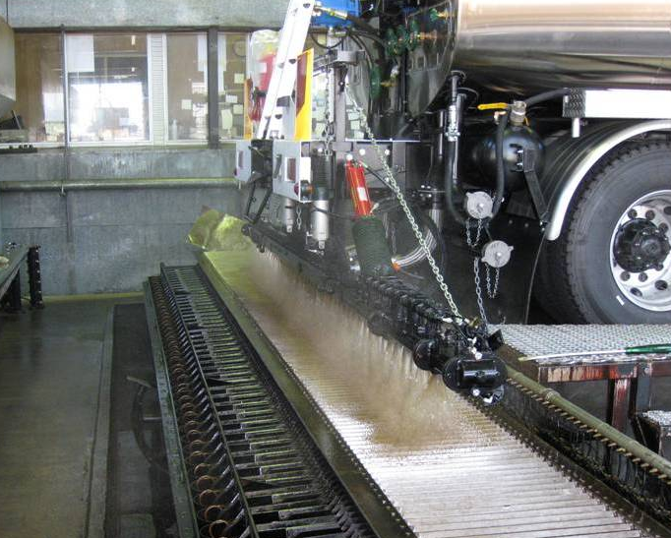

The volume of the trough/fluid collection vessels shall be selected to achieve a minimum of 75% fill during the test.
When calibrating the trough segments, each trough segment shall be calibrated with a known calibration volume, which will be sufficient to fill the troughs to 75% of the fill depth. The calibration (measured in litres, or depth of fluid in mm) shall be verified at this 75% position to within 1% of the calibration volume.
To ensure accuracy of the measurement troughs, the following is required:
- A visual inspection of the troughs should be conducted prior to each use, to check for potential leakage or damage.
- A calibration check of the troughs shall be conducted annually. The volume of at least five, non-sequential, randomly selected individual trough segments shall be measured along the full length of the trough. The measured volume of each segment (measured in litres or depth of fluid in mm) should be within 1% of the calibration volume. If any measured volume is outside the allowable tolerance, then the complete trough should be checked for distortion or damage. A calibration check shall be performed on any distorted or damaged troughs. If more than five troughs are found to require recalibration or if major repairs are required, then full recalibration of all troughs segments shall be conducted.
A full recalibration of all trough segments shall be conducted every five years. This period may be extended where it can be shown that the measuring trough has demonstrated stability over the most recent 10-year period.

Test Mat
The test mat material must have sufficient texture to prevent hot bitumen from migrating across the mat, as this will result in an inaccurate representation of the transverse distribution. A suitable material is marine carpet which has a very uniform density. The test strip should be about 1.2 m longer than the width of spray bar to be tested, and have a collection width at least 0.4 m. Smaller mats can only be used if they can be proved to deliver equivalent results. The mat may need to be placed on a layer of heavy paper or similar to ensure it securely remains in place when the sprayer passes over it during the test. An example of a marine carpet mats prepared for testing is shown in Figure 9.2.
Figure 9.2: Marine carpet mats prepared for testing
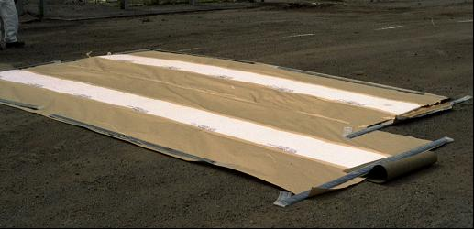

Testing is conducted on the same principle as the trough test capture system. The mat is cut into 50 mm wide test strips to within an accuracy of ±1 mm, and each test strip weighed individually. The location of each strip across the mat must be able to be clearly identified.
For each batch of mat material and prior to performing a mat test, the following minimum requirements must be met to ensure uniformity of the mat material. The weight of representative samples shall be checked for uniformity by taking at least 10 non-consecutive samples with exactly the same area and a minimum strip width of 50 mm. The mat weights must meet the following requirements:
- If the tolerance on uniformity is within 2.5% of the average, the mat material can be used.
- If the tolerance on uniformity is above 2.5%, the mat is rejected or (c) may be applied.
- If the tolerance on uniformity is above 2.5% but below 10%, the mat may be cut into strips and all strips must be pre-weighed to achieve the 2.5% tolerance or the mat is rejected.
If the tolerance on uniformity is greater than 10% the mat material cannot be used for mat testing.

Portable Trough
A portable test trough (Figure 9.3) may be used to test transverse distribution. For practical reasons the portable test trough will be made of a number of sections. The sections may be bolted or clamped together to make up the overall length provided they meet the specified tolerance for each individual portable test trough segment, as detailed below. The portable test trough should be approximately 8 m long overall, and shall be a minimum of 0.3 m wide, divided into segments by a series of transverse vanes, and so arranged that calibration fluid sprayed into each segment will drain into its own measuring container. The trough divisions shall be 50 mm with a tolerance of ± 1 mm. The sides of the divisions must be parallel to each other, and parallel to the centreline of the bitumen sprayer.
The volume of the trough/fluid collection vessels shall be selected to achieve a minimum of 75% fill during the test.
When calibrating the trough segments, each trough segment shall be calibrated with a known calibration volume, which will be sufficient to fill the troughs to 75% of the fill depth. The calibration (measured in litres, or depth of fluid in mm) shall be verified at this 75% position to within 1% of the calibration volume.
To ensure accuracy of the measurement troughs, the following is required:
- A visual inspection of the troughs should be conducted prior to each use, to check for potential leakage or damage.
- A calibration check of the troughs shall be conducted annually. The volume of at least five, non-sequential, randomly selected individual trough segments shall be measured along the full length of the trough. The measured volume of each segment (measured in litres or depth of fluid in mm) should be within 1% of the calibration volume. If any measured volume is outside the allowable tolerance, then the complete trough should be checked for distortion or damage. A calibration check shall be performed on any distorted or damaged troughs. If more than five troughs are found to require recalibration or if major repairs are required, then full recalibration of all troughs segments shall be conducted.
A full re-verification of all through segments shall be conducted every three years.
The portable test trough must be placed on a reasonably level and flat surface.
Figure 9.3: Section of portable test trough, filled with calibration fluid after a spray
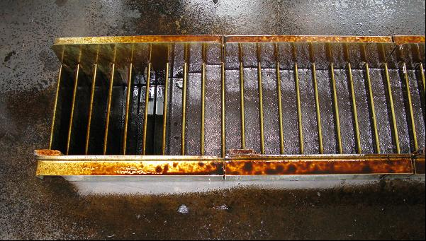

Bitumen Sprayer
An example of a sprayer in use is shown in Figure 9.4.
Figure 9.4: Bitumen sprayer in use
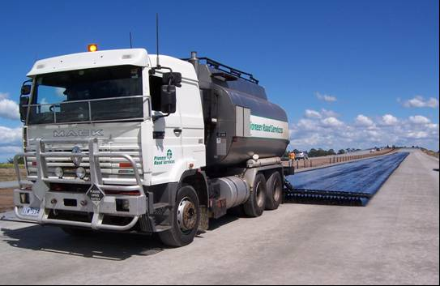

Bitumen Pump
The type or condition of the bitumen pump is not prescribed in these calibration test methods.

Spray Bar
The maximum width of the spray bar to be tested shall be fitted, including extensions.
The spray bar must be straight, both horizontally and vertically, and any extension pieces fitted must align correctly with the main bar section. The extension pieces must be uniquely identifiable to the bitumen sprayer.
The sprayer owner has to provide the sprayer in a good working condition with a competent operator.

Timing Device
Stop watch or other suitable timing device able to measure up to 30 minutes and readable to 0.01 s.

Reporting

Sprayer Calibration Certificate
Based on the information recorded from the testing, and provided the sprayer passes all tests required, the testing facility will prepare a ‘Sprayer Calibration Certificate’ (refer to Section 6.2).
There is no standard certificate template. Each facility prepares and issues its own certificate. In addition to the requirements of ISO/IEC 17020 and NATA, the following additional information shall be included on the certificate:
General information:
- sprayer owner
- sprayer identification
- sprayer manufacturer
- sprayer make and model
- sprayer nominal capacity (in Litres)
- date of expiry of certificate (12 months from the end of the month in which calibration was completed)
name and signature of testing officer/issuing officer.
Technical information for sprayer operation (table format recommended):
- maximum effective width of spray
type and output of nozzles.
Technical information regarding spray bar and pump:
- width (from minimum to maximum width)
- number of nozzles
- pump speed for spraying
pump speed for bar circulate (if applicable).
Distance indicator:
- correction factor to determine ‘actual distance’, in metres, from indicated distance (if applicable).
Optional additional information:
Any additional information agreed between the testing facility and the owner, and/or as may be required by a jurisdiction, may be included; for example, the range of specified/agreed rates of application of binder for ‘residual binder’ at 15 °C (for spraying emulsions) and ‘hot bitumen’ at spraying temperature, as follows, to allow for these two systems used in Australia:
- rate of application (in L/m² at 15 °C and/or L/m² hot application)
sprayer speed (in m/minute) for the rate of application.
If any of the information provided appears to be incorrect it is recommended the owner contact the testing facility.
Amendment Record
Amendment No. | Clauses amended | Action¹ | Date
1 | Commentary Page  Footer and header  Applied revised test method number  Applied new styles | New  Format  Format  Format | June 2005
2 | Preface  Title  Footer  Replace all references to superseded Austroads test method numbers | Substitution  Substitution  Substitution  Substitution | June 2006
3 | Title  Footer and header  Preface  Foreword  Objectives  Scope  Clauses 1–4  Clauses 5–8  Appendix A  Replace all references to superseded Austroads test method numbers | Substitution  Substitution  Substitution  Substitution  Substitution  Substitution  Substitution  New  Substitution  Substitution | February 2012
4 | Preface  References  Clause 2  Clauses 7–8  Appendix A | Substitution  Substitution  Substitution  Substitution  Substitution | November 2012
5 | Objectives  References  Clauses 2-3, 7  Applied new styles | Substitution  Substitution  Substitution  Substitution | May 2015
6 | All | Substitution | June 2018
7 | Clause 4, 5, 6.2, 7 (Update reference to AP-T262) | Format | September 2019

¹Key
Format | Change in format
Substitution | Old clause removed and replaced with new clause
New | Insertion of new clause
Removed | Old clauses removed

