
AUSTROADS TEST METHOD AGPT/T534
Transverse Distribution by Portable Trough
Contents
1. Preface 1
2. Scope 1
3. Safety Disclaimer 1
4. References 2
5. Equipment 2
5.1 Collection Device 2
5.2 Calibration Fluid 2
5.3 Timing Device 2
6. Procedure 2
6.1 Testing Procedure by Sprayer
Type 2
6.1.1 Single Bar Sprayer 2
6.1.2 Multiple Bar and/or Multiple Pump Sprayer 3
6.1.3 Telescoping Bar Sprayer 3
7. Acceptance Criteria 4
8. Reporting 5

Preface
This test method was prepared by the Bituminous Surfacings Working Group (BSWG) on behalf of the Austroads Pavements Task Force (PTF).
Representatives of Austroads, the Australian Road Research Board (ARRB), the National Association of Testing Authorities (NATA) and the Australian Asphalt Pavement Association (AAPA) have been involved in the development, review and update of this test method.

Scope
This test method is for bitumen sprayers as specified in AGPT/T530 Calibration of bitumen sprayers: general introduction and list of methods.
It sets out the procedures for determining the transverse distribution of bitumen sprayers, and is based on the approach of using a portable trough capture system and a suitable calibration fluid.
It is applicable to all sprayer types whose spray patterns can be fully contained by the portable trough.

Safety Disclaimer
Warning: The use of this Austroads test method may involve hazardous materials, operations and equipment. This Austroads test method does not purport to address the safety requirements associated with its use. It is the responsibility of the user of this Austroads test method to establish appropriate work health and safety practices and determine the applicability of regulatory limitations prior to use.

References
The following documents are referred to in this method:
Austroads
AGPT/T530: | Calibration of bitumen sprayers: general introduction and list of methods.
AGPT/T536: | Calibration of bitumen sprayers: viscosity of test fluid.

Equipment
The following equipment is required:

Collection Device
Use a portable trough as specified in AGPT/T530.

Calibration Fluid
Use a calibration fluid as specified in AGPT/T536.

Timing Device
Use a timing device as specified in AGPT/T530.

Procedure
The following steps are to be followed to ensure a consistent approach to testing transverse distribution:
- The spray nozzles should be mounted at the appropriate rotational angle and at the respective height above the trough for the duration of the test. Guidance may be sought from bitumen sprayer and/or nozzle manufacturers.
- The spraybar should be positioned so that the full lateral width of spray is collected by the trough.
- During testing the volume of calibration fluid in the sprayer tank must not fall below 10% of its nominal capacity.
- Timing of each test shall be of duration long enough to fill most trough segments to a minimum of 75% of their capacity, excepting those near the ends of the spraybar where reduced nozzle overlap reduces the sprayed volume. The spray duration shall be a minimum of 10 seconds.
Variability in transverse distribution must conform to the specified limits given in Section 7.

Testing Procedure by Sprayer Type

Single Bar Sprayer
The sprayer is tested at the full intended width of the spraybar for which certification is required, and at the specified output for the nozzles fitted.

Multiple Bar and/or Multiple Pump Sprayer
When a sprayer has multiple bars and/or multiple pumps, each possible bar and pump combination to be used must be tested individually and independently.
Each spraybar is to be tested at its full width, at the specified output for the nozzles fitted.
If the sprayer is required to provide both uniform transverse distribution and variable transverse distribution, the uniform distribution must be tested as specified in Section 6.1.1.
When seeking certification as a variable sprayer, the owner shall nominate the maximum and minimum spraybar widths for a typical variable spray pattern.
When spraying a variable pattern as shown in Figure 6.1, the sprayer owner shall nominate the ratio of maximum spray rate to the design spray rate (e.g. 120:100). This ratio is governed by the size of the nozzles fitted in the respective bars. If more than one ratio is required, a full suite of testing is required for each ratio.
Figure 6.1: Example of a variable application rate spray pattern
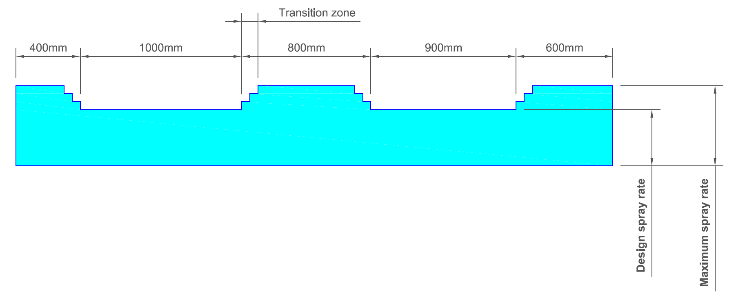

Telescoping Bar Sprayer
This section is applicable only to sprayers:
- that are fitted with telescoping spraybars
- where the telescoping spraybar position is infinitely adjustable between the nominated maximum and minimum spraybar widths
that will continuously operate over the infinitely adjustable range of positions.
It is not applicable to telescoping bars that are adjustable in width increments equal to the nozzle spacing distance (e.g. 100 mm increments).
This test is to verify that the application rate remains within the prescribed limits in the vicinity of the emerging nozzles at the point of overlap of the two spraybar spray patterns. The test is to ensure that the spray rate in this transition zone is within the tolerance of ±10% between the design and maximum application rates specified.
Where the overlap occurs within the area of the design spray rate then a test shall be performed using nozzles spraying at the design spray rate. Similarly, if the overlap occurs within the area of the maximum spray rate then a test shall be performed using nozzles spraying at the maximum spray rate. Hence two sets of tests may be required.
The test procedure for a telescoping bar sprayer is as follows:
- Extend the spraybar to the full nominated maximum width.
- Nominate one of the bars to be stationary for the purpose of the test.
- Align the nozzle at the end of the stationary bar to overlap with the first nozzle on the telescoping bar, as shown in Figure 6.2 (for X = 0 mm).
- Perform the transverse distribution test.
- Retract the telescopic spraybar by 25 mm (X = 25 mm in Figure 6.2), and repeat the transverse distribution test.
- Further retract the telescoping spraybar, repeating the transverse distribution test over the range of positions X = 50 mm, X = 75 mm and X = 100 mm.
- Repeat the tests when extending the spraybar in the reverse direction, at the range of positions X = 100 mm, X = 75 mm, X = 50 mm and X = 25 mm. This will give a second set of results.
For all test results, apply the test limits specified in Section 7.
Figure 6.2: Telescoping test

Acceptance Criteria
Any segment on the ends of the test trough that measures less than 80% of the average should not be included in the results. The effective spray width can be determined from the remaining width of the segments.
The following criteria must be met for all measurements of uniform and variable transverse distributions:
- Any segment shall not exceed ±20% of the average of all segments.
- A maximum of two in any consecutive ten segments may exceed ±15% of the average of all segments.
A maximum of four in any consecutive seven segments may exceed ±10% of the average of all segments.
Up to three segments along each end of the effective width can be excluded when calculating the acceptance criteria.

Reporting
It shall be reported whether the bitumen sprayer passes or fails the acceptance criteria.
The information recorded from the testing will be used by the testing facility in preparing a Sprayer Calibration Certificate, as per the requirements of AGPT/T530.
Amendment Record
Amendment No. | Clauses amended | Action¹ | Date
1 | Commentary page  Footer and header  Applied revised test method number  Applied new styles | New  Format  Format  Format | June 2005
2 | Complete change of test method including title | Substitution | February 2012
3 | Preface  Clauses 3–4 | Substitution  Substitution | November 2012
4 | Scope  Clauses 3, 5  Applied new styles | Substitution  Substitution  Format | April 2015
5 | All | Substitution | October 2016
6 | Safety Disclaimer | New | June 2018

¹Key
Format | Change in format
Substitution | Old clause removed and replaced with new clause
New | Insertion of new clause
Removed | Old clauses removed

