

AUSTROADS TEST METHOD ATM 105

Complex Modulus (G*) of Aged Bitumen

Contents

1. Preface 1

2. Scope 2

3. Further Development 2

4. References 2

5. Equipment 3

5.1 Pressure Ageing Vessel (PAV) System 3

5.2 Dynamic Shear Rheometer (DSR) System 3

5.3 Other Equipment 3

6. Verification of PAV and DSR Systems 4

7. PAV Ageing Treatment Procedure 4

7.1 Preparation of the PAV System and Bitumen Samples 4

7.2 PAV Ageing Treatment of Bitumen Samples 5

8. DSR Test Procedure 5

8.1 Preparation of the DSR System and PAV-treated Bitumen Samples 5

8.2 Measurement of DSR Test Parameters 7

9. Calculation 8

10. Test Report 8

11. Precision 8

Preface
This test method was prepared by the Bituminous Surfacings Technical Group (BSTG) on behalf of the Austroads Pavements Task Force (PTF). Representatives of Austroads, the National Transport Research Organisation (NTRO) and the Australian Flexible Pavement Association (AfPA) were involved in developing and reviewing this test method.
This test method was developed based on research studies conducted in Austroads Project APT1975 Maximising the Life of Sprayed Seals – Future Proofing Binders. The results of the APT1975 project indicated that the fatigue cracking performance of aged bitumen could be ranked by measuring the complex modulus (G*) of a bitumen sample at 15 °C after it had been aged in the laboratory using a pressure ageing vessel (PAV).
During the test, a bitumen sample is aged in the laboratory for 72 hours using a PAV. The complex modulus (G*) of the PAV-treated bitumen sample is then measured at 15 °C using a dynamic shear rheometer (DSR).
Any DSR brand/model name used in this document is information given for the convenience of users and does not constitute an endorsement.

Scope
This test method sets out procedures for the ageing treatment of bitumen samples under specific conditions using a PAV. It also contains the procedures for determining the complex modulus (G*) of PAV-treated bitumen samples under specific conditions using a DSR.

Further Development
This test method is under development and some changes to the test procedures may occur in the future.

Safety Disclaimer
Warning: This Austroads test method may involve hazardous materials, operations and equipment. This Austroads test method does not purport to address the safety issues associated with its use. It is the responsibility of the user of this Austroads test method to establish appropriate workplace health and safety practices and determine the applicability of regulatory limitations before use.

References
The following normative documents are referred to in this method and are required to perform the test:
Australian/New Zealand Standards
AS/NZS 2341.21 | Methods of testing bitumen and related roadmaking products, Method 21: Sample preparation
AASHTO Standards
AASHTO R028-22 | Standard practice for accelerated aging of asphalt binder using a pressurized aging vessel (PAV)
AASHTO T315-24 | Standard method of test for determining the rheological properties of asphalt binder using a dynamic shear rheometer (DSR)
ASTM International
ASTM D7175-25 | Standard test method for determining the rheological properties of asphalt binder using a dynamic shear rheometer

Equipment
The following items of equipment are required:

Pressure Ageing Vessel (PAV) System
- A PAV system that satisfies the mechanical and operational requirements of Clause 6.1 (and associated subclauses) of AASHTO R028-22.
Note 1: The pressure levels described in AASHTO R028-22 (e.g. 2.1 or 2.2 MPa) correspond to pressures above ambient atmospheric pressure.
- PAV sample pans that satisfy the requirements of Clause 6.2 of AASHTO R028-22, with the additional requirement that the inside diameter of the pans is 140 ± 3 mm. The metric dimensions included in Clause 6.2 of AASHTO R028-22 shall be used instead of the imperial dimensions.

Dynamic Shear Rheometer (DSR) System
- A DSR system that satisfies the mechanical and operational requirements of Clause 6.1 (and associated subclauses) of AASHTO T315-24 or Clause 6.1 (and associated subclauses) of ASTM D7175-25.
- DSR sample trimming tool – a metal sample trimming tool that satisfies the operational requirements of Clause 6.3 of AASHTO T315-24 or Clause 6.3 of ASTM D7175-25.
- A computer capable of operating the DSR manufacturer-supplied control/data acquisition unit and software.

Other Equipment
- Fan-assisted oven – meeting the requirements of the fan-assisted oven described in AS/NZS 2341.21.
- Balance – of at least 200 g capacity, having a resolution of 0.01 g or less and with a limit of performance not exceeding 0.05 g.
- Spatula – a heat-resistant spatula that is suitable for scraping a hot bitumen sample from a PAV sample pan.
- Sample containers – made of metal or glass, of a suitable size for collecting and storing PAV-treated bitumen samples, or preparing subsamples for DSR testing.
Note 2: Glass jars with an inside diameter of 40 mm and height of 40 mm have been found to be suitable.
- Infrared lamp – suitable for heating small bitumen samples for DSR testing, preferably with adjustable height.
Note 3: A 240 V, 275 W infrared lamp has been found to be suitable.
- Metal rod/spatula – suitable for transferring a hot bitumen sample from a sample container to a DSR test plate.
- Small butane torch – used to assist with trimming of bitumen samples on the DSR.

Verification of PAV and DSR Systems
The PAV and the DSR systems should be verified at regular intervals in accordance with the quality assurance procedures applicable to the laboratory and according to the instrument’s operating manual or manufacturer’s instructions.
Note 4: A PAV system verified for its temperature and pressure sensors in accordance with Clause 9 (and associated subclauses) of AASHTO R028-22 has been found to satisfy the operational requirements of this test method. A DSR system checked and verified for its test plate geometry, temperature control and overall operation in accordance with Clause 9 (and associated subclauses) of AASHTO T315-24 or Clause 8 (and associated subclauses) of ASTM D7175-25 has been found to satisfy the operational requirements of this test method.

PAV Ageing Treatment Procedure

Preparation of the PAV System and Bitumen Samples
- Prepare the PAV system for ageing treatment in accordance with the manufacturer’s instructions using a treatment temperature of 100 °C.
- Prepare the bitumen sample for PAV ageing in accordance with the oven method described in AS/NZS 2341.21.
- Preheat a sufficient number of PAV sample pans as required for subsequent testing (up to 10) by placing them in the same fan-assisted oven as used to heat the bitumen samples for a minimum of 20 minutes.
Note 5: The amount of bitumen contained within one PAV sample pan (15.6 ± 0.5 g) is sufficient for conducting the duplicate DSR tests described in Clause ‎8 of this test method.
- Place each preheated PAV sample pan on the balance and pour 15.6 ± 0.5 g of bitumen into each PAV sample pan. Tilt each PAV sample pan from side to side to ensure the base of each PAV sample pan is visibly evenly covered with bitumen.
Note 6: Placing a PAV sample pan in the fan-assisted oven set to the same temperature as used to heat the bitumen sample for 5 minutes can assist with spreading the bitumen evenly over the pan base. 15.6 g of bitumen will provide a nominal 1.0 mm film if spread evenly over the PAV sample pan base.
- After adding the bitumen to the required number of PAV sample pans, place the PAV sample pans in the PAV using the pan holder included in the PAV system. Place the PAV sample pans in the PAV as soon as possible after the bitumen has been poured to ensure that any cooling is minimised.
- Close the PAV, secure the PAV lid and set up the PAV for binder ageing as per the manufacturer’s instructions.

PAV Ageing Treatment of Bitumen Samples
- Once the temperature inside the PAV is greater than 80 °C, apply an air pressure of 2.1 ± 0.1 MPa (above ambient) to the PAV, and then start timing the test. If the temperature inside the PAV is not in the range of 100 ± 1 °C within 2 hours after timing has commenced, the treatment shall be stopped and the samples discarded.
If the software that controls the PAV starts timing the test when both the air pressure is 2.1 ± 0.1 MPa (above ambient) and the temperature is at 100 ± 1 °C, the test timing can be started at this point if it occurs less than 30 minutes after applying the air pressure to the PAV.
- After the initial 2 hours of treatment, maintain an applied air pressure of 2.1 ± 0.1 MPa and temperature of 100 ± 1 °C to the PAV. Bitumen samples shall be subjected to a total PAV treatment time of 72 hours ± 1 hour from when the timing was started.
- At the end of the PAV treatment period, reduce the internal pressure of the PAV to ambient pressure over a period between 8 and 20 minutes. The temperature of the PAV should be less than 60 °C within 1 hour of the completion of the PAV treatment if the samples are not immediately removed from the PAV after the pressure has been released.
- Remove the PAV sample pans from the PAV and place the PAV sample pans in a fan-assisted oven set to a temperature not exceeding 165 °C for a minimum period of time until sufficiently fluid to pour.
Note 7: Placing the PAV sample pans in a fan-assisted oven set to 150 °C for about 5 minutes has been found sufficient.
- Pour the hot PAV-treated bitumen sample from the PAV sample pans into a sample container. Use the spatula to transfer any remaining PAV-treated bitumen sample from the PAV sample pans to the sample container. PAV-treated bitumen samples shall be stored at ambient temperature until required for testing.
Note 8: Glass jars with an inside diameter of 40 mm and height of 40 mm are able to collect the PAV-treated bitumen sample obtained from 2 PAV sample pans.

DSR Test Procedure

Preparation of the DSR System and PAV-treated Bitumen Samples
- Prepare the DSR system in accordance with the manufacturer’s instructions. The DSR shall be set up so that complex modulus (G*) results are calculated at the outer-most perimeter of the test plates.
Note 9: Preparation of the DSR system includes turning on the DSR and the associated computer, as well as the compressed air-supply (if a compressed air-supply is required for the device in use). A preparation procedure known as ‘zero-gap’ may be required at the target test temperature if it has not already been completed.
Note 10: For some DSR systems, it is necessary to adjust the DSR operational software from default values so that G* values are calculated at the outer-most perimeter of the test plates. In the case of an Anton Paar MCR302 DSR, the ‘Calculation mode’ in the operational software needs to be set to ‘DIN 53018 Rmax’ in the ‘Dimensions, Factors’ sheet included in the ‘Measuring System’ menu of the operational software. In the case of TA Instruments DSRs or Kinexus DSRs, this step may not be required as these DSRs, by default, calculate G* values at the outer-most perimeter of the test plates.
- Mount 8 mm diameter test plates in the DSR. Set the DSR temperature to 100 °C and set the test plate gap to approximately 2 mm to preheat the test plates.
- Prepare the PAV-treated bitumen sample for testing in accordance with the oven method described in AS/NZS 2341.21, except that the PAV-treated bitumen sample may be heated in a fan-assisted oven set to a temperature not exceeding 165 °C.
Note 11: If glass jars with an inside diameter of 40 mm and height of 40 mm are used to collect the PAV-treated bitumen sample, the PAV-treated bitumen sample can be made sufficiently fluid to stir and pour by heating in a fan-assisted oven set to 160 °C for 20 minutes.
- Mount the hot PAV-treated bitumen sample on the test plate of the DSR using either Option A or B below:
Option A – Transferring a hot PAV-treated bitumen sample to the upper test plate
This procedure should be used for DSRs where the upper test plate can be removed from the DSR without requiring the zero-gap procedure to be re-performed:
  - Place the hot PAV-treated bitumen sample under the infrared lamp. Increase the gap between the upper and lower test plates so that the upper test plate can be removed from the DSR.
  - Remove the preheated upper test plate from the DSR and place under the infrared lamp next to the PAV-treated bitumen sample. Transfer an appropriate amount of the hot PAV-treated bitumen sample from the sample container to the upper test plate using the metal rod/spatula.
  - Mount the upper plate in the DSR as per the manufacturer’s instructions.
Option B – Transferring a hot PAV-treated bitumen sample to the lower test plate without removing the upper test plate from the DSR
This procedure shall be used for DSRs where the upper test plate cannot be removed from the DSR without re-performing the zero-gap procedure.
  - Increase the gap between the upper and lower test plates so that a hot PAV-treated bitumen sample can be transferred to the lower test plate.
  - Place the hot PAV-treated bitumen sample under the infrared lamp. Transfer an appropriate amount of the hot PAV-treated bitumen sample from the sample container to the lower test plate on the DSR using the metal rod/spatula.
- Decrease the gap between the DSR test plates to 2.05 mm. This should squeeze excess PAV-treated bitumen sample out from the plate perimeter.
- Ensure that there is excess PAV-treated bitumen sample present in all directions between the 2 DSR test plates. If the PAV-treated bitumen sample fails to completely fill the space between the 2 DSR test plates, discard the PAV-treated bitumen sample and repeat the sample mounting procedure with a new PAV-treated bitumen sample.
- Lower the DSR temperature to the test temperature of 15 °C.
- Heat the tip of the DSR sample trimming tool using the small butane torch. Trim the excess PAV-treated bitumen sample from around the perimeter of the gap between the 2 DSR test plates using the heated DSR sample trimming tool. The surface of the PAV-treated bitumen sample shall be visibly flush with the perimeter of the 2 DSR plates after trimming (see Figure ‎8.1 (a)).
- Decrease the gap further to 2.00 mm to form a small convex bulge in the PAV-treated bitumen sample around the perimeter of the 2 test plates (see Figure ‎8.1 (b)). If the bulge is visibly too large (Figure ‎8.2 (a)) or has a concave shape (Figure ‎8.2 (b)), discard the PAV-treated bitumen sample and repeat the sample mounting procedure with a new PAV-treated bitumen sample.
- Condition the PAV-treated sample at the test temperature of 15 °C for 20 ± 5 minutes.
Figure ‎8.1: Examples of properly prepared PAV-treated bitumen samples
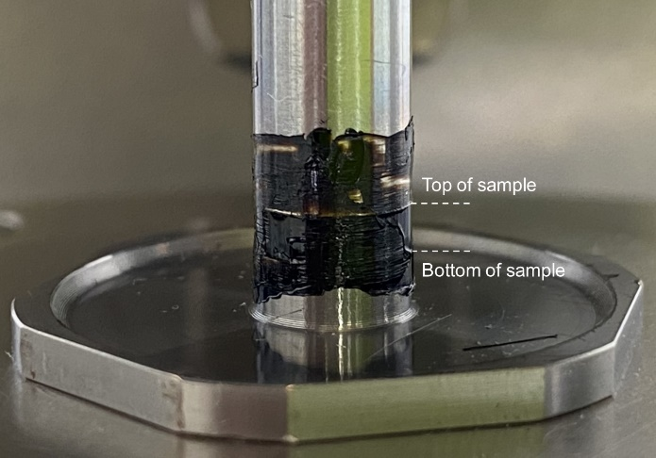 | 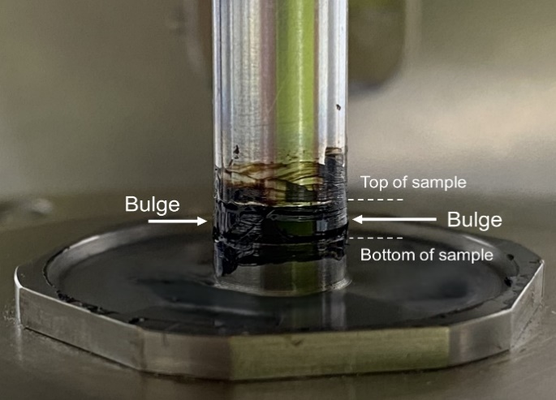
- PAV-treated bitumen sample trimmed to be flush with the perimeter of the DSR test plates | - Gap decreased to create a small convex bulge around the perimeter of the DSR test plates
Figure ‎8.2: Examples of incorrect bulge size or shape
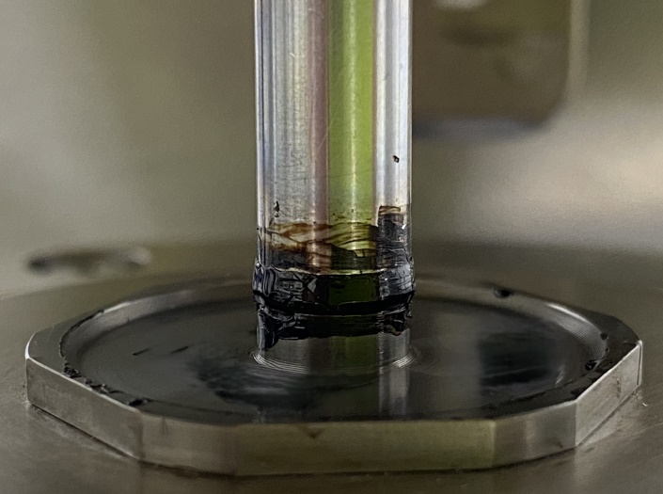 | 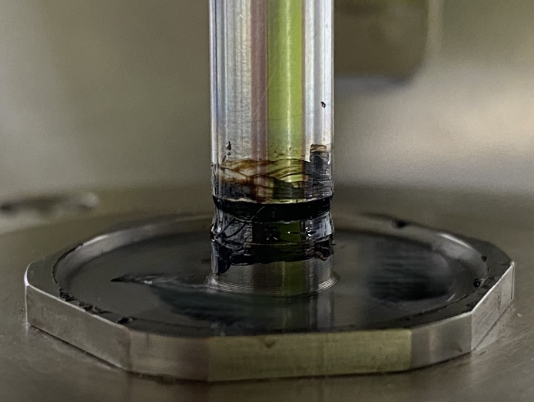
- Oversized bulge on PAV-treated bitumen sample | - PAV-treated bitumen sample with a concave shape

Measurement of DSR Test Parameters
- Set the DSR to a strain-controlled oscillation test mode as follows:
  - Test temperature of 15 °C.
  - Sinusoidal oscillation frequency of 10 Hz.
  - Peak strain of 0.001 (i.e. 0.1%).
- Conduct a DSR test on the PAV-treated bitumen sample. Apply sufficient oscillation cycles to yield 30 datapoints.
- Determine the average values of the complex modulus (G*₁, in kPa) and the phase angle (δ₁, in degrees (°)) using the last 10 datapoints of the test. Remove the PAV-treated bitumen sample from the DSR and clean the DSR test plates for subsequent testing.
- Prepare a duplicate PAV-treated bitumen sample for DSR testing by repeating Clause 8.1‎(b) to Clause 8.1‎(j).
- Conduct a duplicate DSR test by repeating Clause 8.2‎(a) to Clause 8.2‎(b).
- Determine the average values of the complex modulus (G*₂, in kPa) and the phase angle (δ₂, in degrees (°)) using the last 10 datapoints of the duplicate test. Remove the PAV-treated bitumen sample from the DSR and clean the DSR test plates.

Calculation
- Calculate the complex modulus result (G* in kPa) for the PAV-treated bitumen sample by averaging the values of G*₁ and G*₂.
- Calculate the phase angle result (δ, in degrees (°)) for the PAV-treated bitumen sample by averaging the values of δ₁ and δ₂.

Test Report
The following shall be reported:
- Complex modulus result (G*) for the PAV-treated bitumen sample, in kPa to the nearest 10 kPa.
- Phase angle (δ) for the PAV-treated bitumen sample, in degrees (°) to the nearest integer.
- DSR test temperature in °C.
- DSR oscillation frequency in Hz.
- DSR peak strain.
- DSR manufacturer.
- DSR model number.

Precision
No inter-laboratory testing has been conducted on the range of bitumen samples currently available.

Amendment Record
Edition no. | Clauses amended | Action | Date
1.0 | New test method | New | June 2026

Key
Format | Change in format
Substitution | Old clause removed and replaced with new clause
New | Insertion of new clause
Removed | Old clauses removed

See: Austroads (2026) Investigations into Fatigue Cracking Performance Tests for Aged Bitumen, AP-T393-26, Austroads, Sydney, NSW.

