AUSTROADS TECHNICAL SPECIFICATION ATS 2180  Dry Deep Soil Mixing | 
Contents
1. Scope 2
2. Referenced Documents 2
3. Definitions 3
4. Quality System Requirements 4
5. Site Investigation and Preliminary Testing 5
General 5
Lot Identification and Location 5
Test Areas Within Lots 5
6. Materials 6
7. Plant and Equipment 6
8. Site Preparation and Management 7
General 7
9. Construction – General 7
Quality Plan 7
Column Position and Dimension 8
Control and Monitoring 8
Ground/Column Heave and Lateral Displacement 8
Construction Records 9
10. Trial Columns 9
Field Trial Mixing Parameters 9
Construction of the Trial Columns 10
Testing of the Trial Columns 10
Acceptance of Trial Columns 11
11. Production Columns 11
12. Testing of the DSM Columns 12
13. Conformity Requirements 12
Acceptance Criteria 12
Treatment of Nonconformity 14
14. Completion of the DSM Columns 14
Annexure A Summary of Hold Points, Witness Points and Records 15
Annexure B Test Method to Determine UCS and 50% UCS Secant Modulus 16
Annexure C Test Method for Concrete Compressive Strength Using Cores 18
Annexure D Column Pull Out Resistance Test (PORT) and Push In Resistance Test (PIRT) 19
D.1 Vane Equipment Details 19
D.2 Testing Procedure – PORT 19
D.3 Testing Procedure – PIRT 20
D.4 Submission of Test Results 20
Annexure E Column Head Exposure Test 21
Amendment Record 22

Scope
  - Austroads Technical Specification ATS 2180 sets out the requirements for ground improvement by deep soil mixing (DSM) using the dry mixing method.
  - DSM is undertaken by the following process:
  - penetration of a special mixing tool into the ground to the required depth of treatment;
  - injecting the Binder (as a dry powder) through the tip of the tool via compressed air; and
  - mixing the Binder and soil by mechanical means to cause disaggregation of the soil and thorough mixing with the Binder to form a column.
  - DSM must be constructed in accordance with the Design Documentation and this Specification.

Referenced Documents
  - The following documents are referenced in this specification:
Australian/New Zealand Standards
AS 1141.19 Methods for sampling and testing aggregates, Method 19: Fine particle size distribution in road materials by sieving and decantation
AS 1289 Methods of testing soils for engineering purposes
Method 2.2.1 Soil moisture content tests – Determination of the moisture content of a soil – Oven drying method (standard method)
Method 3.3.1 Soil classification tests – Calculation of the plasticity index of a soil
Method 3.5.1 Soil classification tests – Determination of the soil particle density of a soil –Standard method
Method 3.6.3 Determination of the particle size distribution of a soil – Standard method of fine analysis using a hydrometer
Method 4.1.1 Soil chemical tests – Determination of the organic matter content of a soil –Normal method
Method 6.4.1 Soil strength and consolidation tests – Determination of compressive strength of a soil – Compressive strength of a specimen tested in undrained triaxial compression without measurement of pore water pressure
AS 1726 Geotechnical site investigations
AS 3972 General purpose and blended cements
Austroads
ATS 1160 Safety Management Systems
ATS 3145 Supply of Binders for Earthworks and Pavements
International Standards and Guidelines
CT97-0351 EuroSoilStab – Design Guide Soft Soil Stabilisation
SGF Report 4:95E Swedish Geotechnical Society – Lime and Lime Cement Columns – Guide for Project Planning, Construction and Inspection

Definitions
The following definitions and abbreviations apply to this Specification.
Binder: | Cement or other approved cementitious products used for the construction of columns.
Blade Rotation Number (BRN): | Total number of mixing blade rotations per metre of shaft movement of the mixing equipment.
Column Design Depth: | The depth to the base level of the production column as shown in the Design Documentation. Where columns designated as ‘full depth columns’ are shown in the Design Documentation as terminating at the top of the founding layer, an additional one metre of penetration into the founding material beyond the base level shown in the Design Documentation must be added to make up the full column design depth.
Design Documentation: | Drawings, schedules and other documents, designated as such, setting out the requirements for the construction of the DSM.
DSM: | Deep soil mixing.
E_{sec50}: | Secant modulus of elasticity of Binder treated soil, at 50% unconfined compressive strength when tested in accordance with AS 1289.6.4.1.
Lot: | A site defined area to be treated that meets the requirements of Clause ‎5.6.
Mixing Parameters: | Parameters applicable to the construction of the columns, including Binder content, auger withdrawal speed, Binder injection air pressure, rate of Binder addition and BRN.
PIRT: | Push In Resistance Test (using vane equipment).
PORT: | Pull Out Resistance Test (using vane equipment).
Production Columns: | Columns shown on the Design Documentation that form part of the permanent Works.
Professional Engineer: | A person who:  - is registered on any scheme of registration of engineers prescribed by legislation in the applicable jurisdiction;  - is appropriately registered or prequalified, if the Principal has implemented an applicable registration or prequalification scheme; and  - satisfies at least one of the following requirements:  - is a Chartered Professional Engineer; or  - holds a 4-year civil engineering degree from a university that is accredited under the Washington Accord and is registered in a relevant area of practice on the National Engineering Register (in Australia) or the Register of Chartered Professional Engineers (in New Zealand).
Test Area: | An area within each Lot nominated for preliminary testing and Trial Column construction.
Trial Binder Content: | The Binder content, determined from the testing of Trial Columns in accordance with ‎Annexure B, at which 2.5 times the design column UCS specified in the Design Documentation is achieved.
Trial Columns: | Columns constructed in Test Areas prior to commencement of Production Column construction to determine production Mixing Parameters and the properties of the columns.
UCS: | Unconfined compressive strength.

Quality System Requirements
  - The Contractor must prepare and implement a Quality Plan that includes the documentation in Table ‎4.1.
Table ‎4.1: Quality Plan
Clause | Description of document
‎7.1 | Details of plant and equipment.
‎9.1 | Details, procedures and Inspection and Test Plans for construction of the DSM works.
‎12.1 | Details, procedures and Inspection and Test Plans for the testing of the DSM columns.
  - If not included in the construction program (alternatively referred to as a ‘contract program’), a program showing the sequence of work and timing must be submitted with the Quality Plan. This program must include:
  - site investigation and preliminary testing (refer to Clause ‎5);
  - Trial Column construction (refer to Clause ‎10); and
  - Production Column construction (refer to Clause ‎11).
HOLD POINT 1
Process Held | Commencement of site investigation and preliminary testing
Submission Details | The Quality Plan must be submitted to the Principal at least 10 working days prior to the commencement of work on site.

Site Investigation and Preliminary Testing

General
  - Prior to the commencement of column construction, the Contractor must:
- undertake a site investigation in each Test Area using the following process to obtain the soil samples:
    - drill at least one borehole to the column design depth, using thin-walled tubes of minimum 75 mm diameter;
    - retrieve a continuous sample of the in situ soil from the borehole;
- carry out testing of the samples in accordance with the laboratory test method set out in ‎Annexure B to determine the Trial Binder Content and other Mixing Parameters;
- prepare a Site Investigation Report that includes:
- a Laboratory Mixes Test Report that includes the results of all the tests carried out under ‎Annexure B;
- calculations to determine the minimum Binder content for the full column depth that corresponds to 2.5 times the design column UCS; and
- submit the report to the Principal.
  - Samples must be handled, managed, logged, classified and recorded in accordance with AS 1726.
  - If there are varying column design depths within the Test Area, the site investigation borehole must be drilled to the deepest column design depth.
  - The Contractor may submit a proposal to the Principal to forgo the testing specified in Clause ‎5.1 and use test results and the associated Trial Binder Content from other areas of similar soil characteristics. The Principal is under no obligation to accept any such proposal.

Lot Identification and Location
  - The Lot identification and its location details (indicating the total number of Lots), and the number of Test Areas within each Lot, are stated in the Design Documentation. However, if nothing is stated, by undertaking a suitable investigation to assess the geotechnical conditions of the site, the Contractor must determine this information, taking into consideration the homogeneity of the in situ material.
  - Within a Lot, the soil properties of shear strength, moisture content, compressibility, clay mineralogy and organic content must be substantially consistent. A lot must not exceed 200 m in length along the road alignment and not exceed 1000 m² of the designated ground improvement area

Test Areas Within Lots
  - Each Lot must contain at least one Test Area. For each Test Area, the Contractor must delineate the boundary of the Test Area and mark out the columns that will be used for testing. The Test Areas selected must be adjacent to and similar in soil characteristics to the permanent works areas, so that the results of the testing are representative of other columns in the Lot.
Figure ‎5.7: Trial columns, test area and lot for field trials (illustration only)
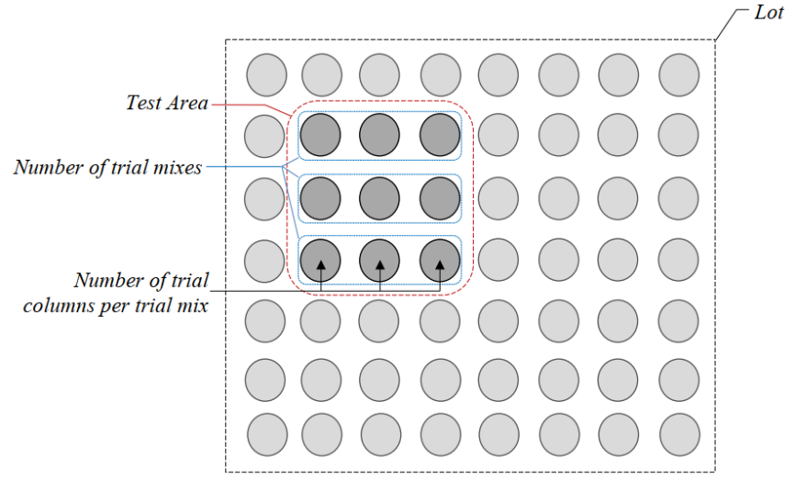
Notes:
- Figure 5.7 serves merely as an illustration of a Test Area, and its associated trial columns, within a Lot.
- The total number of columns shown in Figure 5.7 is for illustration purposes only, and not indicative of the total number of columns required. The actual total number of columns within a Lot will differ from project to project.
- At least 3 trial mixes each with a different Binder content must be carried out for each Test Area, and at least 3 trial columns must be constructed for each trial mix, as shown in Figure 5.7. Hence the minimum number of trial columns for each Test Area is 9.The Principal may direct that Test Areas, in addition to those specified in Clause ‎5.7, are created if variable ground conditions appear likely to exist within a Lot.

Materials
  - The type of Binder must be as specified in the Design Documentation. If nothing is specified, general purpose cement (Type GP) complying with AS 3972 must be used as the Binder. The Contractor may submit a proposal to the Principal to use other Binders, such as hydrated lime alone or Granulated Blast Furnace Slag (GGBFS) in conjunction with GP cement.
  - Fly ash must not be used as a Binder for DSM.
  - Binders must be supplied in accordance with ATS 3145.

Plant and Equipment
  - The Quality Plan must include:
  - details of all plant and equipment associated with the construction of the DSM, including type, output capacity, and monitoring systems; and
  - full description of the mixing tool.
  - All plant and equipment must be:
  - operated in accordance with the manufacturer’s instructions and within the recommended maximum production capacity;
  - kept clean and free from any contaminant or debris; and
  - capable of installing the columns in accordance with this Specification.

Site Preparation and Management

General
  - Further to the requirements for the management of Work, Health and Safety (refer to ATS 1160), the Work Health and Safety Management Plan must include details, procedures and/or Safe Work Method Statements for:
  - the preparation and maintenance of the Site (including the working platforms) for safe working and plant movements; and
  - control of the site to exclude or restrict access.
  - The Contractor must:
  - ensure that the working area for installation of the DSM is safe and stable for the operation of large machinery; and
  - submit certification from a Professional Engineer to the Principal that the site meets the requirements of the applicable Work, Health and Safety Legislation.
  - maintain the working platforms for safe working and repair any damage caused by the work, flooding or any other cause.
  - A granular material must be used for construction of the working platforms.
  - If requested by the Principal, the Contractor must submit supporting calculations, including rollover stability analysis, with the certification.
HOLD POINT 2
Process Held | Establishment of the installation rig
Submission Details | Certification from a Professional Engineer that the site meets the requirements of the applicable Work, Health and Safety Legislation must be submitted to the Principal at least 2 working days prior to the establishment of the installation rig on site.

Construction – General

Quality Plan
  - The Quality Plan must include details, procedures and/or Inspection and Test Plans that address the following:
  - plan(s) showing each Lot, the Test Area(s) and trial columns within each Lot, and proposed sequence of column construction;
  - construction methodology, including penetration and retrieval, mixing and execution sequence;
  - penetration termination criteria for the full depth and floating columns;
  - correct handling of possible interruptions during deep mixing operations;
  - installation accuracy and methods to verify compliance with the specified tolerances;
  - measures to protect adjacent structures or previously installed columns against ground heave and settlement arising from the construction of the columns;
  - identification and control of nonconformities;
  - spoil management;
  - keeping construction records, including the binder type and volume used per column mixing and the process of submitting the records to the Principal; and
  - safety and environmental risk assessment.

Column Position and Dimension
  - The position and verticality of the mixing must be checked prior to commencement of the construction of each column.
  - Where the Design Documentation shows ‘full depth columns’ that terminate at the top of the founding layer, the columns must be constructed with an additional one metre of penetration into the founding material beyond the base level shown in the Design Documentation.
  - Where columns overlap to form a contiguous panel:
  - unless shown otherwise in the Design Documentation, each column must be set out to overlap the adjoining column by 20% of the column diameter or 150 mm, whichever is the greatest overlap, measured along the centreline of the panel at the cut off level; and
  - the actual column overlap must not be less than 80 mm at any level of the column.

Control and Monitoring
  - The injection air pressure must be kept to the minimum required to:
  - ensure the even delivery of Binder over the full cross section of the column; and
  - control levels of air entrainment in the columns and surrounding soil in order to avoid settlement caused by the collapse of air voids within the columns.
  - An automated monitoring system must be used that indicates the following parameters during the construction of each column:
  - rate of mixing shaft withdrawal (mm/rev or mm/min);
  - mixing shaft rotation speed during withdrawal (rev/min);
  - binder addition rate per metre of depth during withdrawal (kg/m³/m);
  - binder injection air pressure (kPa);
  - profile of torque generated varying with depth during penetration and withdrawal; and
  - profile of the column shape along the depth.
  - The parameters listed in Clause ‎9.6 must be recorded by the monitoring system at depth intervals not exceeding 0.1 m or continuously.

Ground/Column Heave and Lateral Displacement
  - The construction sequence must:
  - minimise any ground and/or column heave and lateral displacements; and
  - not damage the adjacent structures or previously constructed columns.
  - Construction of a column within a clear distance of 2 diameters or 2.5 m from a previously constructed column is not permitted until the previously constructed column has attained a strength of at least 0.5 MPa.
  - If there are signs of damage to adjacent structures or columns, the Contractor must revise the column construction sequence or method, including the Mixing Parameters. The Quality Plan must be updated accordingly and resubmitted to the Principal.

Construction Records
  - At a minimum, the Contractor must record the following for each Trial Column and Production Column:
Before commencement of each DSM
  - date and time of construction;
  - column reference number and diameter;
  - working platform and ground levels (Australian Height Datum);
  - operator and supervisor details;
  - plant details;
  - Binder type and Binder content (kg/m3);
During penetration
  - BRN;
  - profile of generated torque;
  - penetration termination criteria applied;
During withdrawal
  - log of rate of mixing shaft withdrawal (mm/rev or mm/min);
  - log of mixing shaft rotation speed (rev/min);
  - log of Binder addition rate per metre of depth (kg/m3/m);
On completion of mixing
  - column verticality, overlapping, positional and dimensional values achieved;
  - horizontal position of the centre of the column using GPS co-ordinates;
  - toe level and top mixing level;
  - profile of the column shape, demonstrating uniformity along its depth.
  - The Contractor must submit the construction records for each column to the Principal within 2 working days of completion of that column. The construction records must also be included in the Completion Report (refer to Clause ‎14.1).

Trial Columns

Field Trial Mixing Parameters
  - For each Test Area, the Contractor must use the Trial Binder Content derived from the testing of the laboratory mixes under Clause ‎5.1 to produce a field trial mix for use in the construction of a set of 3 trial columns in that Test Area.
  - Two other Binder contents, one for each field trial mix, must be nominated for use in construction of 2 more sets of 3 trial columns (refer to Figure ‎5.7). Three sets of trial mixes must be used to determine an optimum Binder content for use in the production columns.
  - A range of Mixing Parameters must be nominated to cover the variations that may be encountered during construction of the production columns.

Construction of the Trial Columns
  - For each Test Area, the Contractor must construct a set of at least 3 trial columns for each of the 3 field trial mixes (i.e. minimum total of 9 trial columns for each Test Area) in accordance with Clause ‎10.1, to determine and confirm:
  - the production mix design and Mixing Parameters that will achieve the column design parameters stated in the Design Documentation; and
  - the procedures for the construction of the production columns, including the method of determining penetration termination.
HOLD POINT 3
Process Held | Construction of the first Trial Column in each Test Area
Submission Details | The Laboratory Mixes Test Report (refer to Clause ‎5.1 and ‎Annexure B) and details of nominated trial mixes for the Test Area must be submitted to the Principal at least 10 working days prior to the construction of the first Trial Column.

WITNESS POINT 1
Process | Construction of subsequent Trial Columns, after the first Trial Column in each Test Area
Notification | Notification of the time and location of the Trial Column construction to be provided at least one working day (not less than 24 hours) prior to the commencement.

Testing of the Trial Columns
  - The Contractor must test the Trial Columns in accordance with Table ‎10. and Clause ‎12.
Table ‎10.5: Testing of Trial Columns
Type of test | Test Method | Minimum test frequency ^{(1,2)}
Compressive strength – Cores | Refer to ‎Annexure C. | One Trial Column cored per trial mix in each Test Area, i.e. minimum of 3 Trial Columns per Test Area.
Column PORT | Refer to Annexure C. | All Trial Columns other than those to be cored for UCS testing.
Column PIRT ⁽³⁾ | Refer to ‎Annexure D. | Where approved, all Trial Columns other than those to be cored for UCS testing.
Column head exposure tests | Refer to ‎Annexure E. | At least one Trial Column that has been constructed using the Mixing Parameters that will be adopted for Production Columns per Test Area.
Notes:
- Tests carried out on Trial Columns that have subsequently been accepted as production columns do not count towards the percentage of production columns to be tested.
- The number of columns per Lot quoted is the number of columns shown on the Drawings for the Lot, regardless of whether some of the production columns were originally trial columns.
- Only carried out if proposed by the Contractor and approved by the Principal as an alternative to PORT.
  - Sampling and testing of the Trial Columns must be carried out in accordance with Clause ‎12 and verify that the columns comply with this Specification.
  - Following completion of testing for each Test Area, a Trial Column Test Report containing the following details, as a minimum, must be prepared and submitted to the Principal:
- Trial Column results:
- Mixing Parameters used in the construction of the Trial Columns, including penetration termination for each set of Trial Columns and reasons for their selection;
- monitoring records during mixing for each of the Trial Columns; and
- results of the Trial Columns testing and analysis and discussion of the results;
- Recommendations for the Production Columns:
- recommended Binder content (‘production Binder content’);
- recommended Mixing Parameters and their permitted variation ranges;
- recommended equipment and construction methodology; and
- certification that the recommended production Binder content, Mixing Parameters, equipment and construction methodology will be suitable to meet the specified design requirements for the production columns.
  - If, as a result of the construction of the Trial Columns, the Binder, equipment and/or Mixing Parameters are modified prior to construction of the Production Columns, the Quality Plan must be revised accordingly and resubmitted to the Principal.

Acceptance of Trial Columns
  - Trial Columns satisfying the conformity requirements in Clause ‎13 may be accepted by the Principal as production columns.

Production Columns
  - Construction of the Production Columns must not commence until the Trial Column Test Report, demonstrating compliance with this Specification, has been submitted to the Principal.
HOLD POINT 4
Process Held | Construction of the first Production Column in each Lot
Submission Details | The Trial Column Test Report must be submitted to the Principal at least 5 working days prior to the construction of the Production Columns.

WITNESS POINT 2
Process | Construction of subsequent Production Columns, after the first column in  each Lot
Notification | Notification of the time and location of the column construction, at least one working day prior to commencing.
  - Subject to Clause ‎11.3, the Contractor must construct the DSM using the recommended Mixing Parameters included in the approved Trial Column Test Report. Following the release of Hold Point 3 (Clause ‎10.7) a Mixing Parameter must not be varied outside the approved variation range.
  - If unfavourable ground conditions are encountered, the Contractor may submit a proposal to the Principal to vary a mixing parameter beyond the approved variation ranges. The Principal may require additional trial columns to be constructed and tested in accordance with Clause ‎9 and Hold Point 3 will reapply.
  - Further to the requirements for the management of Work, Health and Safety set out in ATS 1160, prior to commencement of work each day, the Contractor must carry out a safety inspection of the entire Binder injection line and associated equipment to ensure safe working conditions. This includes an examination of all lines for wear, joints for correct coupling and coupling clamps for tightness.
  - The Principal must be immediately notified of any variations in diameter, spacing or depth of the columns arising from site conditions which have not been anticipated in the design. The Contractor must take corrective action as required.

Testing of the DSM Columns
  - The Quality Plan must include details, procedures and Inspection and Test Plans that address:
- details of the testing organisation, including names, qualifications and experience of the personnel undertaking the testing;
  - details of the PORT or PIRT testing methodology, including the type of equipment, testing procedure and proposed interpretation procedure to be adopted, and
  - procedures for preparation and undertaking the other testing.
  - The Contractor must carry out testing of the columns to demonstrate compliance with the acceptance criteria set out in Clause ‎13.
  - The Contractor may submit a Proposal to the Principal to undertake alternative methods of sample recovery and in situ testing of columns. Any alternative sample recovery methods must be capable of obtaining an undisturbed sample of sufficient diameter and length for the proposed testing. Alternative in situ testing must be capable of assessing the shear strength of columns based on established methods. The Principal is under no obligation to accept any such proposal.
  - The selection of columns and samples that are to be tested must be in accordance with this Specification. If nothing is specified, the columns to be tested and core samples to be tested must be selected on a random basis or as directed by the Principal.
  - All test results must be submitted to the Principal within 48 hours of completion of the test. The test results must also be included in the Completion Report (refer to Clause ‎13.1).
  - All test holes must be filled with cementitious grout at the completion of testing.

Conformity Requirements

Acceptance Criteria
  - The Production Columns must be tested at the frequency specified in Table ‎13.1 to demonstrate that the columns comply with the specified acceptance criteria.
Table ‎13.1: Acceptance criteria for DSM
Attribute | Test method | Test frequency ^{(1,2)} | Acceptance criteria
Geometrics
Plan Position of individual columns that do not overlap with other columns | Survey ⁽³⁾ | Each column | The deviation of the column centre from its design plan position does not exceed 75 mm in any horizontal direction, measured at the column cut-off level.
Plan Position of individual columns that overlap with other columns | Survey ⁽³⁾ | Each column | A minimum overlap of 80 mm is achieved at the cut off level.
Verticality | Survey ⁽³⁾ | Each column | The deviation from the vertical at any level of a DSM column at any stage of the construction does not exceed 1:75 (H:V).
Cross-sectional dimension | Determined from automated monitoring system (refer to Clause ‎9.6 f). | Refer to Clause ‎9.7. | Cross-sectional area ≥ 90% of the nominal area at all depths and the average cross-sectional area of the column is not less than the nominal cross-sectional area.
Concrete Compressive Strength
Compressive Strength – determined from cores | Refer to ‎Annexure C. | 0.5% of the number of columns per Lot cored with a minimum of one column per Lot. | Not more than 10% of the test results fall below the specified 28-day compressive strength, provided that all test results are ≥ 75% of the 28-day compressive strength.
Other
Column PORT ⁽⁴⁾ | Refer to ‎Annexure D. | 2% of the number of columns per Lot with a minimum of one column per Lot. | Topmost 3 m (from the ground surface) of the test columns: all results exceed the specified strength.  Below topmost 3 m of the test columns: not more than 5% of any test section measuring 1 m in depth, has strength below the specified strength, provided that the strength of the remaining test section is equal to or greater than 90% of the specified strength.
Column head exposure tests | Refer to ‎Annexure E. | Minimum of 3 columns per Lot. | No diagonal cracks or discontinuities visible. Not more than 10% of the hand vane test results fall below the specified strength.
Notes:
- Tests carried out on Trial Columns that have subsequently been accepted as Production Columns do not count towards the percentage of production columns to be tested.
- The number of columns per Lot quoted is the number of columns shown on the Design Documentation, regardless of whether some of the Production Columns were originally Trial Columns.
- Survey must be carried out in accordance with the requirements included in the Contract documents.
- The Contractor may submit a proposal to the Principal to use Column PIRT in lieu of PORT. If approved, the test frequency and acceptance criteria are the same as for PORT.
  - The specified compressive strength and specified shear strength in Table ‎13.1 are based on the 28-day strengths specified in the Design Documentation. Where this strength is verified as achieved by testing at an earlier age, the Principal will waive the 28-day testing requirement.
  - If approved by the Principal, the 28-day strength may be determined by extrapolation from the 7-day or 14-day results using data from the laboratory and field trials.

Treatment of Nonconformity
  - For any column that does not meet the acceptance criteria, the Contractor may submit a proposal to the Principal to:
- carry out further testing of the columns;
- demonstrate that the nonconformity will not compromise the design intent of the columns; or
- carry out remedial measures.
The Principal is under no obligation to accept any such proposal.

Completion of the DSM Columns
  - Following completion of construction and testing of the Production Columns in accordance with this Specification, the Contractor must:
  - prepare a Completion Report which includes all construction records and all results of tests carried out on the Production Columns, and
  - provide certification that the Production Columns conform to the requirements of this Specification and the Design Documentation.
HOLD POINT 5
Process Held | Construction of subsequent Works above or adjacent to the completed columns
Submission Details | The Completion Report and certification of conformity must be submitted to the Principal at least 5 working days prior to the construction of subsequent Works above or adjacent to the completed columns.
- Summary of Hold Points, Witness Points and Records
The following is a summary of the Witness Points/Hold Points that apply to this Specification and the Records that the Contractor must submit to the Principal to demonstrate compliance with this Specification.
CLAUSE | HOLD POINT | WITNESS POINT | RECORD
4.1 |  |  | Quality Plan
‎4.2 | - Commencement of site investigation and preliminary testing
‎8.4 | - Establishment of the installation rig |  | Certification that the site meets the requirements of the applicable WHS legislation
‎10.4 | - Construction of the first Trial Column in each Test Area |  | Laboratory Mixes Test Report and details of nominated trial mixes
‎10.4 |  | 1. Construction of each Trial Column
‎11.1 | - Construction of the Production Columns |  | Trial Column Test Report
‎11.1 |  | - Construction of subsequent Production Columns, after the first column in each Lot | Construction records for each column
‎13.4 |  |  | Proposal for treatment of nonconformity (where applicable)
‎14.1 | - Construction of subsequent Works above or adjacent to the columns |  | Completion Report and certification of conformity

- Test Method to Determine UCS and 50% UCS Secant Modulus
    - Using the tube sample obtained under Clause ‎5.1, take representative soil samples from each 2.0 m interval section.
    - The topmost (from the ground surface) 2.0 m section may be ignored and samples do not need to be taken from this 2.0 m section.
    - Take sufficient number of representative samples from each section to carry out at least one test for each of the soil properties shown in Table ‎B.1.3.
Table ‎B.1.3: Soil properties
Soil property | Test Method
Moisture Content (MC) | AS 1289.2.2.1
Plasticity Index (PI) | AS 1289.3.3.1
Organic Content (OC) | AS 1289.4.1.1
Specific Gravity of soil particles (SG) | AS 1289.3.5.1
Fine Particle Size Distribution (FPSD) | AS 1141.19 and AS 1289.3.6.3
    - Subject to the Principal’s prior approval, the interval limits for taking samples may be varied to ensure that representative soil samples are taken from each major soil layer and to reduce the number of samples taken from the same soil layer.
    - Unless otherwise specified in the Design Documentation, 3 laboratory mixes using GP cement as the Binder must be prepared for each representative soil sample taken. Each laboratory mix must have a different Binder content (expressed in kg/m³ of in situ soil). The same Binder content must be used consistently for all samples of the same laboratory mix. The quantity of binder used in production of DSM columns generally is in the range of 120 to 200 kg/m³ of the volume of in-situ soil, depending on soil type, moisture content and organic content.
    - For each laboratory mix of each sample, prepare and cure 2 cylinders as test specimens. Preparation of the laboratory mixes, preparation of the cylinders and curing of the cylinders must be in accordance with the EuroSoilStab CT97-0351.
    - Test the specimens for unconfined compressive strength (UCS) at 28-days in accordance with AS 1289.6.4.1.
    - Determine the 50% UCS secant modulus (E_{sec50}) from the stress-stain curve for each test specimen.
    - Plot the UCS results against the Binder content of the associated test specimens, as shown in Figure ‎B.1.11.
    - For each Test Area, determine the minimum Binder content for the full column depth that corresponds to 2.5 times the design column UCS specified in the Design Documentation, to cater for ground condition variability, construction tolerances and other related issues. Interpolation of the test results, but not extrapolation, may be used to determine this Binder content.
    - The Binder content thus determined is the ‘Trial Binder Content’.
Figure ‎B.1.11: Plot of UCS against Binder content (illustration only)
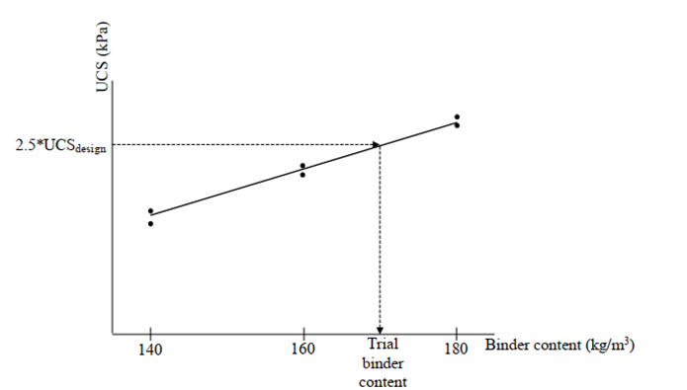
Notes:
- The figure above serves merely as an illustration of the procedure to determine the ‘Trial Binder Content’ for a Test Area.
- The Binder contents of 140, 160 and 180 kg/m³ shown in the figure above are for illustration purposes only. The actual Binder contents will be determined by the Contractor and will differ from project to project.
- Only one set of test results, comprising 3 laboratory mixes from one sample, is shown in the figure. The actual plot will contain multiple sets of test results from different samples, with a pair of UCS test results corresponding to each of the 3 Binder contents (140, 160 and 180 kg/m³ in this example).
    - Prepare a Laboratory Mixes Test Report containing the following information for each Test Area:
  - plotted stress-strain curves, Esec50 values, UCS test values and other reporting requirements as specified in AS 1289.6.4.1;
  - plot(s) of UCS against Binder content; and
  - Trial Binder Content.

- Test Method for Concrete Compressive Strength Using Cores
    - Carry out triple tube coring (minimum core diameter of 63 mm), or other approved insitu sampling method, to the full depth of the test column at between 7 and 14-days after the DSM column construction.
    - From each 2 m depth interval section of the full length of the recovered core, take 3 sets of samples, with each set comprising a pair of test cylinders, at locations within the core selected by the Principal.
    - The number of sets of samples may be reduced if approved by the Principal in instances where the length of intact core samples retrieved is limited.
    - Seal the samples and store them in an environment of constant 90% humidity at a temperature of 20° ± 2°C prior to testing.
    - Water curing method at a temperature of 20 ± 2°C may be used if approved by the Principal in instances where the humid curing environment is impractical.
    - For all of the samples taken, test one set at 28-days age in accordance with AS 1289.6.4.1. One of the remaining 3 sets may be used to test at an earlier age.
    - Store the remaining set(s) of samples and the remainder of the core in the same humid environment as that specified above until conformity with the 28-day strength is verified or use them for further testing if required. If requested, provide any remaining samples to the Principal.
- Column Pull Out Resistance Test (PORT) and Push In Resistance Test (PIRT)
  - Vane Equipment Details
    - Use the vane equipment shown in Figure ‎D.1.1 for PORT and PIRT column penetration tests.
Figure ‎D.1.1: Vane for PORT and PIRT column penetration tests
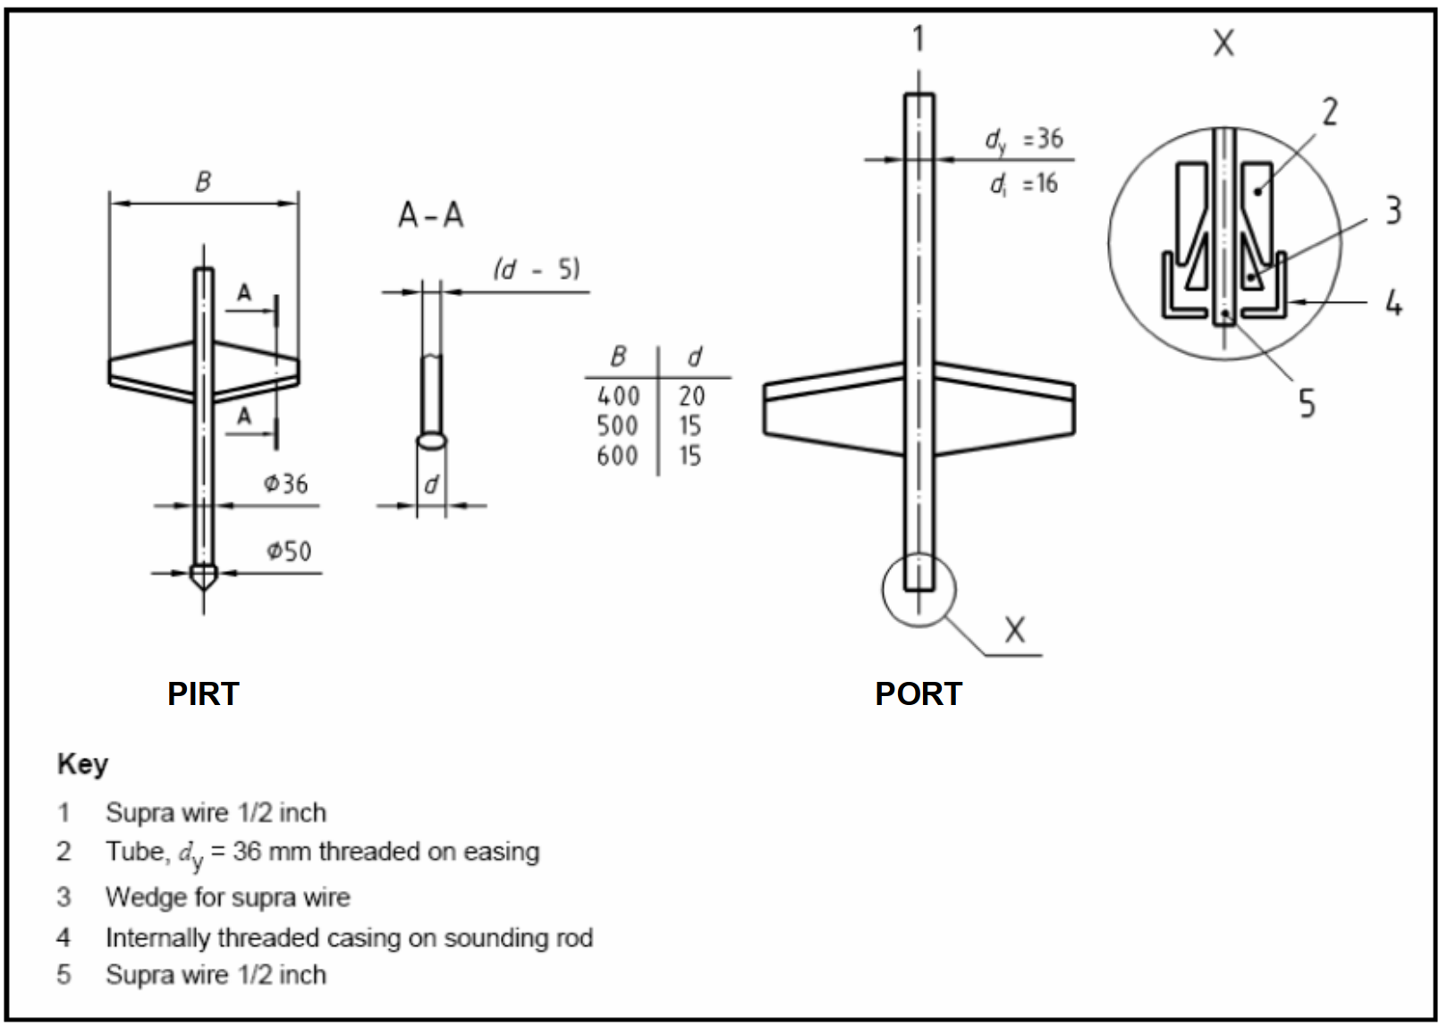
  - Testing Procedure – PORT
    - Adopt the following procedure for PORT:
  - Immediately after mixing, install the vane to below the base of the column by pushing the vane through the column.
  - Once installed, confirm the verticality of the vane.
  - Rotate the vane blade 90 degrees after it has been installed below the column in order to align it with the intact column material.
  - Pull the vane up 100 mm to 200 mm within 48 hours of installation to reduce the bond between the cable and the column.
  - Between 7 and 14-days after its installation, pull out the vane through the column at a constant extraction rate of 20 ± 4 mm per second.
  - Record the resistance continuously along the depth.
  - Testing Procedure – PIRT
    - Adopt the following procedure for PIRT:
  - Between 7 and 14-days after its installation, insert the vane into the column at its centre by pushing in the vane through the column at a constant penetration rate of 20 ± 4 mm per second.
  - Record the resistance continuously or at intervals not exceeding 2 seconds.
  - If required, use pre-boring to maintain verticality during the push in.
  - Submission of Test Results
    - Analyse and report the results of the PORT/PIRT testing using the method described in SGF Report 4:95E, with the exception that the shear strength calibration factor ‘N’ (for interpreting the shear strength obtained from the column penetration test) is determined using the UCS test results from field coring samples described in ‎Annexure C.
    - The reported ‘N’ value is subject to the approval by the Principal.
    - If a calibration is not performed, use a default ‘N’ value of 13.
- Column Head Exposure Test
    - Excavate the column to a depth of 1.0 m below the ground surface.
    - Undertake a visual inspection and photograph the top of the column, recording any cracks or discontinuities.
    - Carry out hand vane testing at 0.1 m centres on 2 orthogonal lines across the centre of the column to assess uniformity of the column strength.

Amendment Record
Edition no. | Clauses amended | Action | Date
1.0 | New specification | New | December 2025

Key
Format | Change in format
Substitution | Old clause removed and replaced with new clause
New | Insertion of new clause
Removed | Old clauses removed

