AUSTROADS TECHNICAL SPECIFICATION ATS 2280  Horizontal Drains | 

Contents
1. Scope 1
2. Referenced Documents 1
3. Definitions 2
4. Quality System Requirements 2
5. Materials 2
Drainpipe 2
Filter Fabric 3
6. Drilling of Drain Holes 3
Location of Drain Holes 3
Drilling 3
Temporary Casing 4
7. Installation of Drainpipes 5
Annexure A: Summary of Hold Points, Witness Points and Records 6
Annexure B: Typical Details of Horizontal Drains 7

Scope
  - Austroads Technical Specification ATS 2280 sets out the requirements for the drilling and installation of nominally horizontal drains in soil/rock into natural and artificial slopes. The work includes:
    - the drilling of drain holes at specified locations, orientations and depths;
    - the installation of slotted UPVC pipes of specified diameter, thickness and length, wrapped in a geotextile filter fabric; and
    - the connection of the installed horizontal drains to the existing stormwater drain network as shown on the Drawings.

Referenced Documents
  - The following documents are referenced in this Specification:
Australian / New Zealand Standards
AS 1477.1 Unplasticized PVC (UPVC) pipes and fittings for pressure applications – Pipes
AS/NZS 2032 Installation of PVC pipe systems
Austroads
AP-C87-15 Austroads Glossary of Terms
ATS 2160 Supply and Installation of Geotextiles (Separation and Filtration)

Definitions
  - The definitions in AP-C87-15 apply to this Specification.

Quality System Requirements
  - The Contractor must prepare and implement a Quality Plan that includes the documentation in Table 4.1.
Table 4.1 Quality Plan
Clause | Description of Document
5.8 | Details of the proposed geotextile filter fabric.
6.4 | Details / procedures for drilling.
7.1 | Details / procedures for installation of drainpipes.

HOLD POINT 1.
Process Held | Commencement of horizontal drain installation.
Submission Details | The Quality Plan must be provided to the Principal at least 10 working days prior to the commencement of work on site.

Materials

Drainpipe
  - The drainpipe must be manufactured from rigid unplasticized polyvinyl chloride (UPVC) complying with AS 1477.1 and have a strength grade of Class 18.
  - Each drain comprises an inner and outer pipe, and the outside diameters and the wall thickness must be as specified in Table 5.2.
Table 5.2: Pipe Diameters and Wall Thickness
 | Outer Pipe | Inner Pipe
Outside diameter | 114 mm | 75 mm
Minimum wall thickness | 8.5 mm | 5.5 mm
  - A UPVC cap complying with the same standard must be fitted to the upstream end of each drainpipe.
  - The pipes must be provided with transverse slots as follows:
- width between 0.90 mm and 1.10 mm;
    - minimum depth equal to 3/8 of the outside diameter of the pipe;
    - maximum depth equal to half the outside diameter of the pipe; and
    - spaced at 25 mm apart.
  - The slots must be cut in groups of twelve. Each set of twelve slots at 30° to the horizontal and orientate each alternate group to lie within the top 240° of the circumference. In this fashion, the bottom 120° of the circumference of the pipe remains uncut over its entire length (refer Annexure B for details).
  - The use of round or rectangular holes in lieu of the slots specified in Clause 5.4 and 5.5 is permitted, provided that the holes have equivalent performance to that provided by the slots and the pipe is not weakened.
  - The pipe must be unslotted and free of holes for a length of 1 m from the outlet end, or whatever length as directed by the Principal.

Filter Fabric
  - The geotextile forming the filter fabric must be a nonwoven geotextile conforming to ATS 2160, hydrophically treated to reduce surface tension and must be abrasion resistant to resist damage during installation. The strength class and filtration class of the geotextile must be determined in accordance with Table 6.4 of ATS 2160.

Drilling of Drain Holes

Location of Drain Holes
  - Unless specified otherwise in the Contract documents, the location, orientation and length of the drain holes must be in accordance with the Drawings and the details shown in Annexure B.
  - The position of each drillhole must be marked on the surface of the slope before the commencement of drilling.
HOLD POINT 2.
Process Held | Commencement of drilling the drain holes.
Submission Details | The notice of intention to commence drilling and the set out of each drillhole must be submitted to the Principal at least 3 working days prior to the commencement of the drilling.
  - The actual position of each drain hole must be within a tolerance of ± 100 mm vertically, ± 300 mm horizontally, of the specified position. The Contractor must provide safe access to enable the inspection of each drain hole by the Principal prior to and during the drilling and installation process.

Drilling
  - The Quality Plan must include details and / procedures for the following:
    - the drilling method and measures to ensure that the specified hole orientation and inclination are maintained during the drilling process; and
    - details of the method to ensure that the drillhole does not collapse in weak soil or rock.
  - Drilling must be carried out using rotary or rotary-percussion drilling equipment. Effective dust suppression and / or containment must be in accordance with all applicable environmental management legislation and Work, Health and Safety legislation applicable in the jurisdiction where the work is being carried out.
  - The drilling of holes must be carried out in a manner which does not affect the stability of the cut batter. In particular, avoiding the introduction of large volumes of water into the slope. Drilling lubricants or flushing mediums other than clean water or air must not be used.
  - Any ground water outflow resulting from the drilling process must be directed to a holding tank to enable settlement of the sediment resulting from the drilling in accordance with the environmental management requirements included in the Contract documents. Discharge of ground water outflow or wastewater onto a pavement is not permitted.
  - The holes for the horizontal drains must be drilled to an inclination of between 3° and 8° dipping towards the exposed slope face or to the inclinations shown on the Drawings. Drillholes must be at least 150 mm in diameter to allow installation of the slotted outer UPVC pipe. Holes must be smooth, clean and true to size.
  - Holes must be drilled in a straight alignment. The maximum permissible deviation of the holes is 2° (as measured on a horizontal plane). Deviation from straight must not exceed 25 mm in any 2 m length of hole.
  - Each hole must be drilled 100 mm longer than the specified length leave space for the deposition of cuttings in the event that they cannot be flushed out of the end of the drillhole in accordance with Clause 6.15.
  - Any hole which is more than 1° from the specified inclination angle is non-conforming and must be redrilled, unless the Principal authorises acceptance of the particular hole.

Temporary Casing
  - The Contractor must ensure that the surrounding soil or rock does not collapse during the drilling and installation process. Where necessary, measures (such as temporary casing which is retracted after each UPVC pipe has been installed) must be put in place to prevent collapse.
  - In the event of a UPVC pipe being damaged at any stage of the installation process, either a new UPVC pipe must be installed in accordance with this Specification or a new hole drilled.
  - Any abandoned hole(s) must be backfilled and sealed.
  - Once drilling is complete, each drillhole must be cleaned of all deleterious material, including drill cuttings from the walls and bottom of the drillholes. Flushing with water, or water in conjunction with air, with side jet bits must be used. Flushing must be carried out with caution and to avoid causing the drillhole to collapse and/or too much water being injected into the slope causing localised instability.
  - The Contractor must prepare a drilling report for each hole which includes the following and submit the report to the Principal within 5 working days of the completion of each drillhole:
    - drain reference number, location, inclination, diameter and length of hole;
    - drilling method and equipment used;
    - types of materials penetrated and presence of groundwater with related depths; and
    - drilling rates and any difficulties or breakdowns.

Installation of Drainpipes
  - The Quality Plan must include details / procedures for installation of the drainpipes. Unless directed otherwise by the Principal, an outer and an inner UPVC drainpipe must be installed in each drillhole.
WITNESS POINT 1.
Process | Installation of UPVC drainpipe into drillhole.
Notification Period | At least 1 working day before the commencement of installing the drainpipe.
  - The unslotted 120° of the circumference section of the pipe must be installed at the bottom (refer Annexure B for details).
  - The pipe must be jointed either as spigot and socket joints, or as butt joints with a sleeve extending about 50 mm over the end of each pipe. Sleeve couplers must not affect the drain installation process. The joints must be secured with PVC solvent cement in accordance with AS/NZS 2032.
  - The upstream end of each pipe must be sealed with a UPVC cap secured with PVC solvent cement in accordance with AS/NZS 2032.
  - The inner pipe must be completely wrapped with geotextile filter fabric with an overlap length of 25mm and fixed with PVC duct tape at 300mm centres.
  - After installation of an outer pipe, the annular space between the drilled hole and the outer pipe must be tightly plugged with cement mortar for a length of at least 0.5 m at the outlet end of the hole.
  - All drainpipes must be connected to the existing stormwater network as shown on the Drawings.

Annexure A: Summary of Hold Points, Witness Points and Records
The following is a summary of the Witness Points / Hold Points that apply to this Specification and the Records that the Contractor must submit to the Principal to demonstrate compliance with this Specification.
Clause | Hold Point | Witness Point | Record
4.1 | - Commencement of horizontal drain installation |  | Quality Plan
6.3 | - Commencement of drilling the drain holes |  | Set out locations of drain holes
6.16 |  |  | Drilling Report
7.1 |  | 1. Installation of drainpipes

Annexure B: Typical Details of Horizontal Drains
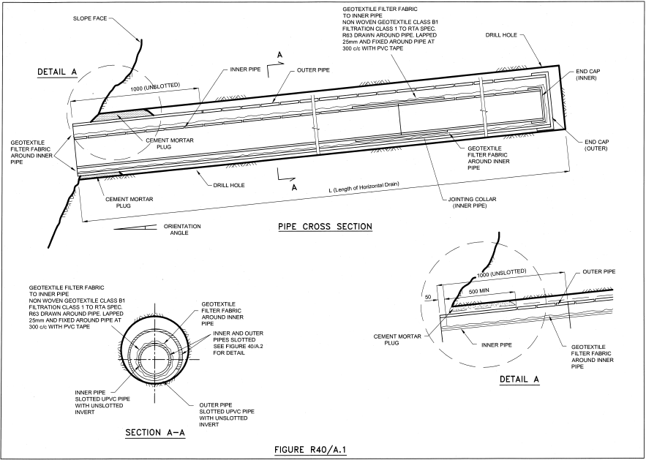
Geotextile filter fabric to inner pipe.
Drawn around pipe, lapped 25 mm and fixed around pipe at 300 mm intervals with PVC duct tape.
Geotextile filter fabric around inner pipe.
Outer pipe slotted UPVC pipe with unslotted invert.
Inner pipe slotted UPVC pipe with unslotted invert.
Inner and outer pipes slotted.
Refer Figure B2 for details.
Geotextile filter fabric to inner pipe.
Drawn around pipe, lapped 25 mm and fixed around pipe at 300 mm intervals with PVC duct tape.
Geotextile filter fabric around inner pipe.
Geotextile filter fabric around inner pipe.
Cement mortar plug.
Cement mortar plug.
Cement mortar plug.
Geotextile filter fabric around inner pipe.
Inner pipe.
Inner pipe.
Outer pipe.
Outer pipe.
Drill Hole.
Drill Hole.
Jointing Collar
(Inner pipe)
End Cap
Outer.
End Cap
Outer.
Slope Face.
FIGURE B1
TYPICAL CROSS SECTION OF HORIZONTAL DRAIN
Geotextile filter fabric around inner pipe.
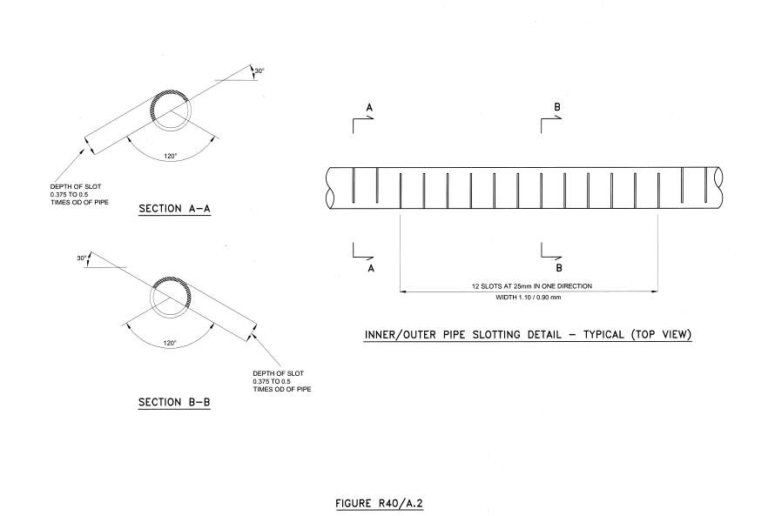
FIGURE B2

Amendment Record
Amendment no. | Clauses amended | Action | Date
- | New specification | New | October 2023

Key
Format | Change in format
Substitution | Old clause removed and replaced with new clause
New | Insertion of new clause
Removed | Old clauses removed

