AUSTROADS TECHNICAL SPECIFICATION ATS 5650  Bonded Metal-Elastomer Expansion Joints | 

Contents
1. Scope 1
2. Referenced Documents 2
3. Definitions 2
4. Quality System Requirements 3
5. Design 3
General 3
Design Loads on Joint 4
Anchors 4
6. Materials 4
Elastomer 4
Metal 5
Corrosion Protection 5
7. Noise 6
8. Certification 6
9. Installation 6
10. Warranty 7
Annexure A: Summary of Hold Points, Witness Points and Records 8
Annexure B: Typical Bonded Metal-Elastomer Joint Details 9

Scope
Austroads Technical Specification ATS 5650 sets out the requirements for the supply and installation of bonded metal-elastomer expansion joints, including reinforced elastomeric units, sealants and anchorage systems.
This type of expansion joint consists of a metal reinforced elastomeric pad that spans the joint gap and is rigidly attached on each side of the gap. The joint movements are accommodated by deformation of the elastomer. The metal reinforcement embedded in the elastomer supports traffic crossing the gap. Refer to Annexure B for typical details.

Referenced Documents
The following documents are referenced in this specification:
Australian / New Zealand Standards
AS 1214 Hot-dip galvanized coatings on threaded fasteners (ISO metric coarse thread series)
AS 1683 Methods of tests for elastomers
AS 1683.11 Tension testing of vulcanized or thermoplastic rubber
AS 1683.13 Compression set of vulcanized rubber under constant deflection
AS 1683.15.1 International rubber hardness
AS 1683.23 Rubber – Vulcanized – Determination of resistance to liquids
AS 1683.24 Methods of test for rubber – Determination of the resistance of vulcanized or thermoplastic rubbers to ozone cracking – Static strain test
AS 3679.1 Structural steel – Hot-rolled bars and sections
AS 4680 Hot-dip galvanized (zinc) coatings on fabricated ferrous articles
AS 5100 Bridge design
AS 5100.2 Part 2 – Design loads
AS 5100.4 Part 4 – Bearings and deck joints
AS/NZS ISO 9001 Quality management systems – Requirements
International Standards
ISO 188 Rubber, vulcanized or thermoplastic — Accelerated ageing and heat resistance tests
Waka Kotahi NZ Transport Agency
SP/M/022 Bridge Manuals
ASTM International
ASTM D746 Standard Test Method for Brittleness Temperature of Plastics and Elastomers by Impact

Definitions
In addition to the definitions in AS 5100.4 (in Australia) or SP/M/022 (in New Zealand), the following definition applies to this Specification.
Principal’s Registration Scheme: | Any scheme for the prequalification, registration or approval of products, manufacturers, suppliers and/or Professional Engineers in operation in the jurisdiction where the expansion joint is to be installed

Quality System Requirements
The Contractor must prepare and implement a Quality Plan that includes the documentation in Table 4.1.
Table 4.1: Quality Plan
Clause | Description of document
5 | Description of the proposed expansion joint and general arrangement drawings showing the details of the expansion joint (including drainage requirements where appropriate)
6.3 | Laboratory test certificates
8.1 | Certification from the manufacturer of the expansion joint
9.1 | Details and / or procedures for installation
10 | The wording of the proposed warranty
The expansion joint must be manufactured under a Quality Management System which is certified as complying with AS/NZS ISO 9001 by a JAS-ANZ accredited organisation and evidence of the certification must be submitted to the Principal.
Where a Principal’s Registration Scheme is in place for the supply of bridge deck expansion joints, the joint must be approved under that scheme and a certificate of compliance must be submitted to the Principal. If a Principal’s Registration Scheme does not apply, the Contractor must submit documentary evidence of the proven performance of the joint and compliance with this Specification with the Quality Plan.
For expansion joints installed in New South Wales, the joints must be an approved product. Refer to TfNSW TS 01621, available from the TfNSW Standards Portal standards.transport.nsw.gov.au.
Where a particular expansion joint shown on the Drawings or specified in the Contract documents, the Contractor must supply and install that expansion joint. The Contactor may submit a proposal to Principal to use an alternative expansion joint, but the Principal is under no obligation to accept any such proposal.
HOLD POINT 1.
Process Held | Installation of the Expansion Joint
Submission Details | The Quality Plan and the other documentation required under Clause 4 must be submitted to the Principal at least 15 working days prior to the commencement of the installation of the expansion joint.

Design

General
The design of the joint must comply with AS 5100.4 (in Australia) or SP/M/022 (in New Zealand) and as amended by this Specification.
The bonded metal-elastomer expansion joints must be designed to possess the necessary properties of extension, compression and deformation to give the required range of movement, as shown on the drawings. The wearing surface of the joint must be of metal which is wear and skid resistant.
The required profile of the bonded metal-elastomer joint to match the bridge cross section may be obtained by sealing together straight lengths of joint by means of a sealant recommended by the manufacturer of the expansion joint.
The maximum transverse movement of the joint in service must be not more than ±1/12 of the total maximum movement range.

Design Loads on Joint
The joint must be designed to withstand the following loads:
- A vertical live load from an A160 individual heavy axle in accordance with AS 5100.2, and
- A concurrent longitudinal live load that is a minimum of 35% of the vertical load acting at road level parallel to the direction of traffic.
The design loads must be applied at any location on the deck joint to give the worst loading case. The dynamic load allowance must be 0.6.
The design load must be multiplied by the dynamic load allowance by a factor of 1.8 for ultimate limit state effects, 1.0 for serviceability limit state effects and 0.6 for fatigue.

Anchors
The supplier must comply with AS/NZS ISO 9001 Clause 8.3 with respect to the design of the anchors. The anchors must be designed to meet the requirements of AS 5100.4 and the following additional requirements:
The forces in the anchors must be calculated in accordance with the laws of statics, assuming that the concrete above the line joining the points of connection between the anchors and the member is ineffective.
- Anchors must have a minimum thickness of 12 mm if rectangular bars and must not be less than 20 mm in diameter if round bars.
- Bars used as anchorages must form a loop of sufficient size to permit anchoring into the concrete with the contribution of the transverse and other reinforcement.
- Any welding of anchorage bars must develop the full strength of the bar and accommodate an infinite number of fatigues cycles.
- Stud welded shear connectors used as anchors must be at least 16 mm diameter and 150 mm in length and welded only by resistance welding using a welding gun. Stud shear connectors must not be welded to aluminium, and
- Anchors must be designed to allow easy replacement of the joint.

Materials

Elastomer
The elastomeric components of the joint must be made from vulcanized compound having polymerized chloroprene as the only base polymer.
Unless approved otherwise by the Principal, testing must be performed by a laboratory which is accredited by a body that is a signatory to the International Laboratory Accreditation Cooperation Mutual Recognition Arrangement (ILAC MRA). The National Association of Testing Authorities (NATA) and International Accreditation New Zealand (IANZ) are signatories to ILAC MRA.
Documentary evidence must be provided to the Principal to verify that the elastomer used in the manufacture of the seal has been tested in a laboratory meeting the requirements of Clause 6.2 and conforms to Table 6.3.
Table 6.3: Elastomeric Seal Properties
Test reference | Requirement | Test description
1. General
a) Tensile Strength | 12.0 MPa minimum | AS 1683.11 (Dumb-bell test pieces)
b) Elongation at Break | 350% minimum | AS 1683.11 (Dumb-bell test pieces)
c) Hardness | IRHD 59±5 | AS 1683.15.1
2. Accelerated Ageing |  | ISO 188 (Method A for 72 hours at 100°C)
a) Tensile Strength Change | -15% to +15% | AS 1683.11 (Dumb-bell test pieces)
b) Elongation at Break Change | -40% to 0 | AS 1683.11 (Dumb-bell test pieces)
c) Hardness Change | IRHD -15 to +15 | AS 1683.15.1
3. Resistance to Ozone | No visible cracking | AS 1683.24 (Ozone concentration 50 pphm in air, 20% strain, 72 hours at 40°C)
4. Change in Volume in Oil | +30% maximum | AS 1683.23 (Using Oil No. 3, after 72 hours at 100ºC)
5. Compression Set | 40% maximum | AS 1683.13 (72 hours at 100ºC)
6. Brittleness | Not brittle | ASTM D746 (B) (At –30ºC)
The Contractor may submit a proposal to Principal to waive the requirement for testing as above. Any such proposal must be supported by evidence that:
- the elastomer of the seal is supplied by a company which has a third party certified quality management system to AS/NZS ISO 9001 for the manufacture and supply of elastomer
- test certificates are supplied to prove that the elastomer meets the properties specified in Table 6.2 in Type Tests which are not more than six months old
- day to day batch quality control on the manufacture of the elastomer is exercised by performing a test which accurately measures the cure characteristics of the elastomer and highlights variations resulting from incorrect ingredients or levels thereof, and
- the manufacturer establishes control points and limits on batches which have been Type Tested and uses these control points and limits for subsequent quality control purposes.
The elastomer must be completely uniform and homogeneous throughout without imperfections, surface splits, or indentations.

Metal
Structural steel embedded in the elastomer must conform to AS/NZS 3679.1 Grade 250 unless noted otherwise on the Drawings or in the Specification.
Other embedded metal must conform to the relevant Australian / New Zealand Standard for the strength grade specified in the design.

Corrosion Protection
The anchors must be hot dipped galvanized in accordance with AS/NZS 4680 or AS/NZS 1214 unless shown otherwise on the Drawings.

Noise
It is possible that the centre portion of the expansion joint, in a compressed condition, lifts off the support, forming a convex profile. As vehicles travel across the joint a thumping noise may emanate. If required by the Principal, the Contractor must provide evidence of the field performance of noise levels under similar site and temperature conditions and state the measures implemented to eliminate noise resulting from the lifting of the joint.

Certification
The Contractor must provide a certificate from the manufacturer of the joint verifying that it complies with the drawings and this Specification. This must include certification from a suitably experienced professional engineer eligible for Corporate Membership of Engineers Australia that the design conforms to this Specification. This Clause 8.1 does not apply to expansion joints installed in New Zealand.
HOLD POINT 2.
Process Held | Dispatch of the expansion joint to site.
Submission Details | The certificate from the supplier of the joint verifying its conformity with the Drawings and this Specification must be provided at least 7 days prior to the commencement of the installation of the Expansion Joint.

Installation
The Quality Plan must include details and / or procedures for:
- Deck preparation, including blockout reinforcement, dimensions and tolerances required (where applicable).
- Anchor locations and pre-setting required to suit the bridge deck temperature at the time of joint installation.
- Preparation of the blockout base to ensure a true and even surface on which to bed the joint units (where applicable).
- Methods of sealing joint units at kerbs, gutters and horizontal directional changes in the bridge deck profile.
- Sequence of installation of the units (where applicable).
- Method of achieving a watertight seal at the interfaces between the concrete blockout and the joint units.
- Method of joining adjacent joint units to ensure a watertight seal.
- Torque requirements for anchors and the method of sealing bolt hole cavities.
- Filling for the gap between the edges of the unit and the adjacent road surfaces.
- Time after completion of installation when traffic is allowed on the road; and
- Method for testing of the installed joint for watertightness.
Expansion joints must be handled in a manner which prevents damage to the joints and any protective coatings.
The expansion joint and any proprietary products must be installed in accordance with the manufacturer’s instructions and the Quality Plan to the specified tolerances.
WITNESS POINT 1.
Process | Installation of expansion joint
Notification | Notification must be provided at least 2 working days prior to the commencement of expansion joint installation
The joint must not be inserted into the blockout until at least 3 days after all deck concreting in the adjacent spans or abutments is completed.
The top surface of the expansion joint must be set 4 mm ± 1 mm below the deck wearing surface.
Expansion joints must not be subjected to construction or traffic loading until all components of the joint have achieved sufficient strength to support the loading without damage.

Warranty
The expansion joint must be supplied with a manufacturer’s warranty in the name of the Principal. The warranty must:
- cover defective workmanship, material and serviceability (which includes watertightness of the joint)
- fully cover the replacement / rectification of a defective expansion joint, and
- apply for a minimum period of 5 years (in Australia) or 10 years (in New Zealand) from the date of installation.

Annexure A: Summary of Hold Points, Witness Points and Records
The following is a summary of the Witness Points / Hold Points that apply to this Specification and the Records that the Contractor must submit to the Principal to demonstrate compliance with this Specification.

Clause | Hold point | Witness point | Record
4.3 | Installation of the Expansion Joint. |  | Quality Plan, details of the expansion joint and warranty
8.1 | Dispatch of the expansion joint to site |  | Certificate of Conformance
9.1 |  | 1. Installation of expansion joint and /or placement of concrete around the joint
10 |  |  | Warranty

Annexure B: Typical Bonded Metal-Elastomer Joint Details

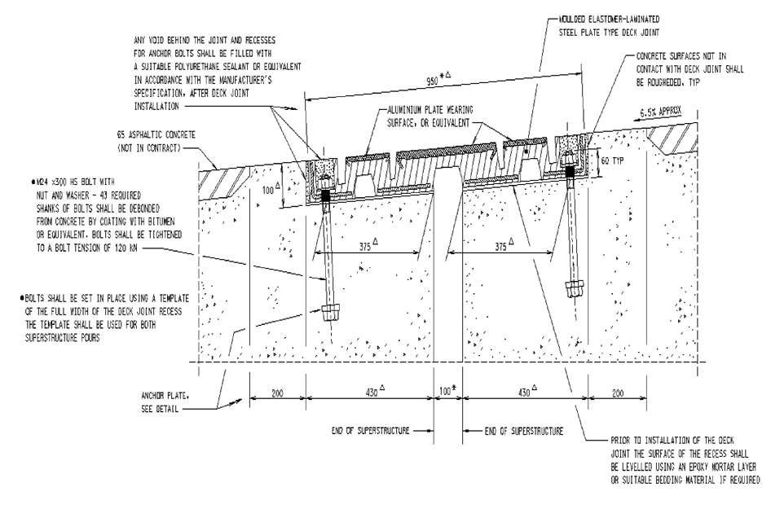

Amendment Record
Amendment no. | Clauses amended | Action | Date
- | New specification | New | December 2022
1 | 4.4 - Link to Transport for New South Wales portal inserted | New | October 2023

Key
Format | Change in format
Substitution | Old clause removed and replaced with new clause
New | Insertion of new clause
Removed | Old clauses removed

