COMMENTARY TO AG:PT/T252 - PENETRATION OF ROAD BASES BY BITUMINOUS PRIMERS OR PRIMERBINDERS

PREFACE
This sprayed seal design method was prepared by the Bituminous Surfacings Research Review Group on behalf of Austroads. Representatives of Austroads, ARRB Group and the Australian Asphalt Pavement Association have been involved in the development and review of this method.

FOREWORD
This method has been developed from a Roads and Traffic Authority test method.

SCOPE
This test method sets out the procedure for assessing the degree of absorption of a primer or primerbinder by a given road gravel in bituminous surfacing work. The standard procedure is designed to simulate the following three conditions:

- Gravel drying out from optimum moisture content.

- Gravel maintained at a constant nominated moisture content.

- Gravel in the air-dried condition.

A primerbinder can be applied to a dry surface or a surface to which a light water spray has been applied; whichever simulates the condition expected immediately prior to the application of a primerbinder.

Two techniques are offered depending upon the equipment available. Technique B should only be used if equipment required for Technique A is unavailable.

Further Development
None.

PENETRATION OF ROAD BASES BY BITUMINOUS PRIMERS OR PRIMERBINDERS

TECHNIQUE A
- REFERENCED DOCUMENTS
The following documents are referred to in this method:

AUSTROADS

AST 005 Sample Preparation – Compaction of asphalt slabs suitable for characterisation

AS /NZS

1289.5.1.1 Soil compaction and density test – Determination of the dry density/moisture content relation of a soil using standard compactive effort.

1289.6.1.1 Soil strength and consolidation tests – Determination of the California Bearing Ratio of a soil- Standard method for a remoulded specimen

1141.2 Methods for sampling and testing aggregates – Basic testing Equipment

1141.3.1 Methods for sampling and testing aggregates – Sampling Aggregates 1152 Specification for test sieves

DEFINITIONS
The following definitions are applicable to this test method:

  - Basecourse Curing - The period during which the specimen is sealed in an airtight container to allow uniform moisture distribution and/or stabilising agent hydration prior to the application of any bituminous primer or primerbinder. Basecourse curing shall be carried out at 23°C unless otherwise specified.

  - Primer or primerbinder Curing - The period during which the specimen is stored in a temperature controlled cabinet after the application of a bituminous primer or primerbinder. Primer or primerbinder curing shall be carried out at 50°C unless otherwise specified.

  - Homogeneous Penetration - Penetration of a bituminous primer or primerbinder into the basecourse material where the bituminous material and solvent remain mixed is essentially the same proportions as when applied. The penetrated layer is black over its full depth, except in tests where the bitumen content of the bituminous primer or primerbinder is very low.

  - Segregated Penetration - When the penetrated layer is split into two contrasting fractions, a black upper fraction (bituminous primer or primerbinder) and a lighter coloured fraction (solvents), penetration is said to be segregated. Both bituminous

material penetration and solvent penetration are measured from the top of the test specimen.

APPARATUS
The following apparatus is required:

  - A constant temperature cabinet with about 0.12 m³ storage capacity for specimens, thermostatically controlled to within ± 2°C of the desired test temperature and supplied with a fan to circulate the air within the cabinet.

  - The cabinet is to contain a dish of water, checked daily and refilled as required. The dish should be about 150 mm in diameter and be non-corroding.

  - A cylindrical metal mould having an internal diameter of 152 ± 0.5 mm and an effective internal height of 175 ± 5 mm, split horizontally into two sections and fitted with a base plate (see Fig. 1). Provision shall be made for the split sections to be clamped together and to the base plate.

  - Metal spacer, 70 ± 5 mm high, and having an outside diameter which ensures a neat fit inside the assembled mould (i.e. approximately 151 mm diameter, see Fig. 1).

  - Three perforated plates complying with AS 1289.6.1.1.

  - Three PVC plastic rings of the following sizes:

    - 153 ± 1 mm internal diameter x 38 ± 2 mm high x 1 mm wall thickness, and

    - 153 ± 1 mm internal diameter x 50 ± 2 mm high x 1 mm wall thickness

  - A metal rammer complying with AS1289.5.1.1 (Standard Compaction).

  - A balance of 10 kg capacity readable to 0.1g with precision limit of 0.5g.

  - An immersion thermometer graduated from 0 to 250°C and a maximum/minimum thermometer graduated from 0 to 100°C, readable and accurate to 1°C.

  - A spatula with a steel blade approximately 75 mm long.

  - Bitumen dispensing container suitable for pouring hot primer or primerbinder.

  - Water sprayer, suitable for applying light spray of water to specimens.

  - A rapid cure silicone sealant (clear or coloured) and suitable applicator.

  - A straight edge, about 250 mm long, 25 mm wide and 3 mm thick, preferably with one bevelled edge.

  - A spirit level approximately 200 mm long.

  - A cooling cabinet capable of cooling to temperatures of 3°C.

  - A hot plate capable of heating primer or primerbinder to temperatures of 200°C.

  - Flat dishes having an internal diameter of approximately 200 ± 10 mm and a depth of 15 ± 5 mm. They must be rigid and may be steel or plastic.

  - A supply of clean, dry, one-sized sand, such that 95% or more pass a 1.18 AS sieve and 95% or more be retained on a 0.3 mm AS sieve. The sand should be free from organic material.

  - A 19 mm sieve complying with AS 1152.

  - Quartering or riffling equipment complying with AS 1141.2.

  - A hammer.

  - Thick adhesive tape, approximately 15 mm wide (“Duct” tape has been found suitable).

  - Miscellaneous mixing and moisture content determination apparatus, such as pan or bowl, spoon, trowels and oven trays.

MATERIALS
The following minimum quantities of materials are required:

  - 30 kg of basecourse aggregate (passing the 19.0 mm sieve).

  - 1 litre of each primer or primerbinder proposed for use.

  - 2 kg of stabilising agent (if required).

Note: Stabilising agent should be stored in sealed containers and protected from moisture until used. It should be stored for no longer than three months from the date of receipt.
  - Care should be taken to ensure that additives are from the same source and manufacturer as that proposed for use in the field.

  - Safety gloves and glasses should be worn when using cement, lime, slag, flyash and blended stabilising agents to protect the eyes and hands during use. Consult the appropriate Material Safety Data Sheets for more information

PROCEDURE

  - Overview
Fig. 2 graphically illustrates the sequence of primer or primerbinder applications and testing. Eight days should be allowed to complete the full test method.

  - Determination of the dry density/moisture content relationship.
    - Pass the entire bulk sample over the 19.0 mm sieve and discard any retained material.

    - Determine the maximum dry density and optimum moisture content of the remaining fraction using:

      - Untreated crushed rocks and gravels AS 1289.5.1.1

      - Cement treated base course AS 1141.3.1 & AS 1289.5.1.1

      - Lime treated base course AS 1141.3.1 & AS 1289.5.1.1

  - Mix preparation.
    - By riffling or quartering, obtain sufficient basecourse material to provide six 150 mm diameter by 45 mm high specimens plus a surplus of 20%. Weigh and record the mass of the selected sample, M₋₁₉ (see Note 1).

    - Calculate the dry mass of test sample, M_{d}, using the following equation:

Md = 
M −19
MC 

1 + 100 
 

Where MC = the moisture content of the basecourse material passing the 19.0 mm sieve.

    - If the basecourse is to be stabilised, calculate the mass of the stabilising agent, M_{s} (in gram) to add to the basecourse material using the following equation.

M s =
S

100
× Md

Where S = the percentage by mass of stabilising agent to add to the basecourse material.

    - If the basecourse is to be stabilised, calculate the total mass of dry basecourse material including stabilising agent using the following equation,

M s + d
= M s + M d

    - Determine the target wet mass of the mix, M_{w} (in gram) using the following equation:

If stabilised
M = M
1 + OMC 

w S +d 



100 

If not stabilised
M = M
1 + OMC 

w d 



100 

Where OMC = the target moisture content (usually optimum) of the stabilised basecourse material, expressed as a percentage.

- Calculate the mass of water, Mwater to add to the test sample to bring it to optimum moisture content using the formula.

      - If stabilised

      - If not stabilised
M water = (MW − M s +d ) − (M −19 − M d )
M water = (MW − M d ) − (M −19 − M d )

Note: A negative value of Mwater indicates that the sample will require drying back before use.
    - Add any extra water required and mix for approximately two minutes; add the stabilising agent (if required), continue mixing until all material is thoroughly mixed. Do not allow more than 10 minutes to elapse between addition of water and completion of mixing.

    - Calculate the mass of material required to fill the specimen mould at 100% of maximum dry density. For non-stabilised materials, a period of pre-compaction curing may be necessary to allow the moisture to homogenise throughout the sample. Weigh out at least three (3) equal test portions into individual plastic bags.

Note: The target thickness of each specimen shall be 45 ± 1 mm.

  - Test specimen compaction and basecourse curing
    - Assemble the split mould, spacer disc and base plate.

    - Compact each specimen in one layer using 61 blows of the rammer evenly distributed over the surface of the specimen.

    - Remove the collar while the mould is still attached to the base plate. Using the straight edge trim and level the surface ensuring that the amount of stone protruding above the top of the mould is approximately equivalent to the hollows below the level of the mould.

    - Invert the specimens onto a perforated plate. Carefully remove the base plate, spacer disc and the mould and seal into a plastic bag or suitable air tight container (see Note 2).

    - Repeat steps (a) to (d) for each specimen.

Allow each specimen of compacted basecourse to cure at 23°C for a period of 48 hours from the commencement of mixing (see Note 3).

  - Test specimen preparation
    - Dry-out Condition
    - Remove a sample from its plastic bag or container.

    - Using a brush with brass bristles, scarify the surface to replicate those conditions expected in the field. Ensure that the surface is reasonably dust free before proceeding.

    - On a flat dish, place approximately 500 g of the sand in a layer of relatively uniform thickness.

    - Place the compacted face of the sample onto the sand surface so that the sample is central on the dish. A slight twisting motion may be applied to bed the sample in and create complete contact with the sand.

    - Place a clean 50 mm high PVC ring over the specimen and apply a similar twisting and downwards force as above to nest the ring slightly in the sand. The top of the ring should be approximately 5 mm proud of the test surface.

    - Constant-moisture Condition
- Remove a sample and perforated plate from the plastic bag or container.

- Using a brush with brass bristles, scarify the surface to replicate those conditions expected in the field. Ensure that the surface is reasonably dust free before proceeding.

- Place a 50 mm high PVC ring around the specimen and slide it down until it is firmly seated on the perforated plate. The top of the ring should be approximately 5 mm proud of the test surface. Seal the horizontal gap between the ring and the lid with adhesive tape.

    - Air-dry Condition
- Remove a sample and perforated plate from the plastic bag or container.

- Place the specimen in a dry sheltered area and weigh at regular intervals until a constant mass is attained (see Note 4).

- Using a brush with brass bristles, scarify the surface to replicate those conditions expected in the field. Ensure that the surface is reasonably dust free before proceeding.

- Place a 50 mm high PVC ring around the specimen and slide it down until it meets the perforated plate. The top of the ring should be approximately 5 mm proud of the test surface. Seal the horizontal gap between the ring and the lid with adhesive tape.

  - Primer or primerbinder application and curing
    - Place a small 120 mm diameter ring on the test surface of each specimen so that it is concentric with the outer PVC ring.

    - Apply a generous bead of silicone sealant (see Note 5) to fill the annulus between the inner and outer rings (see Fig. 2) for all three specimens. By moving a gloved finder around the annulus, push the silicone into the voids not filled by the initial application. Ensure that no excess is squeezed out onto the test surface.

    - Allow the silicone to skin dry (generally about 10 mins). Spray the test surface of each specimen with water (if necessary) noting the amount of water applied. Where a damp surface is required, the application of the water should be light. Allow the water to soak into the test surface for no longer than 5 minutes.

    - Prepare the primer or primerbinder in accordance with the manufacturers recommendations.

    - Apply the primer or primerbinder (see Note 5) to the test surface of the three specimens. Ensure that all areas of the test surfaces are covered by the primer or primerbinder. Spreading of the primer or primerbinder may be facilitated by tilting the specimen in a rolling motion or by using the thin cardboard slip. Care should be taken to prevent primer or primerbinder loss. Record the exact amount of primer or primerbinder applied. Record the total mass of the specimen, rings, sealant, tin lid and primer or primerbinder as M_{1DO}, M_{1CM} and M_{1AD} for the dry-out, constant-moisture and air-dry conditioned specimens respectively.

    - Immediately following primer or primerbinder application, place the sample in a 50°C controlled environment chamber on a flat and level surface. Use the spirit level to ensure that the top of the specimen is level, making adjustments where necessary.

Primer or primerbinder curing should continue for a period of 48 hours.

  - Specimen evaluation
    - Remove the three test specimens from the temperature controlled cupboard and allow to cool to room temperature.

    - Weigh and record the total mass of the specimens as M_{2DO}, M_{2CM} and M_{2AD} for the dry-out, constant-moisture and air-dry conditioned specimens respectively , including the rings, lid and sealant, and calculate the moisture loss for each specimen using the following equation.

    - Moisture Loss = M1 – M2

    - Examine the primer or primerbinder retained on the test surface and record the activity (Wet, Tacky, Tacky-Dry or Dry) and colour (Black, Dark brown, Brown, Light brown).

    - Without adversely disturbing the basecourse material, expose several small parts of the test surface by removing the primer or primerbinder from the specimen with a blade or suitable object. Determine and record the following:

    - The average thickness of primer or primerbinder retained on the test surface (to the nearest 0.5 mm)

    - The quality of adhesion of the primer or primerbinder to the base (Good, medium, poor)

Poor | Primer or primerbinder easily peels away from the basecourse with little or none of the basecourse adhering to the primer or primerbinder film.
Medium | Primer or primerbinder film can be lifted away in patches. If some of the upper surface attached to the film then an extra noted is required stating the cohesion within the basecourse was low.
Good | Primer or primerbinder can not be lifted from the basecourse specimen.  If the primer or primerbinder film can be separated from the basecourse specimen (with the upper part of the base course attached) then an extra note is required stating that the cohesion within the basecourse specimens was low.

    - Break the specimen into two pieces along its diameter. For homogenous penetration, measure to the nearest 1 mm the penetration of the primer or primerbinder into the basecourse aggregate. Ignoring edge effects within 10 mm of the perimeter of the test surface, record the following:

      - Maximum penetration

      - Minimum penetration

      - Mean penetration

    - If the penetration is segregated, measure penetration of the bituminous material and solvent separately and record as per (e) above for each material penetration.

INFORMATION TO BE REPORTED
The report should include the following information for each test specimen:

  - The test conditions, i.e. degree of compaction, target moisture content at compaction, surface condition, and target rate of application of primer or primerbinder.

  - Moisture loss during primerbinder curing, in grams.

  - The test surface finish prior to primerbinder application (e.g. Tight, medium, porous).

  - Note on whether the penetration was homogenous or segregated.

  - Maximum, minimum and mean penetration values (for both bituminous and solvent penetration where applicable).

  - The thickness of the primerbinder remaining on the surface following primerbinder curing.

  - The activity of the binder.

  - The colour of the primerbinder after primerbinder curing.

  - The quality of the primerbinder adhesion to base.

  - Any other relevant observations. In many case it would be advantageous to keep photographic records of the specimens.

  - Reference to this standard, i.e. AG:PT/T252

Notes
- Whilst only three samples are required to test any one primer-base or primerbinder- base combination, it has been found that the quantity of material required to mould three samples is insufficient to ensure optimum mixing of raw materials. To avoid problems that arise from lack of material, it is better to make up a mix of sufficient size to mould at least six specimens. If the excess material can not be utilised, it should be discarded.

- The purpose of the airtight container is to prevent the sample from drying out. The test surface of the sample must not rest on the container otherwise the specimen surface may become glassy.

- A lesser period of basecourse curing may be specified if it more likely to simulate field conditions

- In ambient laboratory conditions, constant dry mass is generally obtained after about 4 days of air drying. The sample should not be exposed to temperatures less than 10°C or greater than 35°C during this period.

- The fumes from silicone sealants and many primer or primerbinders may be a health hazard. Only handle in well ventilated areas provided with exhaust fans and fume cupboards. Gloves and eye glasses should be used when handling these materials.
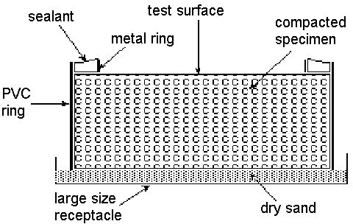

Fig. 1 Cross section of the specimen prepared for the “dry out condition”

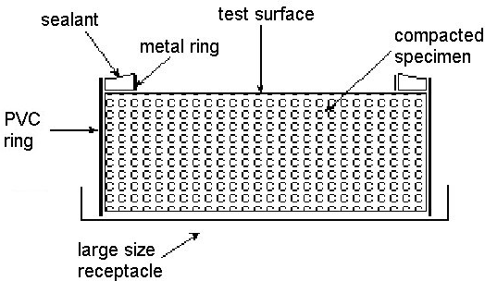

Fig. 2 Cross section of the specimen prepared for the “air dry” and “constant” condition

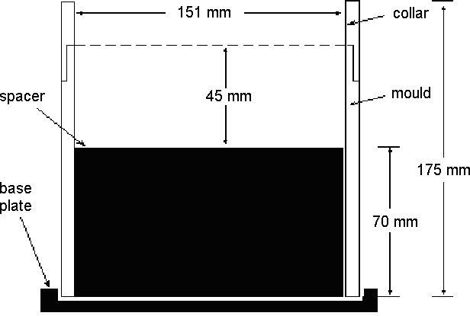

Fig. 3 Suitable method

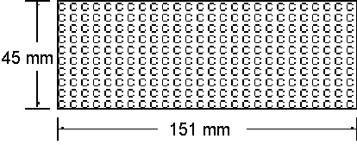

Fig. 4 – Cross section: sample dimension

AMENDMENT RECORD

Amendment No. Clauses amended Action Date

- Commentary Page

Footer and header

Applied revised test method number Applied new styles

New Format Format Format

June 2005

- Preface Substitution June 2006

Key

Format Change in format

Substitution Old clause removed and replaced with new clause New Insertion of new clause
Removed Old clauses removed

