
AUSTROADS TEST METHOD ATM 250 [AG:PT/T250]
Modified Surface Texture Depth (Pestle Method)

Commentary
Contents

1. References 2

2. Apparatus 2

3. Procedure 2

4. Calculations 3

5. Information to be Reported 3

Appendix A Texture Conversion
Charts 6

Preface
This seal design method was prepared by the Bituminous Surfacings Research Review Group on behalf of the Austroads. Representatives of Austroads, ARRB Group and the Australian Asphalt Pavement Association have been involved in the development and review of this method.
Scope
This method describes the procedure for the determination of the surface texture depth of road surfaces, by the sand patch technique. This method is only applicable to surface texture depths greater than 0.3 mm. This method was developed from BS 598:105:1990 and is the preferred method for determining surface texture allowances in the design of sprayed seals.
Further Development
None.

References
The following documents are referred to in this method:
Australian Standard
AS 1289.1.4.2 | Methods of testing soils for engineering purposes – Method 1.4.2: Sampling and preparation of soils-Selection of sampling or test sites-Stratified random number method
Australian/New Zealand Standard
AS/NZS 2009 | Glass beads for pavement-marking materials
British Standards Institution
BS 598:105 | Sampling and examination of bituminous mixtures for roads and other paved areas: Part 105 – Methods of test for the determination of texture depth

Apparatus
The following apparatus is required:
- 50 ml cylinder essential dimensions complying with Figure 1.
- 300 mm rule graduated in mm.
- Clean dry closely graded sand (see Note 1) or glass beads (see note 2) conforming to one of the following size requirements:
- 100% passing 0.850 mm and retained on the 0.600 mm sieve
- 100% passing 0.600 mm and retained on the 0.300 mm sieve
- 100% passing 0.300 mm and retained on the 0.150 mm sieve
- Soft hand brush.
Note 1: Quarry sand has a significantly different Coefficient of Uniformity (Cu) than naturally occurring sand or manufactured glass beads and is also more likely to absorb and retain available moisture (in the air or otherwise) at a higher rate than angular or rounded material of a single size.
Note 2: No glass beads in AS/NZS 2009 Table 3 meet the requirements of this test method therefore inconsistencies in the testing and reporting should be expected if glass beads complying with ASNZS 2009 are used. Only entirely dry, that is containing no moisture, naturally occurring sand or glass beads manufactured to and strictly conforming with the specified particle size distribution (above) shall be used.

Procedure
- Select a sample site in accordance with AS 1289.1.4. 2.
Note 3: Testing may only be performed on dry, mainly horizontal surfaces in weather conditions that do not adversely affect the test result. The imminence of rain and wind greater than 19 km/hr will affect the quality of the test measurements.
- The surface of the sample site must be dry and clean. If necessary, sweep clean using the soft hand brush.
- Fill the cylinder with sand or glass beads. When full, gently tap the base of the cylinder three times on the pavement surface, top up the cylinder with sand or glass beads and level the top with a straight edge.
- Pour the sand or glass beads directly onto the surface of the sample site to form a cone (see Figure 2). Repeat this step, filling the cylinder as in step (b), as often as necessary to obtain the volume of sand or glass beads required for the texture determination. The volume of sand or glass beads used for the texture determination shall be such that the sand patch has a minimum diameter of 170 mm. Table 1 is given as a guide to the volume of sand or glass beads required.
Table 1: Texture depth/volume relationship
Surface texture depth (mm) | Volume of sand or glass beads (cm³)
> 0.3 to < 2.0 | 50
≥ 2.0 to < 4.0 | 100
≥ 4.0 to < 6.0 | 150

- Spread the sand or glass beads evenly by placing the base of the cylinder on the apex of the cone and rotate the base so that the material flows outwards from the cone.
Note 4: Apply only horizontal forces to the cylinder working outwards in a spiral fashion to spread the material in a circular pattern until the surface depressions are filled to the levels of the peaks as shown in Figure 3.
- Measure the diameter of the sand patch to the nearest 1 mm. The diameter shall be measured at four locations at approximately equally spaced distances around the sand patch.

Calculations
- Calculate the average sand patch diameter to the nearest 1 mm.
- Calculate the surface texture depth using the formula:
where
STD | = | surface texture depth in mm
V | = | volume of sand in patch in cm³
D | = | average diameter of sand patch in mm
Note 5: A conversion chart is included as Appendix A to convert the sand patch diameter to surface texture depth without the need for a calculator.

Information to be Reported
Report the following:
- the location of the test (road, chainage, wheel path, etc.)
- the date and time of test
- the surface texture depth to the nearest 0.1 mm.
Notes
- Select the size of the sand or glass beads according to the road texture to be measured, prevailing wind and traffic conditions. The size of the material used shall not exceed the texture depth to be measured.
- The sand or glass beads shall be spread so as not to reach the levels of abnormally high peaks.

Figure 1: Texture depth measuring cylinder
1. | Nitrile rubber base to have international rubber hardness of 70 – 80.
2. | All dimensions are in mm unless otherwise stated.  Mass = 325 ± 25 g  Volume = 50.0 ± 0.20 ml  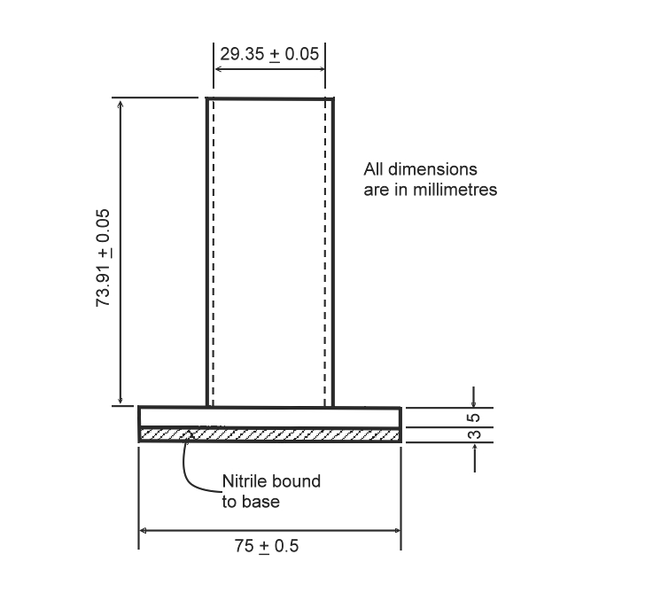

Figure 2: Known volume of sand poured onto the surface to form a cone
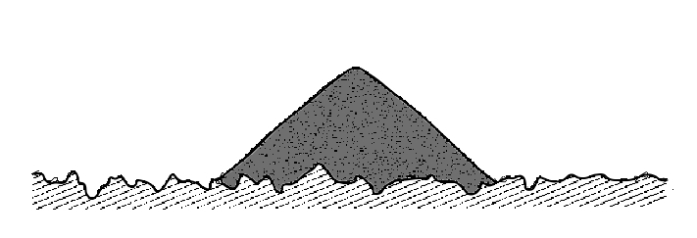
Figure 3: Sand spread to form a circular patch
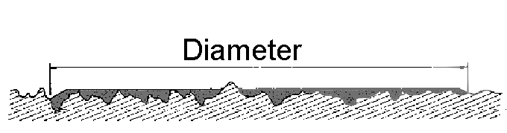

Appendix A Texture Conversion Charts
Table A1 and the chart shown in Figure A1 are provided to convert the sand patch diameter to surface texture depth without the need for a calculator. Operators can use either the table or the chart.
Table A1: Diameter vs. texture depth conversion table
Sand volume  50 cm³ |  | Sand volume  100 cm³ |  | Sand volume  150 cm³
Diameter (mm) | Texture depth (mm) | Diameter (mm) | Texture depth (mm) | Diameter (mm) | Texture depth (mm)
460 | 0.3 | 252 | 2.0 | 219 | 4.0
400 | 0.4 | 246 | 2.1 | 213 | 4.2
357 | 0.5 | 241 | 2.2 | 208 | 4.4
326 | 0.6 | 235 | 2.3 | 204 | 4.6
301 | 0.7 | 230 | 2.4 | 199 | 4.8
282 | 0.8 | 226 | 2.5 | 195 | 5.0
266 | 0.9 | 221 | 2.6 | 192 | 5.2
252 | 1.0 | 217 | 2.7 | 188 | 5.4
241 | 1.1 | 213 | 2.8 | 185 | 5.6
230 | 1.2 | 209 | 2.9 | 181 | 5.8
221 | 1.3 | 206 | 3.0 | 178 | 6.0
213 | 1.4 | 200 | 3.2
206 | 1.5 | 194 | 3.4
200 | 1.6 | 188 | 3.6
193 | 1.7 | 183 | 3.8
188 | 1.8 | 179 | 4.0
183 | 1.9
178 | 2.0

Figure A1: Diameter vs. texture depth conversion chart

Amendment Record
Amendment no. | Clauses amended | Action | Date
1 | Commentary Page | New | June 2005
 | Footer and header | Format
 | Applied revised test method number | Format
 | Applied new styles | Format
2 | Preface | Substitution | June 2006
3 | Changed the required number of patch diameters from five to four | Substitution | Oct 2006
4 | Changed list numbering in apparatus section | Substitution | Jan 2007
5 | Appendix A added | New | May 2008
 | Notes 1, 2, 3 and 5 added | New
6 | Whole document | Format | November 2023
 | References updates throughout document | Substitution
 | Test method number updated on title page and header | Substitution

Key
Format | Change in format
Substitution | Old clause removed and replaced with new clause
New | Insertion of new clause
Removed | Old clauses removed

