
AUSTROADS TEST METHOD ATM 457
Release of Microplastics from Plastic-Modified
Bituminous Mixes (Asphalt Abrasion Test)

Contents

1. Preface 1

2. Scope 2

3. References 2

4. Equipment 2

4.1 Sample Preparation 2

4.2 Abrasion Test 3

4.3 Microplastics Extraction 4

5. Procedure 5

5.1 Sample Preparation 5

5.2 Abrasion test 5

5.3 Microplastics Extraction 6

6. Report 9

Amendment Record 10

Preface
This test method was prepared by RMIT University on behalf of the Austroads Pavements Task Force. Representatives of Austroads, Department of Transport and Planning Victoria, Transport for New South Wales, Main Roads Western Australia, Department of State Growth Tasmania, Queensland Department of Transport and Main Roads, and New Zealand Transport Agency have been involved in the development of this test method.

Scope
This test method sets out the procedure for assessing the potential microplastic release of plastic-modified bituminous mixes.
This test method is applicable to bituminous mixes modified with thermoplastic polymers, such as poly(ethylene) (PE), poly(propylene) (PP), poly(ethylene terephthalate) (PET), acrylonitrile butadiene styrene (ABS), poly(amide) 6/6 (PA 6/6) and their blends recycled from industrial and/or post-consumer commingled streams. Bituminous mixes modified with polyvinyl chloride (PVC) and polystyrene (PS) are excluded from this test method.
This test method is intended to quantify the release of microplastics from plastic-modified asphalt mixes upon abrasion to assess their suitability as asphalt road construction material. Note that details of the optimisation of the method are available in Austroads report AP-R663-21 Use of Road-grade Recycled Plastics for Sustainable Asphalt Pavements: Final Performance and Environmental Assessment Part A.

References
The following documents are referred to in this method:
Australian General Practice Training
AGPT-T272-18 | Determination of Abrasion Loss of Bituminous Slurry (Wet Track Abrasion Test)

Equipment

Sample Preparation
Asphalt specimens shall be supplied as compacted cylinders of 150 mm diameter with an air voids content of 5.0 ± 0.5% and a minimum height of 70 mm. Any sample preparation method can be used, as long as the diameter and minimum height can be reached. The top and bottom sections of the specimen will then be cut to generate 2 test specimens suitable for asphalt testing, using the following equipment and materials:
- 10 kg of the asphalt mix to be tested;
- 10 kg of a standard asphalt mix containing no plastic materials;
- gyratory compactor or equivalent equipped with a 149.95 ± 0.05 mm diameter mould;
- steel wearing disks, 149.8 ± 0.1 mm diameter and approximately 0.9 mm thick;
- oven, thermostatically controlled, able to maintain a constant temperature of up to 200°C;
- paper disks, approximately 149 mm in diameter;
- balance capable of weighing to ± 1 g;
- measuring tool accurate up to at least 0.5 mm, such as a caliper, or equivalent;
- circular saw or equivalent, able to cut asphalt; and
- spirit level.
The 2 asphalt mixes in points (a) and (b) must resemble the same aggregate gradation, aggregate type and total binder content, with the only difference being the presence of recycled plastic in one of them.

Abrasion Test
The following apparatus and materials are required to conduct the abrasion test (adapted from AGPT-T272-18):
- climatic chamber equipped with temperature sensors, able to maintain a constant temperature of 25 ± 1°C;
- Wet Track Abrasion machine, a modified planetary type mixer as described in AGPT-T272-18, such as Hobart model N50 or equivalent, equipped with a rotating abrasion system (Figure 4.1);
- 4 abrasion heads, stainless steel, 125 ± 1 mm (L) × 26.7 ± 0.5 mm (OD) × 2 ± 0.5 mm, or equivalent;
- grade 8 bolts, or higher grade;
- heavy duty G clamp, 75 mm;
- pan and lid custom made to maintain the sample during testing and prevent splashing (details in Figures 1 and A1);
- potable water;
- cut asphalt specimen;
- Schott bottles, 2 l;
- glass funnel, 120 mm diameter or equivalent; and
- time measuring device accurate up to at least 1 s, such as a stopwatch, or equivalent.

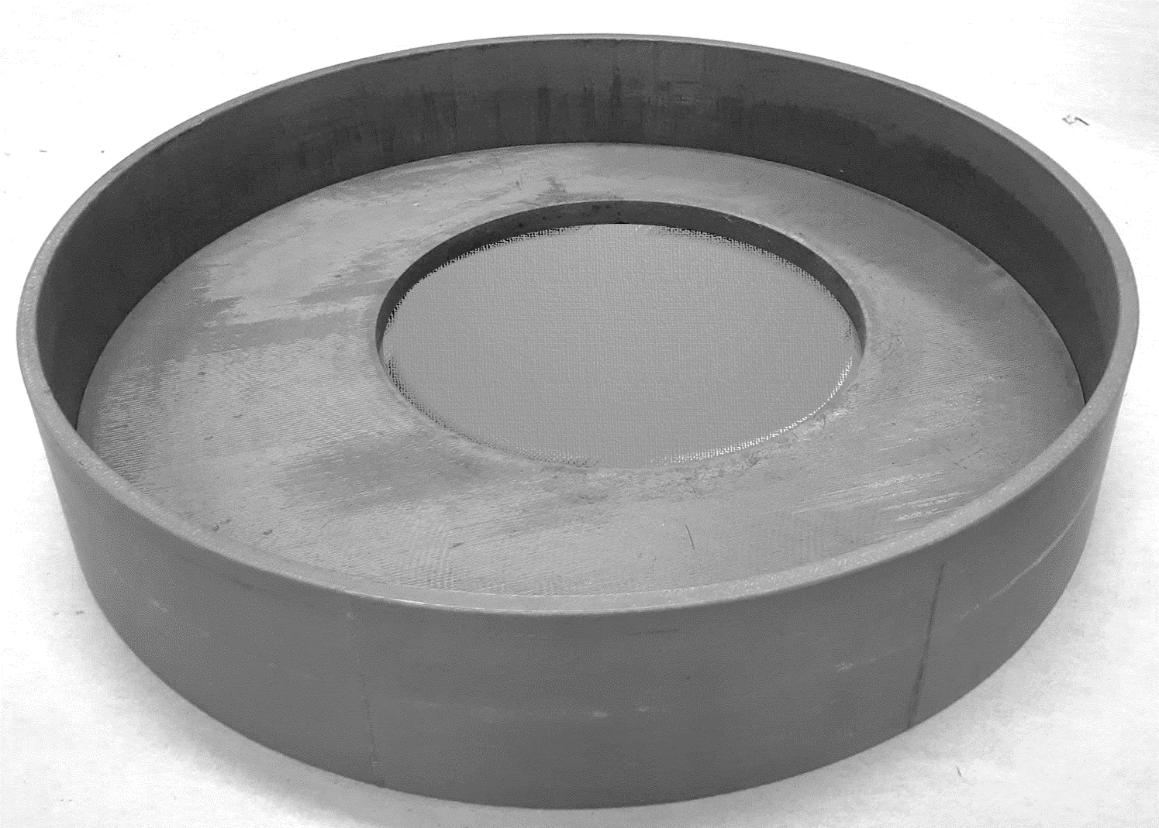
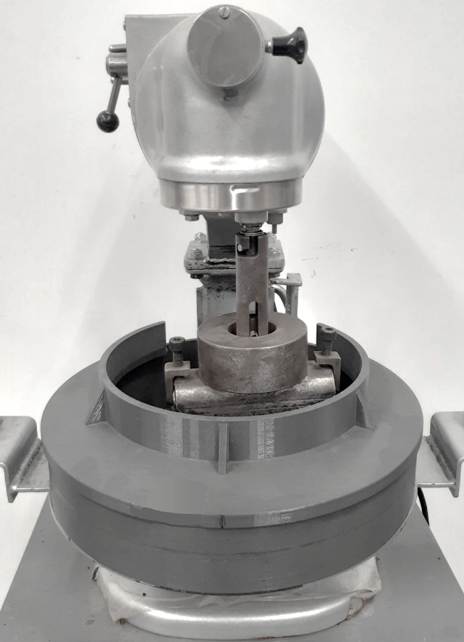
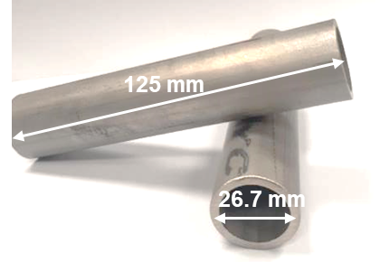
Figure 4.1: Wet Track Abrasion machine equipped with pan (1), lid (2), rotating support (3) and abrasion head (4)
2

2

1

1
3

3
- 3

- 3
1

1
4

4
53

53
3

3

Figure 4.2: Technical drawings of the pan and lid of the Wet Track Abrasion machine
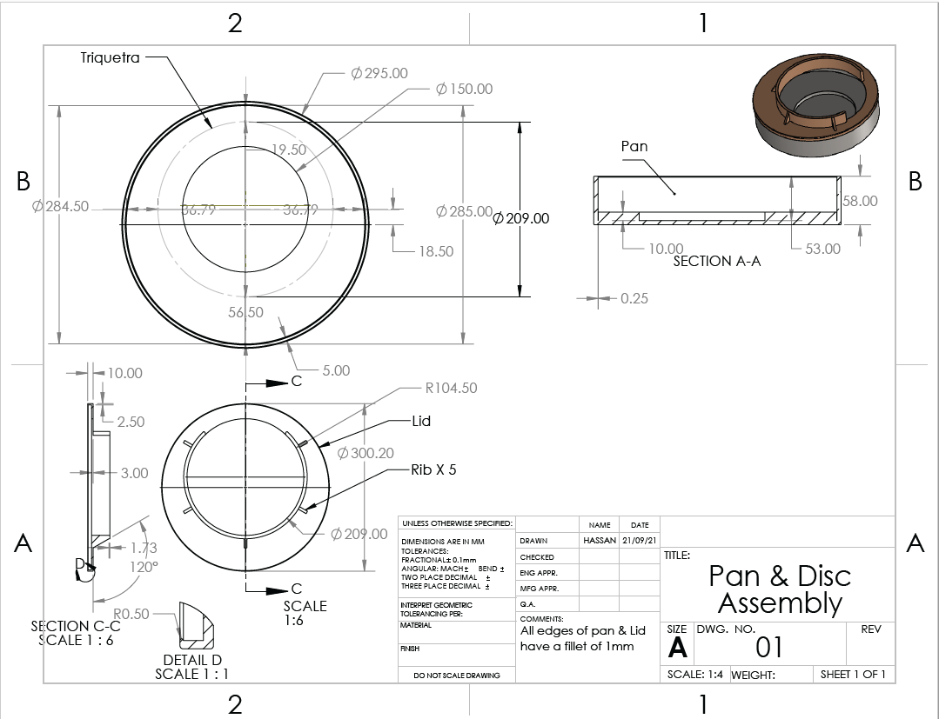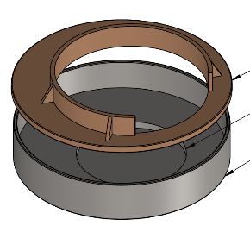
Pan and lid assembly
Lid

Lid
Pan

Pan

Microplastics Extraction
3

3
The following apparatus and materials are required to extract the microplastics from the residues generated after abrasion:
- fume hood;
- centrifuge device with a capacity of 4 × 50 mL and a rotating speed of at least 4,000 rpm;
- magnetic agitator with a mixing speed of at least 500 rpm;
- magnetic stirrer bar;
- Büchner flasks, 2 L and 500 mL;
- ceramic Büchner funnel, 150 mm diameter, with suitable silicon stopper;
- glass filter funnel, 250 mL, with suitable glass funnel support base, stainless steel filter support and clamp;
- vacuum pump;
- Whatman paper filter grade 542, 125 mm diameter, or equivalent;
- PVDF filter, 0.45 μm or equivalent, 47 mm diameter;
- PTFE filter, 0.45 μm or equivalent, 47 mm diameter;
- glass petri dish, 150 mm diameter;
- aluminium foil;
- spatula, stainless steel;
- balance capable of weighing to ± 0.0001 g;
- ultrasonic bath;
- tweezers;
- glass beaker, 100 mL;
- conical flask, 250 mL, with suitable glass stopper;
- glass centrifuge tubes with screw caps, 50 mL or equivalent, to fit centrifuge;
- disposable Pasteur pipettes;
- nitrogen gas;
- toluene, CAS 108-88-3, analytical grade;
- dichloromethane, CAS 75-09-2, analytical grade;
- chloroform, CAS 67-66-3, analytical grade;
- dimethylsulphoxide, CAS 67-68-5, analytical grade; and
- n-heptane, CAS 142-82-5, analytical grade.

Procedure
The following procedure shall be used to evaluate the asphalt mix of interest as well as a standard mix containing no plastic materials. A ‘blank’ experiment is commonly used to account for any cross-contamination and external microplastics (MPs) contamination. All tests shall be performed in quadruplicates to account for small variations of surface texture and plastic dispersion in the asphalt mix.

Sample Preparation
Sample preparation shall be conducted as follows:
- Compact the asphalt mix using a gyratory compactor into a specimen of at least 70 mm in height and 150 mm in diameter, with an air voids content of 5.0 ± 0.5%.
- Using the circular saw, cut the top and bottom sections of the compacted asphalt specimen into 2 slices of 19 ± 3 mm in thickness, with less than 0.2 mm difference between the 2 specimens. Check that the surface of the specimens is levelled using a spirit level. If not, discard the specimen and prepare a new one.
- Repeat steps (a) and (b) to compact another cylindrical specimen of the same asphalt mix and cut 2 other test specimens for a total of 4 specimens to be tested.
- Follow steps (a) to (c) to prepare 4 specimens of a standard asphalt mix containing no plastic material.

Abrasion test
Sample testing shall be conducted as follows, starting with the blank specimens (without plastic) (adapted from AGPT-T272-18):
- Place the blank asphalt specimen in the pan. Check that the test specimen cannot move when placed in the centre of the pan.
- Place the pan in the Wet Track Abrasion machine located in a climatic chamber.
- Fill the pan with 500 to 600 mL of water. The specimen must be submerged in water by at least 2 mm of water.
- Mount an abrasion head on the detachable rotating support using grade 8 bolts. Tighten the bolts with an appropriate tool.
- Place the rotating support back on the Wet Track Abrasion machine and mount the lid. Check that the head can rotate freely without touching the edges of the lid.
- Secure the pan on the base of the Wet Track Abrasion machine with a G clamp.
- Condition the entire testing set-up for 1 h at 25°C.
- Lift and lock the pan using the lever of the Wet Track Abrasion machine.
- Set the rotating speed to the lowest level and start the test. The climatic chamber is kept at a constant temperature of 25°C.
- After 20 min, stop the test, slightly untighten the abrasion head, roll it by 45° and tighten it again. Place the rotating support back on the specimen.
- Repeat steps (i) and (j) twice. The final testing duration is 1 h for each specimen.
- Carefully remove the asphalt specimen from the pan and rinse it with water to recover any residues stuck onto the specimen. Caution should be taken to ensure that no material is lost by rinsing the specimen within the pan.
- Recover the ‘residues + water’ contained in the pan into a glass bottle fitted with a glass funnel. Rinse the pan, lid and abrasion head with water to recover all residues. In total, no more than 1.5 L of water should be used for rinsing.
- Dry the pan and lid as well as the abrasion head, rotating support, bolts and clamp after each test to prevent cross contamination and corrosion.
- Repeat (a) to (n) 3 times with 3 other blank specimens, followed by 4 plastic-modified asphalt specimens.

Microplastics Extraction
Sample extraction shall be conducted in 3 different steps, including the collection of residues, the dissolution of bitumen and the density separation between microplastics and aggregates, starting with the blank sample (without plastic). Depending on the plastic used to modify asphalt, different organic solvents shall be used. Details are provided in Table 5.1. If the plastic composition is unknown, ATM-458 sections 4.1 and 4.2 shall be applied to determine the plastic types present in the recycled plastic material used in the asphalt specimen.
Table 5.1: Organic solvents to be used for microplastics extraction of asphalt mixes containing recycled plastics
Plastic material | Solvent for collection of residues and bitumen dissolution | Solvent for density separation | Membrane for filtration of microplastics
PE, PP | Toluene | Dichloromethane | PVDF
PET | Toluene | Chloroform | PVDF
ABS | N-heptane | Dimethylsulphoxide | PTFE
Nylon | Toluene | Chloroform | PVDF

Collection of residues
- Connect the vacuum pump to the 2 L Büchner flask fitted with a ceramic 150 mm diameter Büchner filter funnel. Place a Whatman paper filter grade 542 in the funnel and wet it with water.
- Turn the vacuum pump on and pour a small volume of the ‘residues + water’ collected after the abrasion test of the blank specimen into the funnel. Continue until all the ‘residues + water’ have been filtered.
- Replace the 150 mm diameter Büchner filter funnel with a 250 mL glass filter funnel and its support base equipped with a metal filter support. Place the 0.45 μm PVDF membrane on the filter support, mount the glass filter funnel on top of the membrane and secure it with the clamp. Wet the PVDF membrane with water and turn the vacuum pump on.
- Recover the ‘residues + water’ from the 2 L flask and filter it through the 0.45 μm PVDF filter.
- Keep the 2 filters in a glass petri dish and leave them to dry overnight.
- Scrape the dry residues out of the filters using a spatula. Collect the residues into a 250 mL conical flask.
- Under a fume hood, cut the filters into 3 × 3 cm pieces and place them into a 100 mL beaker. Add 20 to 30 mL of suitable solvent to cover the filters (Table 5.1, column 2).
- Sonicate the beaker in an ultrasonic bath for at least 5 min until the residues are removed from the filters.
- With tweezers, remove the pieces of filter from the beaker. Leave them to dry in the fume hood before discarding.

Dissolution of bitumen
- Add the residues recovered by sonication to the conical flask containing the residues scraped from the filters. Add 70 to 80 mL of the same organic solvent as used in section 5.3.1 (g) to reach a final volume of 100 mL. Add a magnetic stirrer, close the flask with a stopper and stir at 200 rpm for 15 min at room temperature.
- Transfer the content of the conical flask into glass centrifuge tubes, close the tubes and centrifuge for 15 min at 4,000 rpm.
- Using a Pasteur pipette, recover the supernatant containing dissolved bitumen. Add up to 40 mL of the same organic solvent as used in section 5.3.1 (g) to the centrifuge tube, close the tube, shake the tube to suspend the residues in the solvent, and centrifuge again for 15 min at 4,000 rpm.
- Repeat (b) and (c) until the supernatant has a light straw colour.
- Evaporate the solvent using a gentle stream of nitrogen.

Density separation of microplastics and aggregates
- Add 40 mL of a suitable organic solvent to the centrifuge tubes containing the dry residues after bitumen dissolution (Table 5.1, column 3). Close the tube.
- Shake the tube to suspend the residues in the solvent, and centrifuge for 15 min at 4,000 rpm.
- Measure the mass of a new 0.45 μm PVDF or PTFE membrane (Table 5.1, column 4) and record it as m_{f1}.
- Connect the vacuum pump to a 500 mL Büchner flask fitted with a 250 mL glass filter funnel and its support base equipped with a metal filter support. Place the membrane on the filter support, mount the glass filter funnel on top of the membrane and secure it with the clamp. Wet the membrane with the same organic solvent as in (a) and turn the vacuum pump on.
- Filter the supernatant of the centrifuge tubes through the membrane.
- Repeat (a) to (d) once.
- Carefully remove the membrane from the Büchner set-up and leave it to dry in a glass petri dish under a fume hood for 1 h.
- Measure the mass of the membrane and put the membrane back under the fume hood for 15 min. Measure the mass again and record it as m_{f2}. Repeat until the difference between 2 15 min successive measurements is less than 5%.
- Calculate the mass of MPs released from the specimen tested using the following equation:
$$m_{MPs}=m_{f2}-m_{f1}$$
Where:
$$m_{MPs}$$ | = | mass of MPs released from the specimen made with the asphalt mix containing plastic material, g
$m_{f2}$ | = | mass of the PVDF or PTFE membrane after filtration, g
$$m_{f1}$$ | = | mass of the PVDF or PTFE membrane before filtration, g
- Conduct the same specimen preparation, abrasion test and microplastics extraction on a standard asphalt mix containing no plastic materials using the same equipment, glassware, chemicals and operator. This blank is used to consider any external MPs contamination from the surrounding environment that could lead to an overestimation of the MPs released by the plastic-modified asphalt mix.

Calculations
- Calculate the mass of MPs released from the blank specimen tested using the following equation:
$$m_{blank}=m_{f2}-m_{f1}$$
Where:
 | $$m_{blank}$$ | = | mass of MPs released from the specimen made with the standard asphalt mix, g
$$m_{f2}$$ |  | = | mass of the PVDF or PTFE membrane after filtration, g
 | $$m_{f1}$$ | = | mass of the PVDF or PTFE membrane before filtration, g
- Calculate $m_{MPs}$ and $m_{blank}$ for each replicate. At least 4 tests for each asphalt mix are required to obtain an average value.
- Calculate the mass of MPs released per square meter of the plastic-modified asphalt mix using the following equation:
$${MP}_{asphalt mix}=\frac{M_{MPs}-M_{blank}}{A}$$
Where:
$${MP}_{asphalt mix}$$ | = | mass of MPs released per square meter of asphalt mix, g/m²
$$M_{MPs}$$ | = | average mass of MPs released from the specimen of interest (obtained from 4 replicates), g
$$M_{blank}$$ | = | average mass of MPs released from the standard asphalt with no plastic (obtained from 4 replicates), g
$$A$$ | = | surface area of the asphalt specimen, m²

Report
The following shall be reported:
- compaction method used to prepare the samples; and
- ${MP}_{asphalt mix}$ value and corresponding standard deviation, g/m².
Note: Where results are to be compared against a selected benchmark, a tolerance level of ± 0.05 g/m² can be applied to account for any variability due to the testing equipment.

Amendment Record
Amendment no. | Clauses amended | Action | Date
- | New test method | New | May 2025

Key
Format | Change in format
Substitution | Old clause removed and replaced with new clause
New | Insertion of new clause
Removed | Old clauses removed

Grade 8 bolts, or higher, are required to ensure that the bolts can withstand the high level of stress generated during the test.
The abrasion head can be deformed during the test. Rolling it by 45° ensures that the surface of the abrasion head in contact with the specimen is uniform for all samples. The head must be replaced after testing 2 specimens.
Keep the water collected from each specimen in separate bottles before extraction.

