
AUSTROADS TEST METHOD ATm 122 [AGPT/T122]
Torsional Recovery of Polymer Modified Binders

Commentary
Contents

1. References 2

2. Principle 2

3. Apparatus 2

4. Procedure 4

4.1 Sample Preparation 4

4.2 Measurement 4

5. Calculation 5

6. Information to be Reported 5

7. Precision 6

Appendix A Example of a Bolt Assembly Containing an Optional Pointer (Informative) 7

Amendment Record 8

Preface
This test method was prepared by the Bituminous Surfacings Technical Group (BSTG) on behalf of the Austroads Pavements Task Force (PTF). Representatives of Austroads, the Australian Road Research Board (ARRB) and the Australian Flexible Pavement Association (AfPA) were involved in developing and reviewing this test method.
Forward
Polymer modified binders (PMBs) are thought to provide benefits due to their increased elastic behaviour. A simple means of determining the elastic properties of a PMB is to measure its torsional recovery. The torsional recovery test is simple and can be readily utilised for routine quality control purposes.
Scope
This test method sets out the procedure for the determination of torsional recovery of PMBs under specific conditions using a simple torsional recovery test apparatus.
Further Development
There are no further plans for the development of this test method.
Safety disclaimer
Warning: The use of this Austroads test method may involve hazardous materials, operations and equipment. This Austroads test method does not purport to address the safety issues associated with its use. It is the responsibility of the user of this Austroads test method to establish appropriate work health and safety practices and determine the applicability of regulatory limitations prior to use.

References
The following normative documents are referred to in this method:
Austroads Test Methods
T101 | Method of sampling polymer modified binders, polymers and crumb rubber.
AGPT/T102 | Protocol for handling modified binders in preparation for laboratory testing.
ASTM Standard
ASTM E1 | Standard specification for ASTM liquid-in-glass thermometers.

Principle
The torsional recovery test apparatus operates by manually rotating a bolt assembly, previously embedded in a sample, through an angle of 180° and measuring the extent of recovery from the original applied rotation. The initial 180° rotation is applied with a spanner or ratchet socket over a 10 s period. The torsional recovery (in %) after 30 s is reported.

Apparatus
The following apparatus is required:
- Bolt assembly – consisting of a bolt, spider and nuts as shown on the left-hand side of Figure 3.1 and Figure 3.2. The total mass of the bolt assembly (including bolt, spider, nuts and optional pointer) shall be 45 ± 5 g. The bolt and spider shall be manufactured from aluminium (or a suitable aluminium alloy). The components of the bolt assembly shall meet the following requirements:
  - Bolt – with bolt head diameter of 28.6 ± 0.1 mm and a bolt head height of 9.5 ± 0.1 mm. The outer surfaces of the bolt head shall be smooth metal surfaces as shown in Figure 3.1 and Figure 3.2. The threaded shank of the bolt should be 44.5 mm long.
  - Spider – with three radial pins which can centre the bolt assembly in the sample cup (examples are shown in Figure 3.1 and Figure 3.2). The spider shall be screwed into the threaded shank of the bolt using a threaded hole in the centre of the spider. The spider shall move with the bolt when it is rotated during testing. If the optional pointer is not used, a thin mark shall be placed on the end of one of the radial pins of the spider so that angle measurements can be determined using the mark.
  - Two metal nuts – which are of suitable size for the threaded shank of the bolt. The nuts shall be firmly fixed to the bolt and shall move with the bolt when it is rotated during testing.
  - Pointer (optional) – which measures the degree of rotation during testing. The pointer shall be secured to the shank of the bolt, or securely fitted to the end of one of the radial pins of the spider, so that it moves with the bolt when it is rotated during testing. Appendix A shows an example of a bolt assembly where the pointer has been secured to the shank of the bolt.
- Sample cup – metal cup of 80 to 85 mL capacity with an internal diameter of 53 ± 2 mm. The walls of the sample cup shall be sufficiently thick so that the sample cup does not deform when it is secured in the sample cup clamp.
- Sample-cup clamp – capable of holding the sample cup within 3 mm of its centre during testing which does not deform the cup by more than 3 mm in any direction.
- Angle measuring device – which can determine the degree of rotation of a sample secured in the sample-cup clamp. The angle measuring device shall have a range of at least 180° with intervals of at least 1°.
- Water bath – capable of operating at 25.0 ± 0.5 °C.
- Thermometer or thermometric device – for measuring the temperature of the water bath.
Note 1: An ASTM 90C thermometer as specified in ASTM E1, or thermometric device with accuracy, precision and sensitivity equal to or better than an ASTM 90C thermometer, have been found to be suitable.
- Fan-assisted oven – an oven in which the air is circulated by a fan. The oven shall be calibrated or validated and capable of maintaining a temperature within ±5 °C of the set temperature.
- Timing device – capable of measuring time to the nearest 0.1 s.
- Spanner or ratchet socket – of suitable size to turn the nuts in the bolt assembly.
Figure 3.1: Schematic of the bolt assembly and overall test setup
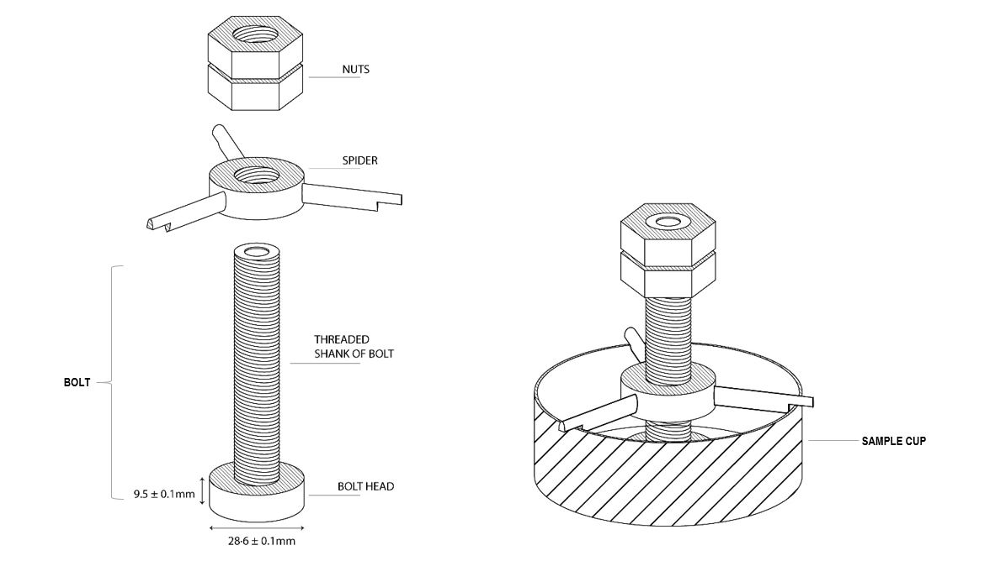
Figure 3.2: Photograph of a suitable bolt assembly and sample cup
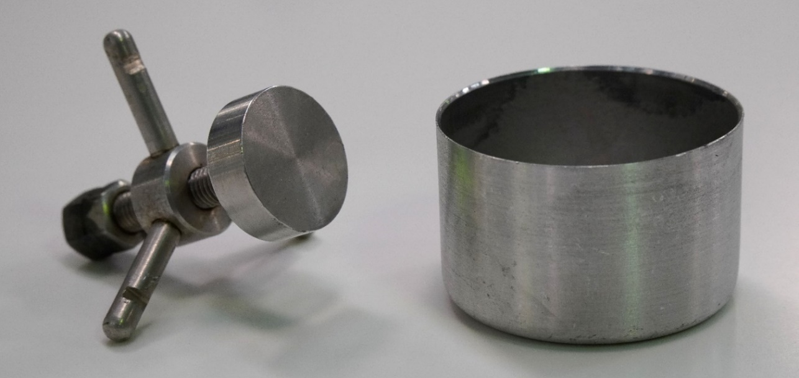

Procedure

Sample Preparation
Binder samples shall be provided for testing in accordance with AGPT/T101. Samples shall be prepared for testing using AGPT/T102.

Measurement
- Place the bolt assembly on the sample cup so that the three radial pins of the spider are in contact with the uppermost edge of the sample cup (see right-hand side illustration in Figure 3.1). Include the pointer in the bolt assembly, if used. Position the bolt assembly so that the centre of the head of the bolt is visually located at the radial centre of the sample cup.
- Adjust the vertical position of the bolt assembly so that the upper surface of the bolt head is positioned 8 ± 2 mm below the uppermost edge of the sample cup by rotating the spider along the threaded shank of the bolt.
- Preheat the bolt/sample cup assembly in an oven at 180 °C ensuring that the position of the bolt assembly does not change during heating.
- Remove the bolt/sample cup assembly from the oven. Pour the binder into the sample cup, until it begins to form a meniscus on the top surface of the bolt head.
- Allow the bolt/sample cup assembly to cool for one hour by leaving it to stand at room temperature.
- Place the bolt/sample cup assembly into the 25 °C water bath and allow it to equilibrate for one hour. Record the temperature of the water bath and ensure it is in the range of 25.0 ± 0.5 °C.
- Remove the bolt/sample cup assembly from the water bath and, without turning the bolt, adjust the spider to a suitable height so that it does not come in contact with the sample cup when the bolt assembly is rotated.
- Immediately after the height of the spider has been adjusted, place the bolt/sample cup assembly in the sample-cup clamp so that the mark on one of the radial pins of the spider, or the pointer (if used), is pointing to either the 0° position or the 180° position. Secure the bolt/sample cup assembly in the sample-cup clamp.
Note 2: The test should be conducted in an air-conditioned laboratory at 25 ± 3 °C.
- Using the spanner or ratchet socket, turn the metal nuts using a steady motion so that the bolt assembly is rotated through an angle of 180° in 10 s. If the radial pin of the spider (or optional pointer) is initially pointing to the 0° position, rotate the bolt assembly from the 0° position to the 180° position in 10 s. If the radial pin of the spider (or optional pointer) is initially pointing to the 180° position, rotate the bolt assembly from the 180° position to the 0° position in 10 s. The shank of the bolt should stay vertical when the bolt assembly is rotated.
Note 3: It is recommended that the time between removing the sample from the water bath and turning the metal nuts be less than 1 minute.
Note 4: The rate at which the torque is applied to the sample is critical for reproducible results.
Note 5: The position of the shank of the bolt can be controlled during rotation by ensuring that the three pins of the spider remain horizontal during rotation. A purpose-built jig may also be used to ensure the shank of the bolt remains vertical during rotation.
- Release the bolt assembly immediately after the bolt assembly has been rotated through an angle of 180° and commence timing.
Note 6: The metal spider shall not come into contact with the rim of the sample cup at any time during the recovery phase.
- Record the angle (A, in degrees (°)) indicated by the mark on one of the radial pins of the spider, or the pointer (if used), 30 s after releasing the bolt assembly.
- Repeat the procedure described in Clauses 4.2 (a) to (k) on a duplicate sample.

Calculation
- If the test was conducted by rotating the bolt assembly from the 0° position to the 180° position, calculate the recovered angle (R, in degrees (°)) for each of the duplicate samples using Equation 1:
$$R = 180-A$$ |  |  | 1
where
$$R$$ | = | recovered angle, in degrees (°)
$$A$$ | = | angle indicated by one of the radial pins of the spider, or the pointer, after 30 s of recovery, in degrees (°)

If the test was conducted by rotating the bolt assembly from the 180° position to the 0° position, calculate the recovered angle (R, in degrees (°)) for each of the duplicate samples using Equation 2:
$$R = A$$ |  |  | 2
where
$$R$$ | = | recovered angle, in degrees (°)
$$A$$ | = | angle indicated by one of the radial pins of the spider, or the pointer, after 30 s of recovery, in degrees (°)
- Calculate the torsional recovery result for each of the duplicate samples using Equation 3:
$$Torsional recovery \left(\%\right)= \frac{100 ×R}{180}$$ |  |  | 3
where
$$R$$ | = | recovered angle (in degrees (°)) determined using Equation 1 or Equation 2

- Calculate the mean of the torsional recovery results obtained for the duplicate samples.

Information to be Reported
The following information shall be reported:
- Mean of the torsional recovery results obtained for the duplicate samples (in %) to the nearest whole number.
- Test temperature in °C.
- Recovery time in seconds.

Precision
No inter-laboratory testing has been conducted on the range of PMBs currently available.
- Example of a Bolt Assembly Containing an Optional Pointer (Informative)
Figure A.1 shows an example of a bolt assembly which includes the optional pointer where the pointer has been secured to the shank of the bolt. An example of a sample cup is also shown in the figure.
Figure A.1: Example of a bolt assembly containing an optional pointer
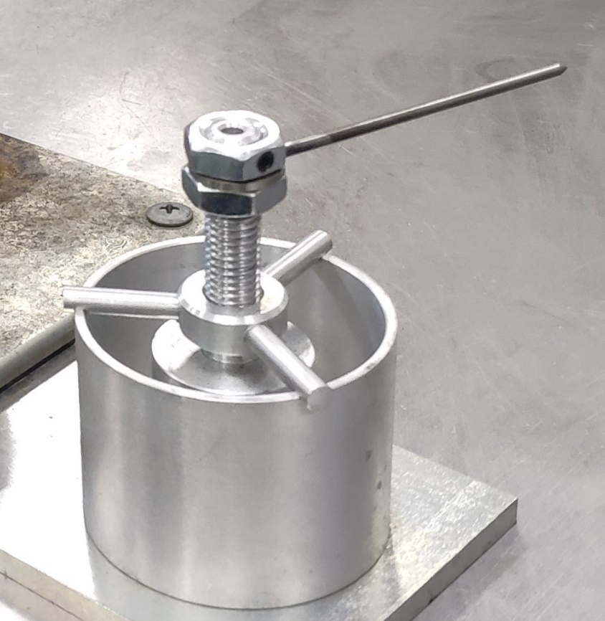

Amendment Record
Amendment no. | Clauses amended | Action | Date
1 | Commentary Page  Footer and header  Applied revised test method number  Applied new styles | New  Format  Format  Format | June 2005
2 | Applied new test method numbers  Moved notes to end of method | Substitution  Format | March 2006
3 | New template applied  Commentary  Safety Disclaimer  Notes integrated into body of test method  References  Apparatus and test procedures  Calculation and information to be reported  Figure 3.1  Figure 3.2  Equation 1  Equation 2  Equation 3  Appendix A | Format  Substitution  New  Format  Substitution  Substitution  Substitution  Substitution  New  New  New  Substitution  New | January 2022

Key
Format | Change in format
Substitution | Old clause removed and replaced with new clause
New | Insertion of new clause
Removed | Old clauses removed

